UNIT -1
CARBOHYRATES
DEFINITION
Carbohydrates are defined as the aldehydic or ketonic derivatives of higher polyhydroxy alcohol or anhydrides of such derivatives.
IMPORTANT FUNCTIONS
Humans and all animals except carnivorous derive the major portion of their food calories from the various types of carbohydrates in their diets. Most of the energy for the metabolic activities of the cell in all organisms is derived from the oxidation of carbohydrates in the form of glucose). In the storage organs of plants in the form of starch ) and in the liver and muscles of animals ( in the form of glycogen ), they are important food reserve. They also serve as an important component of skeletal structures in plants in the form of cellulose) and that of outer structure of microscope.
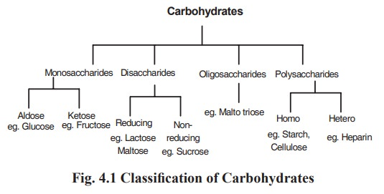
Monosaccharides
These consist of single polyhydroxy aldehyde or ketone unit which cannot be broken down to simpler substances These consist of single polyhydroxy aldehyde or ketone group as the functional group are called aldoses and those hydrolysis . Monosaccharides containing an aldehyde containing a ketone group as the functional group are called ketoses. They are further classified according to the number of carbon atoms present . Monosaccharides containing three to seven carbon atoms are called trioses , tetroses , pentoses , hexoses and heptoses respectively . Glucose ( or dextrose ) is a hexose and it is the principal sugar in blood serving the tissues as a major metabolic fuel. Fructose (or levulose) is an important component of fruit juices and honey. A cyclic hemiacetal structure accounts for their chemical properties.
Examples are-
- Triose sugars( glyceraldehyde, Dihydroxyacetone)
- Pentose sugars(ribose, ribulose)
- Hexose sugars( glucose, galactose, fructose)
Oligosaccharides
They are defined as carbohydrates that contain between two and ten monosaccharides units per molecule joined by glucosidic linkages.
On hydrolysis, they yield monosaccharides.
Depending upon the number of constituent monosaccharides units , the oligosaccharides are called disaccharides , trisaccharides etc.
Disaccharides consist of two monosaccharides joined by a glycosidic linkage. The most common and important disaccharides are maltose , lactose and sucrose . Maltose consists of two molecules of D - glucose joined by a - 1 , 4) - glycosidic linkage . It is an important intermediate product of digestion of starch and glycogen. Lactose consists of galactose and glucose joined by a- (1,4) glycosidic linkage. It is a sugar present in milk to the extent of 5 % Sucrose consists of glucose and fructose joined by a ( 1 ) -1 ( 2 ) glycosidic linkage . It is a plant disaccharide and present in high concentration in sugar cane and beet
Polysaccharides
They are the polymers of monosaccharide units which are joined in linear or branched chain fashion by glycosidic linkages. Polysaccharides contain a large number of sugar components per free carbonyl group.
These can be divided as
( A ) Homopolysaccharides
( B ) Heteropolysaccharides .
- Homopolysaccharides
They contain only one type of monosaccharides as the repeating unit. On hydrolysis, they give only one type of sugar. Example- Starch, glycogen, dextrin etc .
- Heteropolysaccharides
These are made up of mixed disaccharides repeating units and by hydrolysis give mixture of more than one product of monosaccharides and their derivatives.
Examples: Hyaluronic acid and heparin. Hyaluronic acid is present in connective tissues. Heparin is present in liver , lungs , thymus , spleen and blood .
Mucopolysachharides ( Glycoaminoglycans ) are complex carbohydrates containing amino sugars and uronic acids . They may be attached to protein molecules to form proteoglycans, which provide packing substance of connective tissue. Glycoproteins (mucoproteins) contain branched or unbranched oligosaccharide chains. They occur in cell membrane.

PROPERTIES OF CARBOHYDRATES
Following are the important properties of some carbohydrates on which clinical chemistry methods based :

1 Reducing property
Monosaccharides by virtue of free aldehydic or ketonic group in their structure reduce metallic cations , such as , cations in alkaline solution at high temperature . All the monosaccharides and the two disaccharides , maltose and lactose reduce cupric ions present in Benedict's reagent and also in Fehling's reagent.

2. Formation of osazone crystals
The reducing sugars form characteristic osazone crystals. These are obtained by adding a mixture of phenylhydrazine hydrochloride and sodium acetate to the sugar solution and then by heating the mixture in a boiling water bath. These compounds have characteristic crystal structures, melting points, and precipitation times, and are valuable in the identification of sugars. Glucose , fructose and mannose give the same types of osazones ( needle shaped ) maltose forms sunflower type crystals and lactose forms cotton ball types of osazones . Hence , lactose can be differentiated from other reducing substances , if present in urine .

Action of acids
Selivanoff's test : Selivanoff's reagent contains 50 mg of resorcinol in 12% (v / v) hydrochloric acid. Selivanoff's reagent reacts with fructose to form red colored compound . When 5 ml of Selivanoff's reagent is heated and boiled with 5 drops 0.25 ml of fructose solution or urine containing fructose ( 0.5 % ) for 20 to 30 seconds , a positive reaction is indicated by the production of red color , with or without separation of brown red color.

Reaction with iodine ( iodine test )
a ) Starch reacts with dilute iodine solution to form blue colored starch iodine complex .
- Glycogen gives a red color with iodine solution.
- Dextrin however gives red, blue or purple color with dilute iodine solution, depending upon the type of dextrin present.

Reaction with sulfuric acid
( Molisch's test ) Molish's test : It is a sensitive chemical test for the presence of carbohydrates , based on the dehydration of the carbohydrate by sulfuric acid to produce an aldehyde , which condenses with two molecules of phenol ( mainly c - naphthol ), resulting in a red- or purple- colored compound . All carbohydrates such as monosaccharides, disaccharides and polysaccharides give a positive reaction.

Isomerism
Isomerism is exhibited by various carbohydrates such as glyceraldehyde , glucose , fructose etc.

BIOMEDICAL IMPORTANCE
- Carbohydrates are widely distributed in plants and animals; they have important structural and metabolic roles.
- In plants, glucose is synthesized from carbon dioxide and water by photosynthesis and stored as starch or used to synthesize the cellulose of the plant cell walls.
- Animals can synthesize carbohydrates from amino acids, but most are derived ultimately from plants. Glucose is the most important carbohydrate; most dietary carbohydrate is absorbed into the bloodstream as glucose formed by hydrolysis of dietary starch and disaccharides, and other sugars are converted to glucose in the liver.
- Glucose is the major metabolic fuel of mammals (except ruminants) and a universal fuel of the fetus. It is the precursor for synthesis of all the other carbohydrates in the body, including glycogen for storage;
- ribose and deoxyribose in nucleic acids; galactose for synthesis of lactose in milk, in glycolipids, and in combination with protein in glycoproteins and proteoglycans.
- Diseases associated with carbohydrate metabolism include diabetes mellitus, galactosemia, glycogen storage diseases, and lactose intolerance.
- Glycobiology is the study of the roles of sugars in health and disease. The glycome is the entire complement of sugars of an organism, whether free or present in more complex molecules.
- Glycomics, an analogous term to genomics and proteomics, is the comprehensive study of glycomes, including genetic, physiological, pathological, and other aspects.
- A very large number of glycoside links can be formed between sugars. For example, three different hexoses may be linked to each other to form over 1000 different trisaccharides.
- The conformations of the sugars in oligosaccharide chains vary depending on their linkages and proximity to other molecules with which the oligosaccharides may interact.
- Oligosaccharide chains encode biological information and that this depends upon their constituent sugars, their sequences, and their linkages.
CAROHYDRATE
- Carbohydrates biological functions.
- A. Carbohydrates are defined as poly hydroxy alcohols with functional aldehyde or keto group. Functions:
- 1. They are major energy source for man.
- 2. They function as reserve food material in man and plants.
- 3. They are components of connective tissues, bone, cartilage, skin, membrane and nerve tissue.
- 4. They are components of blood group substances, nucleic acids etc.
- 5. Carbohydrate derivatives are vitamins, antibiotics and drugs
- Enantiomers or optical isomers with examples.
- A. Enantiomers (optical isomers): Optical isomers of a compound are called as enantiomers. D and L glucose are examples for optical isomers.
- Epimers and anomers.
- A. Epimers:
- nd rd th 1. They differ in the configuration of –OH and H groups on 2 , 3 and 4 carbon atoms of monosaccharide.
- 2. Glucose and galactose are epimers.
- 3. They differ in the configuration of –OH and H groups on fourth carbon atom.
- 4. Like wise glucose and mannose.
- Anomers:
- 1. Anomers differ in configuration of –OH and-H groups on first or anomeric carbon of sugar.
- 2. α –glucose and β – glucose are two anomers of glucose.
- 3. In α- glucose –OH is present on right side whereas in β –glucose it is present on left side.
- Glucose- lactate cycle OR Cori cycle .
- A. In this cycle lactate that is produced in rapidly contracting skeletal muscle enters blood stream because it is a dead end of glycolysis. Through blood stream it reaches liver where it is converted to glucose through gluconeogenesis. Glucose so formed enters blood stream and reaches skeletal muscle for utilization. Thus the liver supplies glucose to skeletal muscle which in turn supplies lactate to liver.
- These reactions constitutes coricycle or glucose –lactate cycle.
- Skeletal muscle Blood Liver
- Glucose Lactate Lactate Glucose.
- Glycolysis Gluconeogenesis

- Blood
- Diabetes mellitus.and their clinical and biochemical symptoms.
- A. Diabetes mellitus is disease due to lack of action of insulin and characterized by elevated blood glucose level and glucose in urine.
- There are two types of diabetes mellitus.
- I. Type І Diabetes mellitus or insulin dependent diabetes mellitus (IDDM) or Juvenile onset diabetes mellitus :-As the name implies it appears in young people. The age of affected people is always below 30 years. It accounts about 20% of diabetic cases. Usually individuals of this disease are thin or lean and appears as under nourished. It is due to absence of insulin. Hence patients of this disease are treated with insulin injections.
- ii. Type ІІ diabetes mellitus or non insulin dependent diabetes mellitus (NIDDM)or Adults on set diabetes mellitus :As the name implies it appears in adults. The age of affected people is always above 30years. It accounts about 80% of diabetes cases. Usually individuals of this disease are obese. It is due to lack of insulin action i. e. insulin is present but due to lack of insulin receptors its action is lost. Hence patients of this disease cannot be treated with insulin injections.
- Biochemical and clinical symptoms:
- In acute diabetic patients following biochemical and clinical symptoms are seen.
- a. Hypoglycemia
- b. Glycosuria
- c. Polyuria
- d. Increased hunger (Polydipsia)
- e. Increased thrist (polyphasia)
- f. Ketosis in type І diabetes
- g. Weight loss
- h. Delayed wound healing.
- i. Keto acidosis.
- j. Coma and death.
Glycosurias.
- A. Glycosurias are conditions associated with excretion of glucose and or sugars in urine. Most common disease is diabetes mellitus. Renal diabetes is another disease of glycosuria where excretion of sugar or glucose in urine is due to defective reabsorption of glucose in renal tubules. Other glycosurias are
- 1. Lactosuria : It is characterized by excretion of lactose in urine. It occurs in pregnancy.
- 2. Galactosuria: It is associated with excretion of Galactose in urine. It occurs in galactosemia.
- 3. Fructosuria: It occurs in hereditary fructose intolerance and associated with excretion of fructose in urine.
- 4. Pentosuria: It occurs in essential pentosuria and characterized by excretion of pentose xylulose in urine.
- Reducing substances in urine.
- A. Benedict's test is used for detection of reducing substances in urine.
- It involves boiling of urine with Benedict's qualitative reagent. Depending on amount of reducing sugar in urine variety of colors are produced. Reducing monosaccharides and disaccharides are detected in urine by performing this test. Under alkaline conditions reducing sugar decomposes to enediols which reduces cupric to red cuprous oxide.
- Glucose Tolerance Test (GTT)
- A. The ability of body to oxidize a load of glucose given is referred as glucose tolerance. This test is used to distinguish normal people from people with increased or decreased tolerance that occurs in diseases like diabetes mellitus, hormonal disorders etc.
- Procedure: After over night or 12 hour of fasting GTT is done. Fasting blood and urine samples are collected. The subject is asked to drink 200 ml water which contain test dose of glucose. A standard dose of 50gm of glucose or 0. 75 -1. 5 gm per Kg body weight is usually dissolved in 200ml water. The time is noted and for every 30 minutes blood and urine samples are collected for two and half hours. Glucose in the blood samples and urine samples is determined. Usually blood glucose level is measured quantitatively and qualitative Bendicts test is used for urine sugar analysis. The blood glucose values are plotted against time.
- Normal glucose tolerance (response): The fasting blood glucose level is with in range of 60- 90mg%. The blood glucose level reaches a peak within 30 to 60 minutes after consuming glucose test dose. The peak value is 110-130mg%. The initial rise is due to absorption of glucose. However increased blood glucose level returns to normal at the end of 2 hours due to increased glucose utilization. None of the urine samples contain glucose because the blood glucose level is below renal threshold for glucose which is 175mg%.
- Decreased glucose tolerance: Diabetes mellitus is mainly responsible for the diminished glucose tolerance. Fasting blood glucose values are above 120mg % and depends on severity of disease. After test dose of glucose, blood glucose level rises sharply and extent of increase is more than that seen in normal people. The most striking is high blood glucose level even after 2 hours. In mild diabetes minimum one urine sample contains glucose. All urine samples contain glucose in the case of severe diabetes. Decreased glucose tolerance also occurs in Cushing's syndrome, thyrotoxicosis, hyper activity of pituitary gland and in liver disease.
- Increased glucose tolerance: Increased tolerance is seen in addison's disease, myxedema, cretinism, hypopituitarism etc. In cases with impaired glucose absorption also increased tolerance occurs. Sprue, celiac disease, and idiopathic steatorrhea are some intestinal disorders associated with increased tolerance. Usually a flat glucose tolerance curve is obtained.
Metabolism of carbohydrates
- Metabolic enzymes catalyze catabolic reactions that break down carbohydrates contained in food. The energy released is used to power the cells and systems that make up your body. Excess or unutilized energy is stored as fat or glycogen for later use. Carbohydrate metabolism begins in the mouth, where the enzyme salivary amylase begins to break down complex sugars into monosaccharides. These can then be transported across the intestinal membrane into the bloodstream and then to body tissues.
- In the cells, glucose, a six-carbon sugar, is processed through a sequence of reactions into smaller sugars, and the energy stored inside the molecule is released.
- The first step of carbohydrate catabolism is glycolysis, which produces pyruvate, NADH, and ATP. Under anaerobic conditions, the pyruvate can be converted into lactate to keep glycolysis working.
- Under aerobic conditions, pyruvate enters the Krebs cycle, also called the citric acid cycle or tricarboxylic acid cycle. In addition to ATP, the Krebs cycle produces high-energy FADH₂ and NADH molecules, which provide electrons to the oxidative phosphorylation process that generates more high-energy ATP molecules. For each molecule of glucose that is processed in glycolysis, a net of 36 ATPs can be created by aerobic respiration.
- Under anaerobic conditions, ATP production is limited to those generated by glycolysis. While a total of four ATPs are produced by glycolysis, two are needed to begin glycolysis, so there is a net yield of two ATP molecules.
- In conditions of low glucose, such as fasting, starvation, or low carbohydrate diets, glucose can be synthesized from lactate, pyruvate, glycerol, alanine, or glutamate. This process, called gluconeogenesis, is almost the reverse of glycolysis and serves to create glucose molecules for glucose-dependent organs, such as the brain, when glucose levels fall below normal.
- During digestion, carbohydrates are broken down into simple, soluble sugars that can be transported across the intestinal wall into the circulatory system to be transported throughout the body.
- Carbohydrate digestion begins in the mouth with the action of salivary amylase on starches and ends with monosaccharides being absorbed across the epithelium of the small intestine.
- Once the absorbed monosaccharides are transported to the tissues, the process of cellular respiration begins .
This section will focus first on glycolysis, a process where the monosaccharide glucose is oxidized, releasing the energy stored in its bond
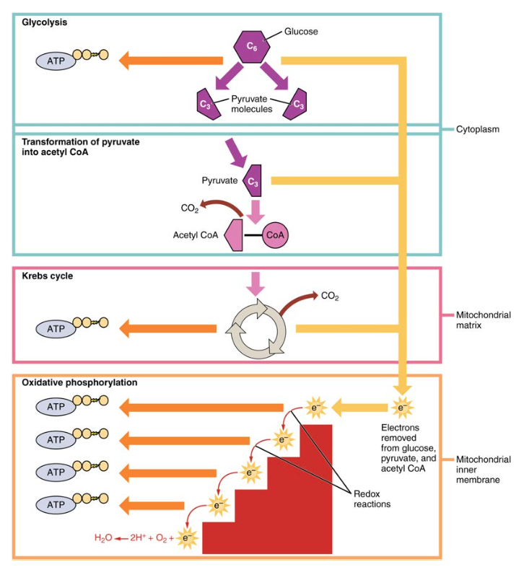
s to produce ATP.

Glycolysis
- Glucose is the body’s most readily available source of energy. After digestive processes break polysaccharides down into monosaccharides, including glucose, the monosaccharides are transported across the wall of the small intestine and into the circulatory system, which transports them to the liver.
- In the liver, hepatocytes either pass the glucose on through the circulatory system or store excess glucose as glycogen.
- Cells in the body take up the circulating glucose in response to insulin and, through a series of reactions called glycolysis, transfer some of the energy in glucose to ADP to form ATP . The last step in glycolysis produces the product pyruvate.
- Glycolysis begins with the phosphorylation of glucose by hexokinase to form glucose-6-phosphate. This step uses one ATP, which is the donor of the phosphate group.
- Under the action of phosphofructokinase, glucose-6-phosphate is converted into fructose-6-phosphate. At this point, a second ATP donates its phosphate group, forming fructose-1,6-bisphosphate.
- This six-carbon sugar is split to form two phosphorylated three-carbon molecules, glyceraldehyde-3-phosphate and dihydroxyacetone phosphate, which are both converted into glyceraldehyde-3-phosphate.
- The glyceraldehyde-3-phosphate is further phosphorylated with groups donated by dihydrogen phosphate present in the cell to form the three-carbon molecule 1,3-bisphosphoglycerate. The energy of this reaction comes from the oxidation of (removal of electrons from) glyceraldehyde-3-phosphate.
- In a series of reactions leading to pyruvate, the two phosphate groups are then transferred to two ADPs to form two ATPs.
- Thus, glycolysis uses two ATPs but generates four ATPs, yielding a net gain of two ATPs and two molecules of pyruvate.
- In the presence of oxygen, pyruvate continues on to the Krebs cycle (also called the citric acid cycle or tricarboxylic acid cycle (TCA), where additional energy is extracted and passed on.
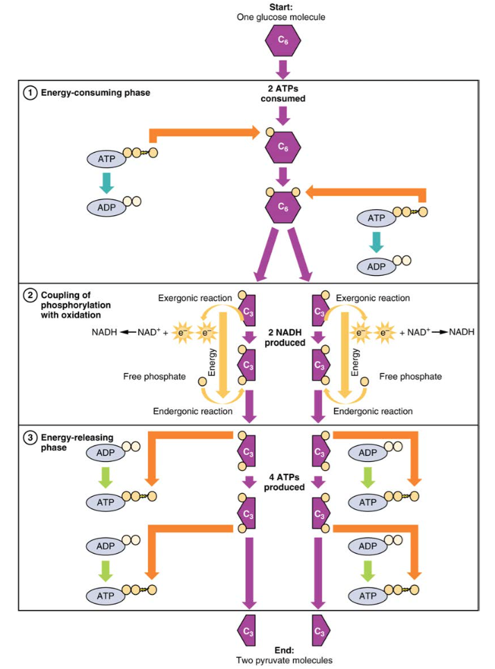
- Glycolysis can be divided into two phases:
- energy consuming (also called chemical priming) and energy yielding. The first phase is the energy-consuming phase, so it requires two ATP molecules to start the reaction for each molecule of glucose. However, the end of the reaction produces four ATPs, resulting in a net gain of two ATP energy molecules.
- When glucose enters a cell, the enzyme hexokinase (or glucokinase, in the liver) rapidly adds a phosphate to convert it into glucose-6-phosphate. A kinase is a type of enzyme that adds a phosphate molecule to a substrate (in this case, glucose, but it can be true of other molecules also). This conversion step requires one ATP and essentially traps the glucose in the cell, preventing it from passing back through the plasma membrane, thus allowing glycolysis to proceed. It also functions to maintain a concentration gradient with higher glucose levels in the blood than in the tissues. By establishing this concentration gradient, the glucose in the blood will be able to flow from an area of high concentration (the blood) into an area of low concentration (the tissues) to be either used or stored. Hexokinase is found in nearly every tissue in the body. Glucokinase, on the other hand, is expressed in tissues that are active when blood glucose levels are high, such as the liver. Hexokinase has a higher affinity for glucose than glucokinase and therefore is able to convert glucose at a faster rate than glucokinase. This is important when levels of glucose are very low in the body, as it allows glucose to travel preferentially to those tissues that require it more.
- In the next step of the first phase of glycolysis, the enzyme glucose-6-phosphate isomerase converts glucose-6-phosphate into fructose-6-phosphate. Like glucose, fructose is also a six carbon-containing sugar. The enzyme phosphofructokinase-1 then adds one more phosphate to convert fructose-6-phosphate into fructose-1-6-bisphosphate, another six-carbon sugar, using another ATP molecule. Aldolase then breaks down this fructose-1-6-bisphosphate into two three-carbon molecules, glyceraldehyde-3-phosphate and dihydroxyacetone phosphate. The triosephosphate isomerase enzyme then converts dihydroxyacetone phosphate into a second glyceraldehyde-3-phosphate molecule. Therefore, by the end of this chemical- priming or energy-consuming phase, one glucose molecule is broken down into two glyceraldehyde-3-phosphate molecules.
- The second phase of glycolysis, the energy-yielding phase, creates the energy that is the product of glycolysis. Glyceraldehyde-3-phosphate dehydrogenase converts each three-carbon glyceraldehyde-3-phosphate produced during the
- energy-consuming phase into 1,3-bisphosphoglycerate. This reaction releases an electron that is then picked up by NAD+ to create an NADH molecule. NADH is a high-energy molecule, like ATP, but unlike ATP, it is not used as energy currency by the cell. Because there are two glyceraldehyde-3-phosphate molecules, two NADH molecules are synthesized during this step. Each 1,3-bisphosphoglycerate is subsequently dephosphorylated (i.e., a phosphate is removed) by phosphoglycerate kinase into 3-phosphoglycerate. Each phosphate released in this reaction can convert one molecule of ADP into one high- energy ATP molecule, resulting in a gain of two ATP molecules.
- The enzyme phosphoglycerate mutase then converts the 3-phosphoglycerate molecules into 2-phosphoglycerate. The enolase enzyme then acts upon the 2-phosphoglycerate molecules to convert them into phosphoenolpyruvate molecules. The last step of glycolysis involves the dephosphorylation of the two phosphoenolpyruvate molecules by pyruvate kinase to create two pyruvate molecules and two ATP molecules.
- In summary, one glucose molecule breaks down into two pyruvate molecules, and creates two net ATP molecules and two NADH molecules by glycolysis. Therefore, glycolysis generates energy for the cell and creates pyruvate molecules that can be processed further through the aerobic Krebs cycle (also called the citric acid cycle or tricarboxylic acid cycle); converted into lactic acid or alcohol (in yeast) by fermentation; or used later for the synthesis of glucose through gluconeogenesis.
- Anaerobic Respiration
- When oxygen is limited or absent, pyruvate enters an anaerobic pathway. In these reactions, pyruvate can be converted into lactic acid. In addition to generating an additional ATP, this pathway serves to keep the pyruvate concentration low so glycolysis continues, and it oxidizes NADH into the NAD+ needed by glycolysis. In this reaction, lactic acid replaces oxygen as the final electron acceptor. Anaerobic respiration occurs in most cells of the body when oxygen is limited or mitochondria are absent or nonfunctional. For example, because erythrocytes (red blood cells) lack mitochondria, they must produce their ATP from anaerobic respiration. This is an effective pathway of ATP production for short periods of time, ranging from seconds to a few minutes. The lactic acid produced diffuses into the plasma and is carried to the liver, where it is converted back into pyruvate or glucose via the Cori cycle. Similarly, when a person exercises, muscles use ATP faster than oxygen can be delivered to them. They depend on glycolysis and lactic acid production for rapid ATP production.
- Aerobic Respiration
- In the presence of oxygen, pyruvate can enter the Krebs cycle where additional energy is extracted as electrons are transferred from the pyruvate to the receptors NAD+, GDP, and FAD, with carbon dioxide being a “waste product” (Figure 3). The NADH and FADH2 pass electrons on to the electron transport chain, which uses the transferred energy to produce ATP. As the terminal step in the electron transport chain, oxygen is the terminal electron acceptor and creates water inside the mitochondria.
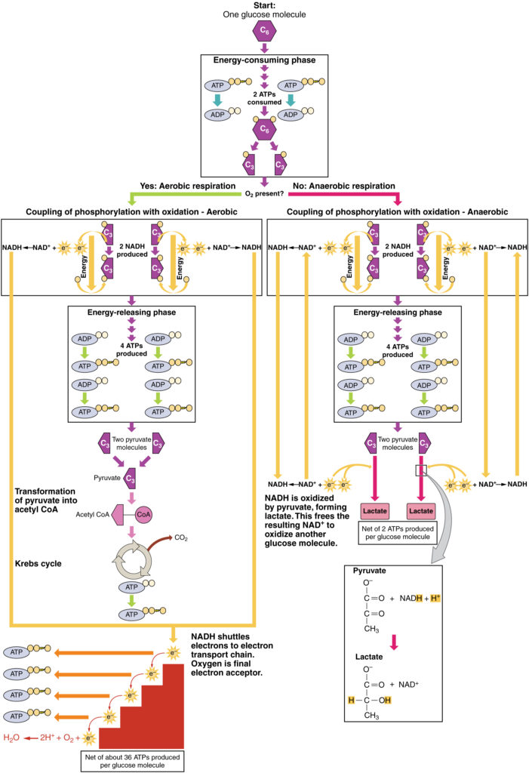

Krebs Cycle/Citric Acid Cycle/ Tricarboxylic Acid Cycle
- The pyruvate molecules generated during glycolysis are transported across the mitochondrial membrane into the inner mitochondrial matrix, where they are metabolized by enzymes in a pathway called the Krebs cycle (Figure 4). The Krebs cycle is also commonly called the citric acid cycle or the tricarboxylic acid (TCA) cycle. During the Krebs cycle, high-energy molecules, including ATP, NADH, and FADH2, are created. NADH and FADH2 then pass electrons through the electron transport chain in the mitochondria to generate more ATP molecules.
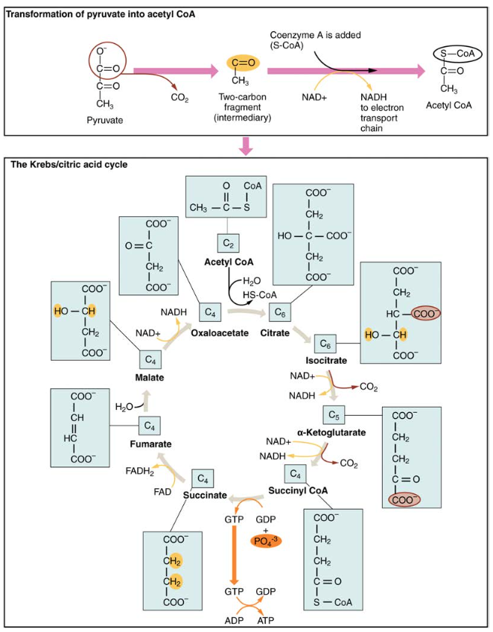
- The three-carbon pyruvate molecule generated during glycolysis moves from the cytoplasm into the mitochondrial matrix, where it is converted by the enzyme pyruvate dehydrogenase into a two-carbon acetyl coenzyme A (acetyl CoA) molecule.
- This reaction is an oxidative decarboxylation reaction
- It converts the three-carbon pyruvate into a two-carbon acetyl CoA molecule, releasing carbon dioxide and transferring two electrons that combine with NAD+ to form NADH. Acetyl CoA enters the Krebs cycle by combining with a four-carbon molecule, oxaloacetate, to form the six-carbon molecule citrate, or citric acid, at the same time releasing the coenzyme A molecule.
- The six-carbon citrate molecule is systematically converted to a five-carbon molecule and then a four-carbon molecule, ending with oxaloacetate, the beginning of the cycle. Along the way, each citrate molecule will produce one ATP, one FADH2, and three NADH. The FADH2 and NADH will enter the oxidative phosphorylation system located in the inner mitochondrial membrane. In addition, the Krebs cycle supplies the starting materials to process and break down proteins and fats.
- To start the Krebs cycle,
- citrate synthase combines acetyl CoA and oxaloacetate to form a six-carbon citrate molecule;
- CoA is subsequently released and can combine with another pyruvate molecule to begin the cycle again.
- The aconitase enzyme converts citrate into isocitrate. In two successive steps of oxidative decarboxylation, two molecules of CO2 and two NADH molecules are produced when isocitrate dehydrogenase converts isocitrate into the five-carbon α-ketoglutarate, which is then catalyzed and converted into the four-carbon succinyl CoA by α-ketoglutarate dehydrogenase.
- The enzyme succinyl CoA dehydrogenase then converts succinyl CoA into succinate and forms the high-energy molecule GTP, which transfers its energy to ADP to produce ATP.
- Succinate dehydrogenase then converts succinate into fumarate, forming a molecule of FADH2.
- Fumarase then converts fumarate into malate, which malate dehydrogenase then converts back into oxaloacetate while reducing NAD+ to NADH.
- Oxaloacetate is then ready to combine with the next acetyl CoA to start the Krebs cycle again .
- For each turn of the cycle, three NADH, one ATP (through GTP), and one FADH2 are created.
- Each carbon of pyruvate is converted into CO2, which is released as a by product of oxidative (aerobic) respiration.

Oxidative Phosphorylation and the Electron Transport Chain
- The electron transport chain (ETC) uses the NADH and FADH₂ produced by the Krebs cycle to generate ATP. Electrons from NADH and FADH₂ are transferred through protein complexes embedded in the inner mitochondrial membrane by a series of enzymatic reactions. The electron transport chain consists of a series of four enzyme complexes (Complex I – Complex IV) and two coenzymes (ubiquinone and Cytochrome c), which act as electron carriers and proton pumps used to transfer H⁺ ions into the space between the inner and outer mitochondrial membranes .
- The ETC couples the transfer of electrons between a donor (like NADH) and an electron acceptor (like O₂) with the transfer of protons (H⁺ ions) across the inner mitochondrial membrane, enabling the process of oxidative phosphorylation.
- In the presence of oxygen, energy is passed, stepwise, through the electron carriers to collect gradually the energy needed to attach a phosphate to ADP and produce ATP.
- The role of molecular oxygen, O₂, is as the terminal electron acceptor for the ETC. This means that once the electrons have passed through the entire ETC, they must be passed to another, separate molecule.
- These electrons, O₂, and H⁺ ions from the matrix combine to form new water molecules. This is the basis for your need to breathe in oxygen. Without oxygen, electron flow through the ETC ceases.
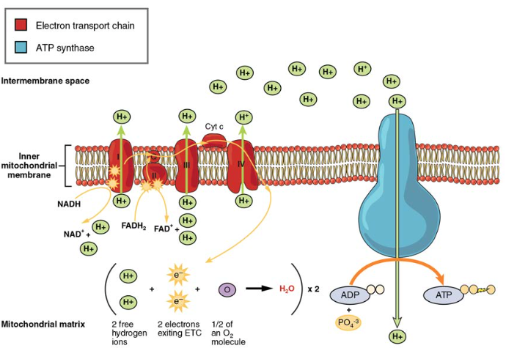
The electrons released from NADH and FADH₂ are passed along the chain by each of the carriers, which are reduced when they receive the electron and oxidized when passing it on to the next carrier. Each of these reactions releases a small amount of energy, which is used to pump H⁺ ions across the inner membrane. The accumulation of these protons in the space between the membranes creates a proton gradient with respect to the mitochondrial matrix.
- Amazing protein pore complex called ATP synthase. Effectively, it is a turbine that is powered by the flow of H⁺ ions across the inner membrane down a gradient and into the mitochondrial matrix. As the H⁺ ions traverse the complex, the shaft of the complex rotates.
- This rotation enables other portions of ATP synthase to encourage ADP and Pi to create ATP. In accounting for the total number of ATP produced per glucose molecule through aerobic respiration, it is important to remember the following points:
- A net of two ATP are produced through glycolysis (four produced and two consumed during the energy-consuming stage). However, these two ATP are used for transporting the NADH produced during glycolysis from the cytoplasm into the mitochondria. Therefore, the net production of ATP during glycolysis is zero.
- In all phases after glycolysis, the number of ATP, NADH, and FADH₂ produced must be multiplied by two to reflect how each glucose molecule produces two pyruvate molecules.
- In the ETC, about three ATP are produced for every oxidized NADH. However, only about two ATP are produced for every oxidized FADH₂. The electrons from FADH₂ produce less ATP, because they start at a lower point in the ETC (Complex II) compared to the electrons from NADH (Complex I).
- Therefore, for every glucose molecule that enters aerobic respiration, a net total of 36 ATPs are produced.
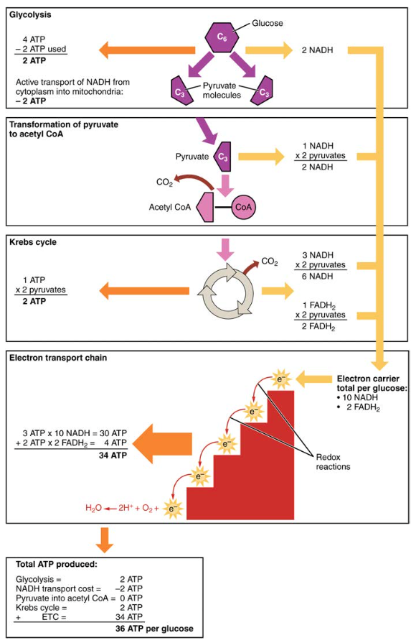

Gluconeogenesis
- Gluconeogenesis is the synthesis of new glucose molecules from pyruvate, lactate, glycerol, or the amino acids alanine or glutamine. This process takes place primarily in the liver during periods of low glucose, that is, under conditions of fasting, starvation, and low carbohydrate diets. So, the question can be raised as to why the body would create something it has just spent a fair amount of effort to break down? Certain key organs, including the brain, can use only glucose as an energy source; therefore, it is essential that the body maintain a minimum blood glucose concentration. When the blood glucose concentration falls below that certain point, new glucose is synthesized by the liver to raise the blood concentration to normal.
- Gluconeogenesis is not simply the reverse of glycolysis. There are some important differences .
- Pyruvate is a common starting material for gluconeogenesis. First, the pyruvate is converted into oxaloacetate.
- Oxaloacetate then serves as a substrate for the enzyme phosphoenolpyruvate carboxykinase (PEPCK), which transforms oxaloacetate into phosphoenolpyruvate (PEP).
- From this step, gluconeogenesis is nearly the reverse of glycolysis. PEP is converted back into 2-phosphoglycerate, which is converted into 3-phosphoglycerate.
- Then, 3-phosphoglycerate is converted into 1,3 bisphosphoglycerate and then into glyceraldehyde-3-phosphate. Two molecules of glyceraldehyde-3-phosphate then combine to form fructose-1-6-bisphosphate, which is converted into fructose 6-phosphate and then into glucose-6-phosphate. Finally, a series of reactions generates glucose itself.
- In gluconeogenesis (as compared to glycolysis), the enzyme hexokinase is replaced by glucose-6-phosphatase, and the enzyme phosphofructokinase-1 is replaced by fructose-1,6-bisphosphatase. This helps the cell to regulate glycolysis and gluconeogenesis independently of each other.
- As will be discussed as part of lipolysis, fats can be broken down into glycerol, which can be phosphorylated to form dihydroxyacetone phosphate or DHAP. DHAP can either enter the glycolytic pathway or be used by the liver as a substrate for gluconeogenesis.
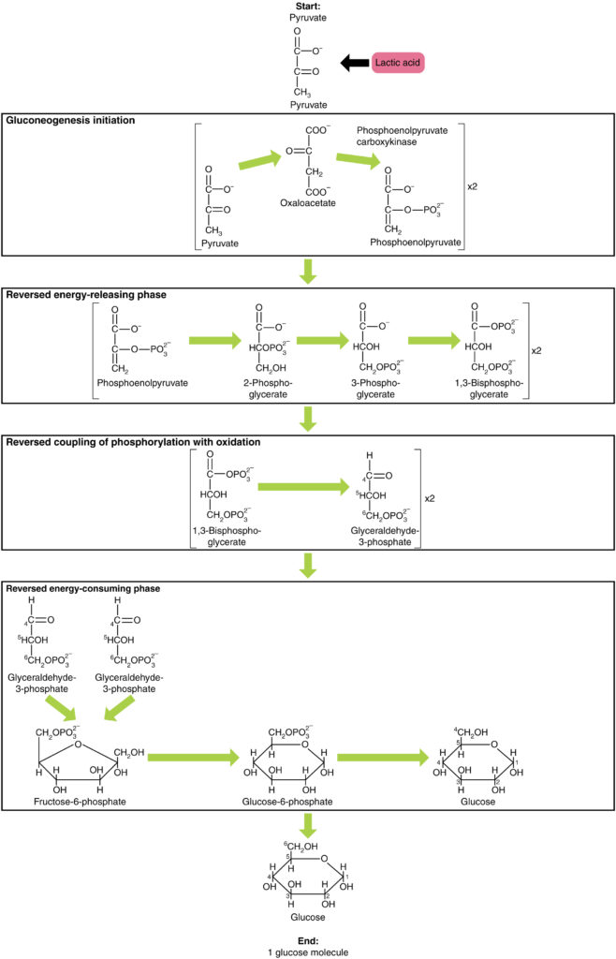
Unit 2 Protein
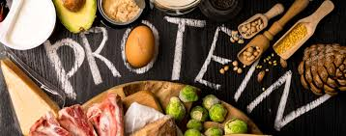
- Protein , Amino acid and their metabolism
- Protein is an important part of a healthy diet. Proteins are made up of chemical 'building blocks' called amino acids. Your body uses amino acids to build and repair muscles and bones and to make hormones and enzymes. They can also be used as an energy source.
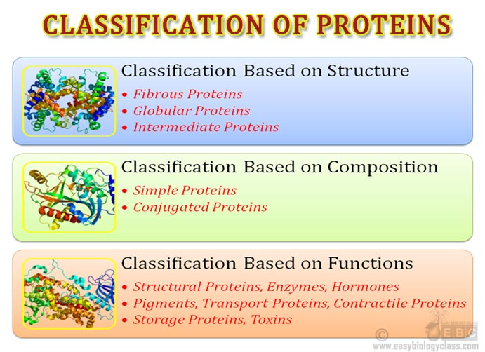
- Proteins based on composition -
- A. Proteins classification, based on composition. According to this proteins are classify into
- a. Simple proteins.
- b. Conjugated proteins.
- c. Derived proteins.
- a. Simple proteins: Are those proteins which yields only amino acids on hydrolysis.
- Ex: Trypsin, plasma albumin, pepsin etc.
- b. Conjugated proteins:
- 1. Are those proteins that yields amino acids and other organic or inorganic molecules
- or non protein molecules on hydrolysis.
- 2. The non protein molecule is called as prosthetic group.
- 3. Usually conjugated proteins are named according to the name of non protein.
- 4. Some examples are tabulated below.
- Non protein part exactly
- 1. Heme proteins Heme Hemoglobin
- 2. Glycoproteins Carbohydrate Immunoglobulins
- 3. Flavoproteins FMN or FAD Succinate dehydrogenase
- 4. Nucleoproteins Nucleic acid Chromatin
- 5. Phosphoproteins Phosphorus Casein
- 6. Lipoporteins Lipids Various
- classes of lipoproteins like VLDL, HDL
- 7. Metalloproteins Metals Cytochromes
- Proteins on the basis of solubility –
- A. Classification of proteins based on their solubility. According to this proteins are
- classified into
- a. Albumins.
- b. Globulins.
- c. Glutelins.
- d. Protamins.
- e. Histones.
- f. Prolamines.
- g. Sclero proteins.
a. Albumins:Are those proteins that are soluble in water as well as salt solutions. Egg
albumin, plasma albumin and lactalbumin are examples.
b. Globulins: Are proteins weakly soluble in water but soluble in salt solutions.
Ovoglobulins, plasma globulin and lactoglobulins are examples.
c. Glutelins: Are proteins soluble in mild acids and alkalis. zein, glutenin and oryzenin
are examples.
d. Protamines: Are proteins soluble in water and ammonia. Fish proteins like salmine and
sturine are examples.
e. Histones: Are those proteins which are soluble in water and dilute acids. Histones
present in chromosomes are examples.
f. Prolamines:Are proteins insoluble in water and alcohol but soluble in dilute alcohol.
Plant proteins zein and gliadin are examples.
g. Sclero Proteins: Are proteins insoluble in water, acids and alkalis. Animal proteins
keratin, elastin and collagen are examples.
Structural organization of proteins.
OR primary, secondary, tertiary and qua ternary structure of protein.
A. Primary structure of proteins :
1. Aminoacid sequence of a protein is known as primary structure of protein.
2. Peptide bonds and disulfide bonds are involved in primary structure.
Primary structure of insulin:
1. It consist of two polypeptide chains.
2. They are A chain and B chain.
3. Inter chain di sulfide bonds links two chains.
4. Further an intra chain disulfide bond is present in A chain.
5. Glycine is the N-terminal aminoacid and aspargine is the C-terminal amino acid in
A chain.
6. In the B chain alanine is C-terminal amino acid and phenyl alanine is the N-terminal aminoacid.
Secondary structure of protein:
1. Two dimentional folding of polypeptide chain is known as secondary structure of
Protein.
2. The folding of protein chain can be ordered or disordered.
3. The ordered secondary structures are α-helix and β-pleated sheet.
4. The disordered secondary structures are random coil and reverse turn or β-turn.
Alpha (α)Helix
It is the secondary structure found in α-Keratin of hair, nails and
epidermis of the skin.
Structural features of α-helix:
a. Coiling of polypeptide or protein chain along long axis produce α-helix.
b. α-helix is stabilized by intra chain hydrogen bonding.
c. Peptide bonds are involved in hydrogen bonding.
d. C=O and –N-H groups of peptide bond participate in hydrogen bonding.
e. There are 3. 6 aminoacids in one turn of α-helix.
f. Peptide bonds that are four aminoacid residues away participate in hydrogen bonding
i. e. -N-H of second aminoacid residue and –C=O of sixth amino acids are involved in hydrogen bonding.
g. α-helix of fibrous proteins is right handed.
h. α-helix is destabilized by hydrophobic aminoacids.
I. In contrast aromatic aminoacids stabilizes α-helix.
j. α-helical regions are found in several other proteins.
Beta (β)Pleated Sheet
When two or more polypeptide chains line side by side along long axis beta pleated sheet is formed. Adjacent segments of a protein or polypeptide chain may also form secondary structure.
Structural features of β-Pleated Sheet
a. Polypeptide chains are fully extended along long axis in beta pleated sheet.
b. Inter chain hydrogen bonds stabilizes beta pleated sheet.
c. Based on direction β-pleated sheet is divided into i. Antiparallel β-pleated sheet and ii.
Parallel β-pleated sheet.
d. In antiparallel β-pleated sheet polypeptide chains run in opposite direction.
e. In parallel β-pleated sheet polypeptide chains run in same direction.
f. Pleated sheet is found in many proteins. Albumin and hemoglobin of blood contains β-
pleated sheet.
g. Antiparallel β pleated sheet is found in β-Keratin of silk fibroin, spider web and amyloid
protein found in the brain of Alzheimer's disease patients.
h. β-pleated sheet content varies among proteins.
Tertiary structure of protein:
1. It is formed due to three dimentional folding of polypeptide chain of protein in space.
2. Tertiary structure of protein contains ordered and disordered secondry structures i.e. α-Helix, β-pleated sheet, random coil conformation etc.
Quaternary structure of protein:
1. Proteins which are made up of more than one polypeptide chain contains quaternary structure.
2. Such proteins are known as oligomeric proteins and constituent polypeptide chains are referred as sub units or protomers.
Hemoglobin, creatine phosphokinase. Lactate dehydrogenase etc are examples for proteins with quaternary structure. Hemoglobin and lactate dehydrogenase are made up of four subunits whereas creatine phosphokinase contains two sub units. 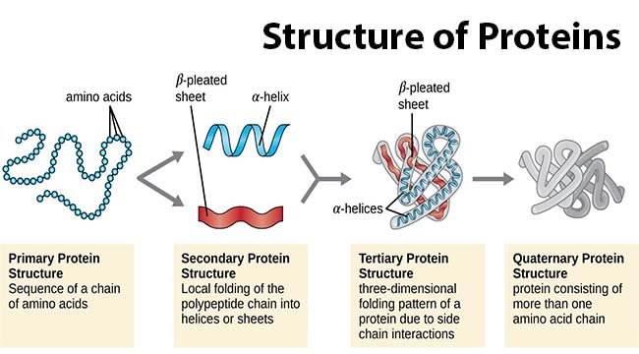

Proteins and their functions.
Proteins are polymers of aminoacids. The aminoacids are joined by peptide bonds.
Hence they are also called as polypeptides.
Functions of Proteins:
Proteins are present in body. They are structural components of tissues, cells etc.
Proteins function as hormones
Proteins functions as enzymes
Proteins regulate gene expression.
Proteins are involved in muscle contraction
Proteins perform transport functions.
Proteins are used as nutrients.
Proteins act as buffers.
Proteins act as reservoir of minerals
Proteins act as infective agents.
Classification of proteins based on their shape.
Protein classification on the basis of shape. According to this proteins are divided into
Fibrous proteins
Globular proteins.
Fibrous Proteins: Are proteins in which polypeptide chains are elongated. Keratin,
collagen and elastin are examples.
Globular Proteins: Are proteins in which polypeptide chains are folded into globular or spherical shape. Hemoglobin, albumin and trypsin are examples.
Composition and functions of various plasma proteins.
Several structurally and functionally different proteins are present in plasma. They are albumin and various components (fractions) of globulins.
Albumin: It contributes osmotic pressure in blood. It is involved in maintenance of blood volume. One gm of albumin can hold 18ml of fluid in blood. It is involved in transport of several substances. Further it binds to various substances and drugs.
Fatty acids and bilirubin are transported by albumin.
Several hormones also transported by albumin Sex hormones and glucocorticoids are transported by albumin.
Albumin function as buffer.
Peripheral tissues use albumin as nutrient.
α -globulins 1
α -antitrypsin and α -acid glycoprotein are principle components of this fraction. Other 1 components are α-lipoprotein, prothrombin, α -fetoprotein, thyroxine binding and retinol 1 binding proteins.
Immunoglobulins
They are involved in defence function. They are antibodies present in serum. They are
produced when foreign molecules or antigens enters inside body.
Structure:
Generally an Immunoglobulin is made up of 4 polypeptide chains. The molecular weight
of this is about 150000 daltons.
Two types of polypeptide chains are present. Two heavy or H chains and two light or L
chains.
Each H chain molecular weight is 50, 000 and contains 450 aminoacids.
Molecular weight of L chain is about 25, 000 and contains 220 aminoacids.
The H chains contains variable region at N terminus [V ] and three 22 regions at H
C terminus [C C and C ]. H1, H2 H3
In the L chain one variable region (V ) at N terminus and constant region (C ) at terminus exist.
The aminoacid sequence varies in variable regions of H and L chains and largely depends on class or type of immunoglobulin.
However constant regions of H and L chain aminoacid sequence is constant or same in
various types of immunoglobulins
The variable regions recognizes antigens.
Peptides-
1. Peptides are compounds containing peptide bonds.
2. Peptides are formed due to inter action between carboxyl group of one aminoacid with amino group of other aminoacids.
3. Peptide bond formation involves loss of one water molecule.
4. Glutathione, thyrotrophin releasing hormone, enkaphalins, oxytocin, vasopressin are examples for peptides.
Amino acid and their functions.
Amino acids are acids containing aminogroups. They are building blocks of proteins and peptides present in humans and other living organisms.
Functions:
Free aminoacids are found in blood and cells of humans. Hormones, purines, pyrimidines, heme, some vitamins, creatine etc found in body are derived from aminoacids.
Semi essential aminoacids:
Semi essential aminoacids are synthesized in the body to some
extent. They are histidine and arginine.
Unusual or rare aminoacids or Non protein aminoacids:
These aminoacids are not found in proteins. But they have other functions.
Examples are
i). Intermediates of urea cycle i. e.
ornithine. citrulline and argininosuccinate.
ii). taurine.
iii). Gamma aminobutyric acid (GABA).
iv). Beta (β)-alanine.
v). Pantothenic acid.
Charge or acid base properties of aminoacids.
1. Depending on pHof surroundings an aminoacid can exist as cation or positively charged
molecule, anion or negatively charged molecule and zwitter ions.
2. Zwitter ion carries no net charge It contains equal number of positive charges and negative charges.
3. Further aminoacids act as acids or bases. When alkali is added aminoacid act as acid by donating proton. Aminoacid act as base by accepting a proton from acid.
4. At neutral pH aminoacid functional groups amino and carboxyl groups exist in ionized form.
5. The amino group exist in protonated -NH +form and carboxyl group in the dissociated 3 –COO-form this is known as zwitter ionic form.
6. In strong acidic conditions –COOH remains undissociated i. e. aminoacid exist as cation.
7. In strong alkaline condition proton from –NH +is lost i. e. aminoacid exist as anion
8. The PHdependence of charge of aminoacid is used for separation of aminoacids.
Protein sources of food And digestion of dietary proteins:-
A. Food Proteins : Animal foods like meat, eggs, milk, fish and plant foods like cereals,legumes, nuts, pulses, vegetables and fruits are protein sources in diet.
Digestion and absorption of proteins
Protein digestion : Hydrolysis of dietary proteins into amino acids is known as protein digestion.
In the mouth : No protein digestion takes place in mouth due to lack of protein digesting enzymes.
In the stomach : In acid environment of stomach dietary protein undergo de naturation. This acid induced protein denaturation aids protein digestion. Pepsin is protein splitting enzyme present in gastric juice. It is active in the acid environment of stomach i. e pH 1. 5-2. 5. It hydrolyzes peptide bonds of proteins and specific for peptide bonds in which amino group is contributed by acidic or aromatic amino acids. Pepsin converts proteins topeptones and proteoses.
Pepsin
Protein Proteoses + peptones.
pH 1. 5-2. 5

In the infant stomach rennin is present. It causes coagulation of milk.
In the small intestine : Small intestine is the major site of protein digestion. Succus entericus of small intestine and pancreatic juice contains several proteases and peptidases.These enzymes converts peptones and proteoses to amino acids. Proteases present in pancreatic juice are trypsin, chymotrypsin, elastase, collagenase and carboxy peptidase. Except carboxy peptidase all other proteases are endopeptidase. They act on peptones and proteoses and convert them to oligopeptides.Trypsin chymotrypsin Proteoses Oligopeptides, peptones Oligopeptides. Carboxy peptidase is an exopeptidase. It hydrolyzes peptide bonds of proteins from carboxy terminus and release one amino acid and polypeptide shorter by one amino acid.
The action of carboxy peptidase continues until a di peptide is formed.
Carboxy
Protein Amino acid + protein shorter by one amino acid
Peptidase
Protein shorter by one amino acid Di peptide
+Amino acids
Aminopeptidase is an exopeptidase and hydrolyzes peptide bond of oligo peptide from
amino terminus and releases an amino acid and oligopeptide shorter by one amino acid.
The action of amino peptidase continues on oligo peptide until it is converted to dipeptide.
Digestion of protein and their absorption, related disorders associated.
A. Protein digestion products absorption : Amino acids produced from dietary proteins in the lumen are absorbed into portal blood. Mediated transport or secondary active transport is major mechanism of amino acid absorption. Various classes of amino acids are absorbed by
different carriers present in enterocyte membrane. There are five different carriers for five different classes of amino acids. For neutral amino acids one carrier, methionine and phenyl alanine another carrier, acidic amino acids third carrier, basic amino acids fourth carrier and fifth carrier for iminoacids. All these carriers are symporters like glucose transporter. They allow sodium transport along with aminoacids.
In some diseases aminoacid absorption and protein digestion are affected. They are
a. Celiac disease : It is due to absorption of oligo peptides of wheat protein gluten. These peptides are produced from gluten by action of protein digesting enzymes. Further they act as antigens and produce immune response in children. Symptoms are inflammation and atrophy of intestinal mucosa. This results in impaired absorption in the small intestine.
b. Non tropical sprue :It is due to absorption of gluten of oat oligo peptides and symptoms are similar to those of celiac disease. Gluten free diet consumption relieves symptoms.
c. Hartnup disease : In this condition aromatic amino acid carrier in the intestine is defective. So their absorption is blocked.
d. Pancreatitis : In this condition protein digestion is affected due to block in flow of pancreatic juice which contains enzymes of protein digestion.
Various types of amino acid deamination.
A. Amino acid deamination is removal of amino group of amino acids. It is the first step of amino acid degradation. It occurs by several ways. They are-
a. Transamination followed by oxidative deamination.
b. Oxidative deamination
c. Non oxidative deamination
A. Transamination
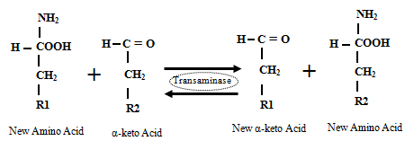
followed by oxidative deamination :
It involves initial transfer of amino group of aminoacid to α-ketoglutarate followed by oxidative deamination of glutamate that is formed by trans amination. Transaminases catalyzes transfer of amino group of amino acids to α-ketoglutarate. They are present in most of the tissues.
They require pyridoxal phosphate as coenzyme. Among many transaminases alanine transaminase and aspartate transaminase are most important. Both of them transfer amino groups of alanine and aspartate to α-ketoglutarate.
The amino group that is collected is removed from glutamate as ammonia by oxidative deamination catalyzed by glutamate dehydrogenase.
B. Oxidative deamination :
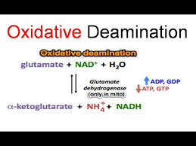
This type of deamination of amino acids is catalyzed by amino
acid oxidases. They are of two types.
a. D-amino acid oxidase b. L- amino acid oxidase. L- amino acid oxidase catalyzes oxidative deamination of all amino acids except glycine and it is FMN dependent enzyme. D- amino acid oxidase acts on glycine and it is an FAD dependent enzyme.
These enzymes first oxidizes amino acid to an imino acid which is followed by hydrolytic loss of ammonia. Further they produce hydrogen peroxide.
Non oxidative deamination :
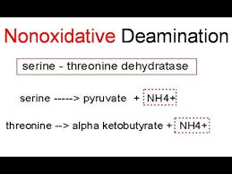
Specific enzymes catalyzes non oxidative deamination of aminoacids. Serine dehydratase catalyzes non oxidative deamination of serine to pyruvate. Cysteine desulfhydrase catalyzes conversion of cyteine to pyruvate. Threonine dehydratase catalyzes conversion of threonine to α- ketobutyrate.

Serine dehy
Serine pyruvate + Ammonia
dratase
Cysteine
Cysteine Pyruvate+ Ammonia+ H₂S
desulfhydrase
Threonine
Threonine α- ketobutyrate +Ammonia.
Dehydratase
Normal plasma ammonia level and Ammonia is transported from brain and skeletal muscle to liver.
- Normal plasma ammonia level is 10-20 μg %. Ammonia produced in peripheral tissue and brain is transported to liver in the form of amino acids alanine and glutamine. More over ammonia in free form is toxic to central nervous system. In the skeletal muscle ammonia is used for the formation of glutamate from α-ketoglutarate by the reversal of glutamate dehydrogenase. Trans amination transfers aminogroup to pyruvate to form alanine Glutamate
α- ketoglutarate + ammonia ^{+NADPH+} ^{H+} Glutamate +H₂O+ NADP dehydrogenase
Alanine
Glutamate pyruvate α-keto glutarate +Alanine
Transaminase

From the brain and other peripheral tissues ammonia produced is transported to liver in the form of glutamine. Glutamine synthetase catalyzes this reaction.
Glutamine
Glutamate + ammonia +ATP Glutamine +ADP+Pi.
Synthetase
Ammonia is removed from alanine and glutamine in liver?
A. In the liver, kidney and intestine ammonia is removed from glutamine by glutaminase.
Glutaminase
Glutamine Glutamate+Ammonia

In the liver ammonia is removed from alanine by transamination followed by glutamate dehydrogenase action.
Alanine + α-ketoglutarate Pyruvate +glutamate α-ketoglutarate +NH₃
Urea cycle and note on disorders of urea cycle.
A. Urea cycle is present in liver. Enzymes of this cycle are located in mitochondria and cytosol of hepatocytes. It converts toxic ammonia to non toxic urea. First two reactions occurs in mitochondria and remaining three reactions takes place in cytosol. All the intermediates of urea cycle are amino acids with out codons. Formation of urea from ammonia requires energy in the form of ATP. For the formation of urea molecule only one ammonia molecule is used as such another ammonia molecule is contributed by amino group of aspartate. Carbon dioxide or bicarbonate serve as source of carbon for urea formation. Since reactions of urea cycle are proposed by Krebs and Henseleit it is known as Krebs- Heneseleit cycle.
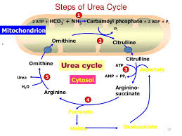
Reactions :
1. Condensation of ammonia and bicarbonate at the expense of two high energy bonds to form carbamoyl phosphate is the first reaction of urea cycle. Mitochondrial carbamoyl phosphate synthetase–І (CAPS-І) catalyzes this reaction. N-acetyl glutamate and magnesium are cofactors required.
2. Carbamoyl phosphate condenses with ornithine in the second reaction. The reaction is catalyzed by ornithine trans carbamoylase and citrulline is the product. Since cytosol is the site for remaining reactions of urea cycle citrulline comes out of the mitochondria through a transporter present in mitochondrial membrane.
3. In the cytosol condensation of citrulline and aspartate yields arginino succinate. It is catalyzed by arginino succinate synthetase and two high energy bonds are used. ATP is hydrolyzed to AMP and PPi.
4. Cleavage of arginino succinate by arginino succinase occurs in this reaction.
5. Finally ornithine is regenerated from arginine by arginase releasing urea.
Ornithine enters mitochondria for continuation of urea cycle through a transporter present in mitochondrial membrane.
Disorders of urea cycle
Diseases due to deficiency of enzyme of urea cycle are known as urea cycle disorders. They are inherited diseases. Ammonia toxicity occurs in this diseases because conversion of ammonia to urea is blocked. Some clinical symptoms commonly seen in these cases are vomiting, irritability, lethargy, mental retardation, seizures, coma and death. Some of them are given below.
1. Hyper ammonemia Type –І: Carbamoyl phosphate synthetase is deficient in this condition. So ammonia accumulates because its conversion to carbamoyl phosphate is blocked. Mental retardation is major symptom of this disorder.
2. Hyper ammonemia Type –ІІ : Ornithine trans carbamoylase is deficient in this condition. Among urea cycle disorders it is most common. So carbamoyl phosphate accumulates and diverted to pyrimidine nucleotide formation. As a result in urine intermediates of pyrimidine nucleotide formation like orotic acid and uracil are
excreted.
3. Citrullinemia : Arginino succinate synthetase is absent in this condition. So citrulline accumulates in blood due to block in its utilization and leads to citrullinemia. Excess citrulline is excreted in urine.
4. Arginino Succinic aciduria : This condition is due to absence of arginino succinase. Hence arginino succinic acid accumulates in blood and get excreted in urine.
5. Hyper argininemia : It is due to deficient arginase. So arginine conversion to urea and ornithine is blocked and accumulation in blood leads to excretion in urine.
6. HHH Syndrome: It is due to defective ornithine transporter. So ornithine accumulates and carbamoylation of lysine occurs leading to formation of homocitrulline. Hyper ornithinemia, hyper ammonemia and homocitrullineia are seen in affected persons and hence name HHH syndrome.
Carbon skeletons of aminoacids. Classify aminoacids giving examples based on fate of their carbon skeletons.
A. After removal of amino group of amino acid the remaining structure of a amino acid is the
carbon skeleton. Twenty different amino acids gives rise to twenty different carbon
skeletons. Based on fate of carbon skeleton amino acids are classified into-
1. Glucogenic amino acids.
2. Ketogenic aminoacids.
3. Glucogenic and ketogenic amino aids.
1. Glucogenic aminoacids: Are those aminoacids whose carbon skeletons are converted to
either glucose or intermediates of TCA cycle. Final products of these aminoacids are pyruvate, oxaloacetate, α-ketoglutarate, fumarate and succinate.
Examples :Glycine, alanine, valine, serine, threonine, aspartate, glutamate, aspargine, glutamine, cysteine, methionine, histidine, arginine and proline.
2. Ketogenic aminoacids :Are those amino acids whose carbon skeletons are converted to
either fat like substance or intermediates of fatty acid oxidation. Final products of these aminoacids are acetyl –CoA or acetoacetyl –CoA.
Examples : Leucine is the only ketogenic amino acid. Isoleucine, phenylalanine, tyrosine, tryptophan and lysine are also ketogenic amino acids.
3. Glucogenic and ketogenic amino acids :Are those amino acids whose carbon skeletons are converted to glucose or intermediates of TCA cycle or fat like substances. Final products of these amino acids are pyruvate, oxaloacetate, succinate, fumarate, α-ketoglutarate, acetyl- CoA and acetoacetyl –CoA.
Examples : Lysine, Phenyl alanine, tyrosine, tryptophain and isoleucine.
Biological roles of glutamine and glutamate.
a. Glutamate biological roles :
- In amino acid metabolism glutamate has key role. It act as amino group source for formation of nonessential amino acids. In amino acid catabolism it act as collecting point of amino groups.
- Glutamate is required for synthesis of glutathione, glutamine, N- acetyl glutamate and glucose.
- Gamma amino butyric acid (GABA):Glutamate gives rise to this compound on decarboxylation catalyzed by pyridoxal phosphate dependent glutamate decarboxylase. It is an inhibitory neurotransmitter present in synaptic vesicles.
- Gamma carboxylation :Glutamate of many proteins are carboxylated at gamma carbon. This carboxylation of glutamate at gamma carbon has role in blood clotting and bone formation.
- Folic acid contains several glutamate residues.
- Glutamate is neuro transmitter.
b. Glutamine biological roles:
- Several compounds amino group is derived from amide group of glutamine. They are purine nucleotides, pyrimidine nucleotides, amino sugars and co enzyme NAD.
- Glutamate is synthesized from glutamine.
- Detoxification reactions use glutamine particularly conjugation reactions.
- Histidine and tryptophan synthesis needs glutamine.
- In blood glutamine is present in high concentration about 10mg.
- Glutamine has role in acid base balance. In kidney glutamine contributes ammonia.

Unit 3- Lipid and Related Metabolism

Membranes function to organize biological processes by compartmentalizing them. Indeed, the cell, the basic unit of life, is essentially defined by its enveloping plasma membrane. Moreover, in eukaryotes, many subcellular organelles, such as nuclei, mitochondria, chloroplasts, the endoplasmic reticulum, and the Golgi apparatus are likewise membrane bounded. Biological membranes are organized assemblies of lipids and proteins with small amounts of carbohydrate.Yet they are not impermeable barriers to the passage of materials. Rather, they regulate the composition of the intracellularmedium by controlling the flow of nutrients, waste products,ions, etc., into and out of the cell. They do this throughmembrane-embedded“pumps” and “gates” that transportspecific substances against an electrochemical gradient or permit their passage with such a gradient.
LIPID CLASSIFICATION
Lipids (Greek: lipos, fat) are substances of biological originthat are soluble in organic solvents such as chloroform and methanol but are only sparingly soluble, if at all, in water. Hence, they are easily separated from other biological materials by extraction into organic solvents and may be further
fractionated by such techniques as adsorption chromatography, thin layer chromatography, and reverse-phase chromatography (Section 6-3D). Fats, oils, certain vitamins and hormones, and most nonprotein membrane components are lipids. In this section, we discuss the structures and physical properties of the major classes of lipids.
A. Fatty Acids
Fatty acids are carboxylic acids with long-chain hydrocarbon side groups (Fig. 12-1). They are rarely free in nature but, rather, occur in esterified form as the major componentsof the various lipids described in this chapter.
The more common biological fatty acids are listed in Table 12-1. In higher plants and animals, the predominant fatty acid residues are those of the C16 and C18 species palmitic, oleic, linoleic, and
stearic acids.
Fatty acids with _14 or _20 carbon atoms are uncommon. Most fatty acids have an even number of carbon atoms because they are usually biosynthesized by the concatenation of C2 units (Section 25-4C). Over half of the fatty acid residues of plant and animal lipids are unsaturated (contain
double bonds) and are often polyunsaturated (contain two or more double bonds). Bacterial fatty acids are rarely polyunsaturated but are commonly branched, hydroxylated, or contain cyclopropane rings. Unusual fatty acids also occur as components of the oils and waxes (esters of fatty acids and long-chain alcohols) produced by certain plants.
Table 12-1 The Common Biological Fatty Acids
Symbola Common Name Systematic Name Structure mp (°C)
Saturated fatty acids
12:0 Lauric acid Dodecanoic acid CH3(CH2)10COOH 44.2
14:0 Myristic acid Tetradecanoic acid CH3(CH2)12COOH 52
16:0 Palmitic acid Hexadecanoic acid CH3(CH2)14COOH 63.1
18:0 Stearic acid Octadecanoic acid CH3(CH2)16COOH 69.6
20:0 Arachidic acid Eicosanoic acid CH3(CH2)18COOH 75.4
22:0 Behenic acid Docosanoic acid CH3(CH2)20COOH 81
24:0 Lignoceric acid Tetracosanoic acid CH3(CH2)22COOH 84.2
Unsaturated fatty acids (all double bonds are cis)
16:1 n–7 Palmitoleic acid 9-Hexadecenoic acid CH3(CH2)5CH“CH(CH2)7COOH _0.5
18:1 n–9 Oleic acid 9-Octadecenoic acid CH3(CH2)7CH“CH(CH2)7COOH 13.4
18:2 n–6 Linoleic acid 9,12-Octadecadienoic acid CH3(CH2)4(CH“CHCH2)2(CH2)6COOH _9
18:3 n–3 _-Linolenic acid 9,12,15-Octadecatrienoic acid CH3CH2(CH“CHCH2)3(CH2)6COOH _17
18:3 n–6 _-Linolenic acid 6,9,12-Octadecatrienoic acid CH3(CH2)4(CH“CHCH2)3(CH2)3COOH
20:4 n–4 Arachidonic acid 5,8,11,14-Eicosatetraenoic acid CH3(CH2)4(CH“CHCH2)4(CH2)2COOH _49.5
20:5 n–3 EPA 5,8,11,14,17-Eicosapentaenoic acid CH3CH2(CH“CHCH2)5(CH2)2COOH _54
22:6 n–3 DHA 4,7,10,13,16,19-Docosahexenoic acid CH3CH2(CH“CHCH)6CH2COOH
24:1 n–9 Nervonic acid 15-Tetracosenoic acid CH3(CH2)7CH“CH(CH2)13COOH 39
A Number of carbon atoms: number of double bonds. For unsaturated fatty acids, n is the number of carbon atoms, n _ x is the double-bonded carbon atom, and x is the number of that carbon atom counting from the methyl terminal (_) end of the chain.
B. Triacylglycerols
The fats and oils that occur in plants and animals consist largely of mixtures of triacylglycerols (also referred to as triglycerides or neutral fats). These nonpolar, water-insoluble substances are fatty acid triesters of glycerol: Triacylglycerols function as energy reservoirs in animals and are therefore their most abundant class of lipids even though they are not components of biological membranes. Triacylglycerols differ according to the identity and placement of their three fatty acid residues. The so-called simple triacylglycerols contain one type of fatty acid residue and are named accordingly. For example, tristearoylglycerol or tristearin contains three stearic acid residues, whereas trioleoylglycerol or triolein has three oleic acid residues. The more common mixed triacylglycerols contain two or three different types of fatty acid residues and are named according to their placement on the glycerol moiety.
C. Glycerophospholipids
Glycerophospholipids (or phosphoglycerides) are the major lipid components of biological membranes. They consist of sn-glycerol-3-phosphate , esterified at its C1and C2 positions to fatty acids and at its phosphoryl group to a group, X, to form the class of substances . Glycerophospholipids are therefore amphiphilic molecules with nonpolar aliphatic “tails” and polarphosphoryl-X “heads.” The simplest glycerophospholipids, in which XH, are phosphatidic acids; they arepresent only in small amounts in biological membranes. In the glycerophospholipids that commonly occur in biological
membranes, the head groups are derived from polar alcohols occur at the C1 position of glycerophospholipids, and the C2 position is often occupied by an unsaturated C16 to C20 fatty acid. Glycerophospholipids are, of course, also named according to the identities of these fatty acid residues .Some glycerophospholipids have common names.
For example, phosphatidylcholines are known as lecithins; diphosphatidylglycerols, the “double” glycerol phospholipids, are known as cardiolipins (because they were first isolated from heart muscle). Plasmalogens.
D. Sphingolipids
Sphingolipids, which are also major membrane components, are derivatives of the C18 amino alcohols sphingosine, dihydrosphingosine, and their C16, C17, C19, and C20 homologs. Their N-acyl fatty acid derivatives, ceramides, occur only in small amounts in plant and animal tissues but form the parent compounds of more abundant sphingolipids:
1. Sphingomyelins
The most common sphingolipids, are ceramides bearing either a phosphocholine or a phosphoethanolamine moiety, so that they can also be classified as sphingophospholipids. Although sphingomyelins differ chemically from phosphatidylcholine and phosphatidylethanolamine, their conformations and charge distributions are quite similar.The membranous myelin sheath that surrounds and electrically insulates many nerve cell axons is particularly rich in sphingomyelin.
2. Cerebrosides
The simplest sphingoglycolipids (alternatively glycosphingolipids), are ceramides with head groups that consist of a single sugar residue. Galactocerebrosides, which are most prevalent in the neuronal cell membranes of the brain, have a -D-galactose head group. Glucocerebrosides, which instead have a _-D-glucose residue, occur in the membranes of other tissues. Cerebrosides,in contrast to phospholipids, lack phosphate groups and hence are most frequently nonionic compounds. The galactose residues of some galactocerebrosides, however, are sulfated at their C3 positions to form ionic compounds known as sulfatides. More complex sphingoglycolipids have unbranched oligosaccharide head groups of up to four sugar residues.
3. Gangliosides form the most complex group of sphingoglycolipids. They are ceramide oligosaccharides that include among their sugar groups at least one sialic acidresidue (N-acetylneuraminic acid and its derivatives) The structures of gangliosides GM1, GM2, and GM3, three of the hundreds that are known, Gangliosides are primarily components of cell surface membranes and constitute a significant fraction(6%) of brain lipids. Other tissues also contain gangliosides but in lesser amounts.
Gangliosides have considerable physiological and medical significance.Their complex carbohydrate head groups, which extend beyond the surfaces of cell membranes, act asspecific receptors for certain pituitary glycoprotein hormones that regulate a number of important physiologicalfunctions. Gangliosides are also receptors for bacterial protein toxins such as cholera toxin . There is considerable evidence that gangliosides are specific determinants of cell–cell recognition, so they probably have an important role in the growth and differentiation of tissues as well as in carcinogenesis (cancer generation). Disorders of ganglioside breakdown are responsible for several hereditary sphingolipid storage diseases, such as Tay-Sachs disease, which are characterized by an invariably fatal neurological deterioration.
E. Cholesterol
Steroids, which are mostly of eukaryotic origin, are derivatives of cyclopentanoperhydrophenanthrene. The much maligned cholesterol (Fig. 12-9), the most abundant steroid in animals, is further classified as a sterol because of its C3-OH group and its branched aliphatic side chain of 8 to 10 carbon atoms at C17. Cholesterol is a major component of animal plasma membranes, where it is typically present at 30 to 40 mol %, and occurs in lesser amounts in the membranes of their subcellular organelles. Its polar OH group gives it a weak amphiphilic character, whereas its fused ring system provides it with greater rigidity than other membrane lipids. Cholesterol is therefore an important determinant of membrane properties. It is also abundant in blood plasma lipoproteins , where _70% of it is esterified to long-chain fatty acids to form cholesteryl esters. Cholesterol is the metabolic precursor of steroid hormones, substances that regulate a great variety of physiological functions including sexual development and carbohydratemetabolism.
Plants contain little cholesterol. Rather, the most common sterol components of their membranes are stigma sterol and beta-sitosterol
5 LIPOPROTEINS
Lipids and proteins associate noncovalently to form lipoproteins, which function in the blood plasma as transport vehicles for triacylglycerols and cholesterol. In this section, we discuss the structure, function, and dysfunction of lipoproteins, and how eukaryotic cells take up lipoproteins and other specific proteins from their external medium through receptor-mediated endocytosis.
A. Lipoprotein Structure
Lipids, such as phospholipids, triacylglycerols, and cholesterol, are but sparingly soluble in aqueous solution. Hence, they are transported by the circulation as components of lipoproteins, globular micellelike particles that consist of a nonpolar core of triacylglycerols and cholesteryl esters surrounded by an amphiphilic coating of protein, phospholipid, and cholesterol. Lipoproteins have been classified into five broad categories on the basis of their functional and physical properties.

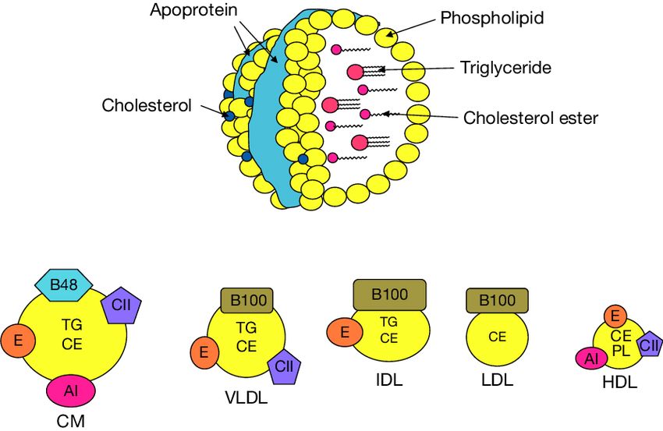

1. Chylomicrons, which transport exogenous (externally supplied; in this case, dietary) triacylglycerols and cholesterol from the intestines to the tissues.
2. Very low density lipoproteins (VLDL),
3. Intermediate density lipoproteins (IDL), and
4. low density lipoproteins(LDL), a group of related particles that transport endogenous
(internally produced) triacylglycerols and cholesterol from the liver to the tissues (the liver synthesizes triacylglycerols from excess carbohydrates.
5. High density lipoproteins (HDL), which transport endogenous cholesterol from the tissues to the liver.
Lipoprotein particles undergo continuous metabolicprocessing, so that they have variable properties and compositions. Each contains just enough protein, phospholipid, and cholesterol to form an _20-Å-thick
monolayer of these substances on the particle surface . Lipoprotein densities increase with decreasing
particle diameter because the density of their outer coating is greater than that of their inner core.

B. Lipoprotein Function
The various lipoproteins have different physiological functions, as we discuss below.
a. Chylomicrons Are Delipidated in the Capillaries of Peripheral Tissues
b. VLDL Are Degraded Much Like Chylomicrons
c. Cells Take Up Cholesterol through Receptor-Mediated Endocytosis of LDL
d. ApoE’s Receptor Binding Domain Contains a Four-Helix Bundle
e. HDL Transports Cholesterol from the Tissues to the Liver.
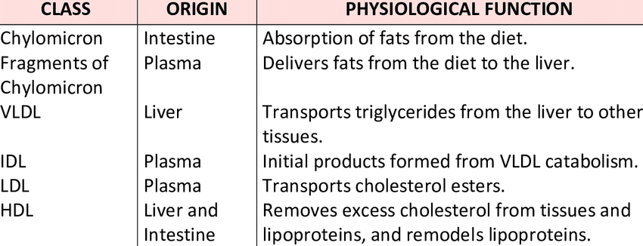

Arteriosclerosis
Arteriosclerosis is the hardening of the arteries. This condition not only thickens the wall of arteries but also causes stiffness and a loss of elasticity. Over time, the arteries become harder and harder as they are slowly damaged by high blood pressure. Arteriosclerosis may be present in any artery of the body, but the disease is most concerning when it attacks the coronary arteries and threatens to cause a heart attack
. 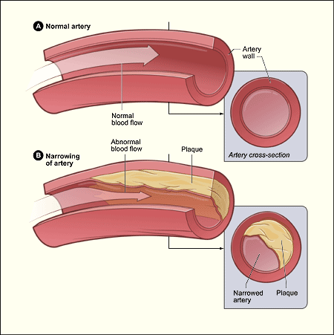
Atherosclerosis is the most common type of arteriosclerosis, or hardening of the arteries, and caused by plaque building up in the vessel. Over time the plaque causes thickening of the walls of the artery. Stiffness and a loss of elasticity also result.
To clarify, a patient with arteriosclerosis (hardened arteries) may not have atherosclerosis (plaque), but a patient with atherosclerosis does have arteriosclerosis. Patients often have both conditions, which can cause a decrease in the blood flow to the heart muscle.

Treatments for Coronary Artery Disease
One of the key principles of treating the hardening of the arteries is to stop the progress of the disease process. The first step in preventing and treating coronary artery disease is to make lifestyle changes. Basically, do all of the things that our doctors tell us to do and we often don't bother to do.¹ Eat a more healthful diet with an emphasis on fruits and vegetables and minimize fats and meats. Increasing fiber intake is also helpful.
Exercise regularly—this doesn't have to be strenuous exercise, it can be a 30-minute walk in the evenings. Frequency counts, so going for a brisk walk every night can be very helpful, you do not need to be running marathons to benefit greatly. Research shows that a modest reduction of weight—about 10% of excess weight—can have significant positive effects on blood pressure, diabetes, and other conditions that worsen heart disease.
Reduce stress in your life, make sure you are getting enough sleep on a regular basis, and, in general, take better care of yourself to stop the progression of heart disease or even reverse it.
If you have a family history of severe coronary artery disease and think there is nothing you can do to change that, ask yourself this question before you decide you can't improve it: Do you have a family history of heart disease OR a shared family history of not exercising, smoking, ignoring your diabetes, eating poorly, sleeping too little, and living with too much stress?
Medications to control cholesterol levels in the body may not improve heart disease, but it may prevent the condition from worsening over time. Diet modification is also important to prevent increasing problems.
For moderate disease, the treatment is often the placement of stents in the coronary arteries, tiny devices made to keep the arteries open enough for blood to flow to the heart. These are placed during a procedure called a cardiac catheterization, or heart cath for short.
In severe cases, coronary artery bypass surgery, or CABG surgery, is required to ensure adequate blood flow to the heart. When coronary artery disease becomes severe, blood does not flow freely to the heart and this can cause chest pain or even a heart attack. When other treatments are ineffective, or when the problem is so severe that it must be treated immediately, the coronary artery bypass graft surgery is the treatment of choice. This procedure takes vessels from the legs and inside the chest to direct blood flow around blocked arteries so that it can flow freely to the heart. Like all open-heart surgeries, the coronary artery bypass procedure is a serious one and requires weeks to months of recovery.

Risk Factors for Atherosclerosis
Atherosclerosis is made worse by cigarette smoking, high cholesterol, being overweight and high blood pressure. Diet has a significant impact on atherosclerosis, as does a lack of exercise. Conditions such as diabetes can also increase the risk of coronary artery disease. Eliminating or controlling those factors, as well as making diet changes that decrease the amount of fat being eaten, can often halt the progression of the disease or even improve the condition. A combination of exercise, diet restrictions, and medications often decrease or stop the formation of plaque in the arteries.
Beta oxidation of fatty acid
Fatty acids provide highly efficient energy storage, delivering more energy per gram than carbohydrates like glucose. In tissues with high energy requirement, such as heart, up to 50–70% of energy, in the form of ATP production, comes from fatty acid (FA) beta-oxidation.
During fatty acid β-oxidation long chain acyl-CoA molecules – the main components of FAs – are broken to acetyl-CoA molecules.
Fatty acid transport into mitochondria
Fatty acids are activated for degradation by conjugation with coenzyme A (CoA) in the cytosol. The long-chain fatty-acyl-CoA is then modified by carnitine palmitoyltransferase 1 (CPT1) to acylcarnitine and transported across the inner mitochondrial membrane by carnitine translocase (CAT). CPT2 then coverts the long chain acylcarnitine back to long-chain acyl-CoA before beta-oxidation.
Beta-oxidation
Beta-oxidation consists of four steps:
1) Dehydrogenation catalyzed by acyl-CoA dehydrogenase, which removes two hydrogens between carbons 2 and 3.
2) Hydration catalyzed by enoyl-CoA hydratase, which adds water across the double bond.
3) Dehydrogenation catalyzed by 3-hydroxyacyl-CoA dehydrogenase, which generates NADH.
4) Thiolytic cleavage catalyzed beta-ketothiolase, which cleaves the terminal acetyl-CoA group and forms a new acyl-CoA which is two carbons shorter than the previous one.
The shortened acyl-CoA then reenters the beta-oxidation pathway.
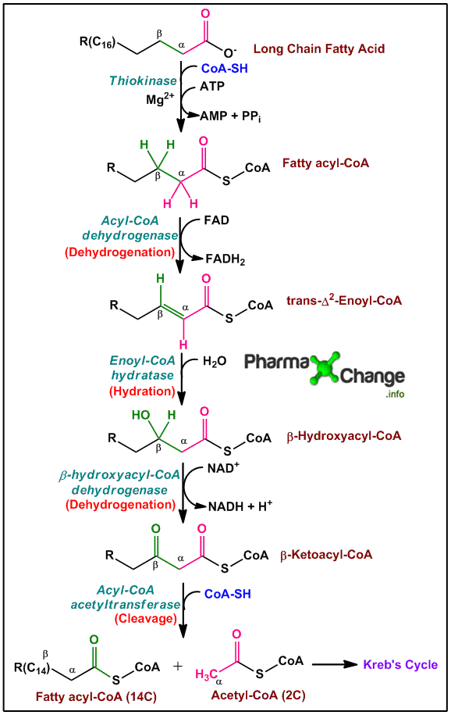
Note:
- Oxidation of odd carbon length fatty acids has additional reactions and is described in detail here: Oxidation of odd carbon chain length fatty acids.
- For unsaturated fatty acids β-oxidation has two more additional steps are required catalyzed by two enzymes isomerase and reductase. Oxidation of unsaturated fats gives less energy as compared to saturated fats. Read more about it here: Oxidation of unsaturated fatty acids.

Energetics of β-oxidation
Each β-oxidation cycle can be represented as following:
C_{(n)}Acyl-CoA + CoA-SH + FAD + NAD⁺ + H₂O → C_{(n-2)}Acyl CoA + Acetyl CoA + FADH₂ + NADH + H⁺
Complete oxidation of Palmitoyl CoA can be represented as following:
(Equation A)
Palmitoyl CoA + 7CoA-SH + 7FAD + 7NAD⁺+ 7H₂O → 8Acetyl CoA + 7FADH₂+ 7NADH + 7H⁺
Converting NADH and FADH₂ to their corresponding ATP equivalents from the above equation gives us:
(Equation B)
Palmitoyl CoA + 7CoA-SH + 7O₂ + 28P_{i} + 28ADP → 8Acetyl CoA + 28ATP + 7H₂O
And after Acetyl CoA molecules enter Kreb’s cycle and Electron Transport Sytem, resulting ATP is shown below:
8Acetyl CoA + 16O₂ + 80Pi + 80ADP → 8CoA + 80ATP + 16CO₂ + 16H₂O
Thus complete energy release is shown in the following equation by combining equation A and B:
Palmitoyl CoA + 23O₂ + 108P_{i} + 108ADP → CoA + 108ATP + 16CO₂ + 23H₂O
Note:
- There is utilization of ATP during the conversion of palmitic acid to palmitoyl-CoA and thus the net gain is ≈106 ATP.
- All the above calculations are done considering that one molecule of NADH gives 2.5 molecules of ATP and one molecule of FADH₂ gives 1.5 molecules of ATP in the Electron Transport System.
Thus by comparing the total molecules of ATP released by oxidation of fatty acids and oxidation of carbohydrates (Read Energetics of Cellular Respiration) it is proved that energy released by oxidation of fats is much more than that by oxidation of carbohydrates.

Regulation of fatty acid oxidation:
- The carnitine shuttle is a rate limiting step in the oxidation of fatty acids in the mitochondria and thus fatty acid oxidation can be regulated at this step.
- Malonyl CoA, an intermediate of fatty acid synthesis present in the cytosol is an inhibitor of carnitine acyltransferase I. This indicates that when fatty acid synthesis is in progress, oxidation of fatty acid cannot occur at the same time as the carnitine shuttle is impaired by inhibition of carnitine acyltransferase I.
- Fatty acid oxidation is also regulated by the acetyl CoA to CoA ratio: as the ratio increases, the CoA-requiring thiolase (the enzyme participating in β-oxidation) reaction decreases.
- When [NADH]/ [NAD+] ratio increases, the enzyme β-hydroxyacyl-CoA dehydrogenase is inhibited.

Unit-4 Enzyme and its classification

Enzymes

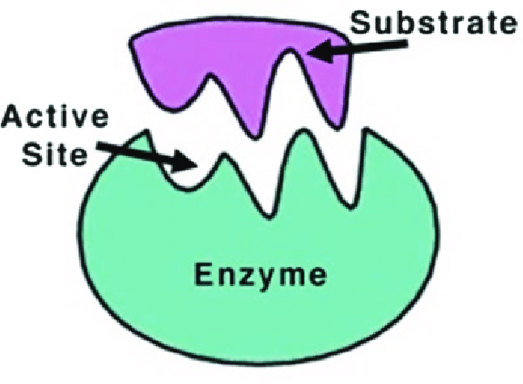

• Enzymes are biological catalysts
• They are not consumed or altered during the reaction
• They do not change the equilibrium, just reduce the time required to reach equilibrium.
• They increase the rate of a reaction by lowering the activation energy barrier.
• The reactant usually binds to the enzyme forming a transition complex that stabilizes the transition state.
• The interaction between enzyme and substrate is very specific. Specificity may be for a class of compounds or for a particular compound. Eg. Hexokinase / glucokinase
Enzyme Structure
• Most enzymes are proteins
• Enzymes may require a non-peptide component as a cofactor. The peptide component is called the apoenzyme, the cofactor is called as the coenzyme and the combined functional unit is the holoenzyme.
• Cofactors that are tightly bound to the polypeptide are called prosthetic groups. Such proteins are called as complex or conjugated proteins. Proteins without prostetic groups are simple proteins
• Common coenzymes are vitamins and metal ions
Enzyme Classification
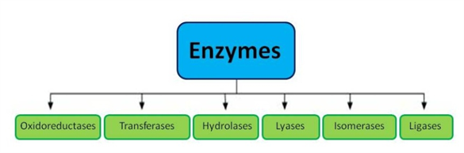
• Every enzyme is identified by a unique set of 4 numbers.
• There are 6 main classes based on the type of reaction catalyzed. This makes up the first number of the enzyme identity.
• Oxidoreductase: oxidation-reduction reaction. (Dehydrogenases)
• Transferase: transfer of intact functional group
• Hydrolase: hydrolysis (addition or removal of water)
• Lyase: Cleavage of a C-C or C-N or C-O bond. Removal (or addition) of water across double bond.
• Isomerase: Isomerization (LÙD, cisÙtrans, CHOÙC=O etc.)
• Ligase: Joining of two molecules requiring energy from ATP.

Reaction Rate and Enzyme Activity
• An enzyme increases the rate of a reaction. Reaction rate is defined as the amount of reactant modified per unit time. Units for reaction rate are µmoles/sec or mol/min.
• Enzymes are required in minute quantities and enhance reaction rates by 1010- to 1020-fold
• Enzyme activity is the ability of an enzyme to modify a reactant. 1 unit (U) is the enzyme activity that converts 1 µmole of reactant per min under standard conditions.
• The specific activity of an enzyme is defined as the activity per unit of mass or U/mg protein
Substrate Binding and Enzyme Action
• The first step in a enzyme catalyzed reaction is the formation of the enzyme-substrate complex. This is represented by the equation: E + S = ES = E + P.
• The region of the enzyme where the substrate binds is called as the active site. This consists of a substrate binding site and the catalytic site.
• The active site is usually a cleft or pocket created by the unique tertiary structure of the enzyme protein
• Enzyme specificity is due to specificity of substrate binding driven by substrate and enzyme 3D structure
• The ES complex is stabilized in the transition state by non-covalent interactions between substrate in the active site
Models of Enzyme-Substrate Binding
• Lock and key model. This means that the enzyme’s tertiary structure consists of a unique pocket or site which is tailor-made to fit only its substrate and nothing else, just as a key fits into a lock.
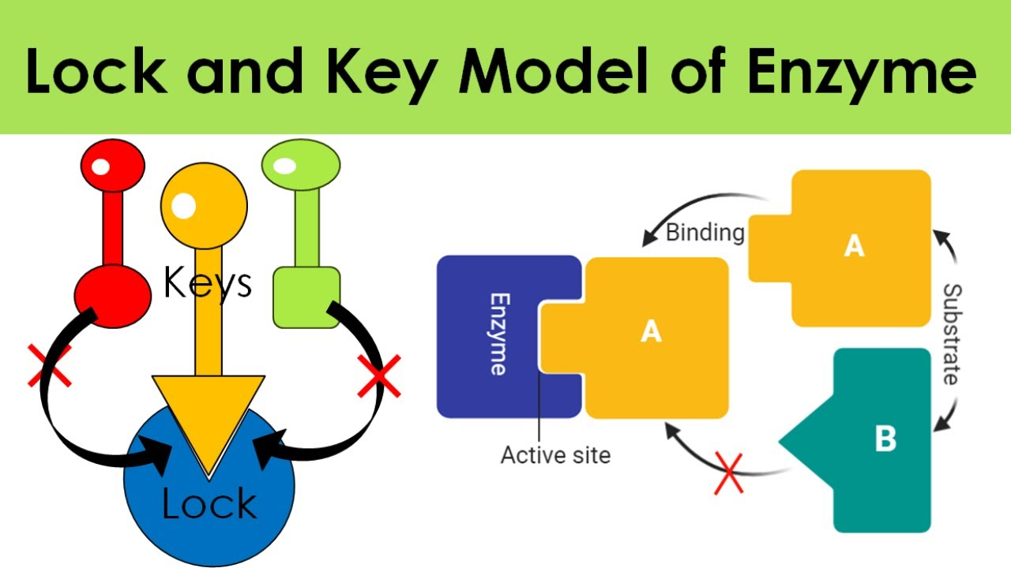
• Induced-fit model: This updated model states that enzymes interact with substrates and in the process change their conformation such that the enzyme is snug around the substrate, sort of like a glove around a hand.
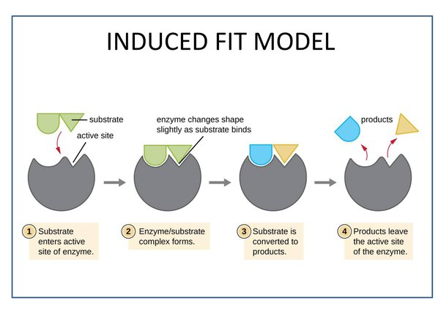
Factors Affecting Reaction Rates
• The study of enzyme reaction rates is called enzyme kinetics.
Enzyme kinetics are affected by:
• Temp and pH: Each enzymatic reaction has an optimum pH and optimum temperature. Extreme temp or pH disrupts enzyme structure and therefore reaction rate decreases
• Enzyme concentration: At saturating substrate concentration, the initial velocity is directly related to the enzyme concentration. E + S = ES = E + P. Thus, as long as S is not limiting, more E leads to more ES.
• Substrate concentration: The reaction rate = k [P] / [S]. The rate can be increased by adding more substrate, or by removing product as it is formed.
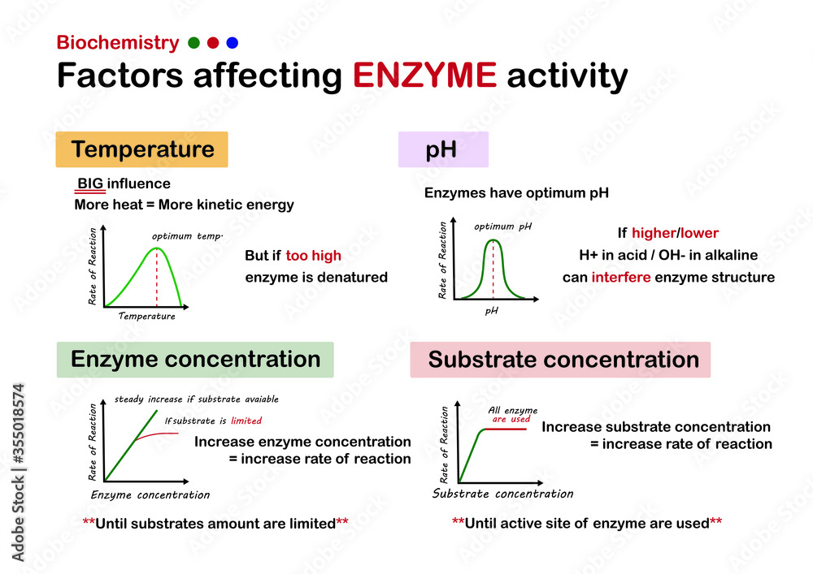

Allosteric Enzymes
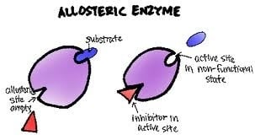
• Allosteric enzymes have one or more allosteric sites
• Allosteric sites are binding sites distinct from an enzyme’s active site or substrate-binding site
• Molecules that bind to allosteric sites are called effectors or modulators
• Binding to allosteric sites alters the activity of the enzyme. This is called cooperative binding. Allosteric enzymes display sigmoidal plot of Vo vs [S]
• Effectors may be positive or negative
• Effectors may be homotropic or heterotropic
• Regulatory enzymes of metabolic pathways are allosteric enzymes (eg: feedback inhibition)

Enzyme Inhibitors-
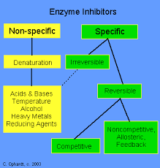
• Specific enzyme inhibitors regulate enzyme activity and help us understand mechanism of enzyme action. (Denaturing agents are not inhibitors)
• Irreversible inhibitors form covalent or very tight permanent bonds with aa at the active site of the enzyme and render it inactive. 3 classes: groupspecific reagents, substrate analogs, suicide inhibitors
• Reversible inhibitors form an EI complex that can be dissociated back to enzyme and free inhibitor. 3 groups based on their mechanism of action: competitive, non-competitive and uncompetitive.
Competitive inhibitors
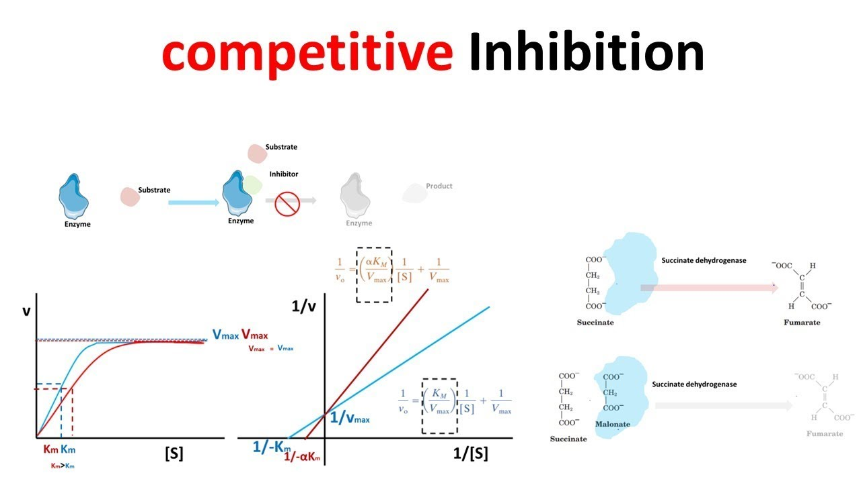
• Compete with substrate for binding to enzyme
• E + S = ES or E + I = EI . Both S and I cannot bind enzyme at the same time
• In presence of I, the equilibrium of E + S = ES is shifted to the left causing dissociation of ES.
• This can be reversed / corrected by increasing [S]
• Vmax is not changed, KM is increased by (1 + I/Ki)
• Eg: AZT, antibacterial sulfonamides, the anticancer agent methotrexate etc

Non-competitive Inhibitors
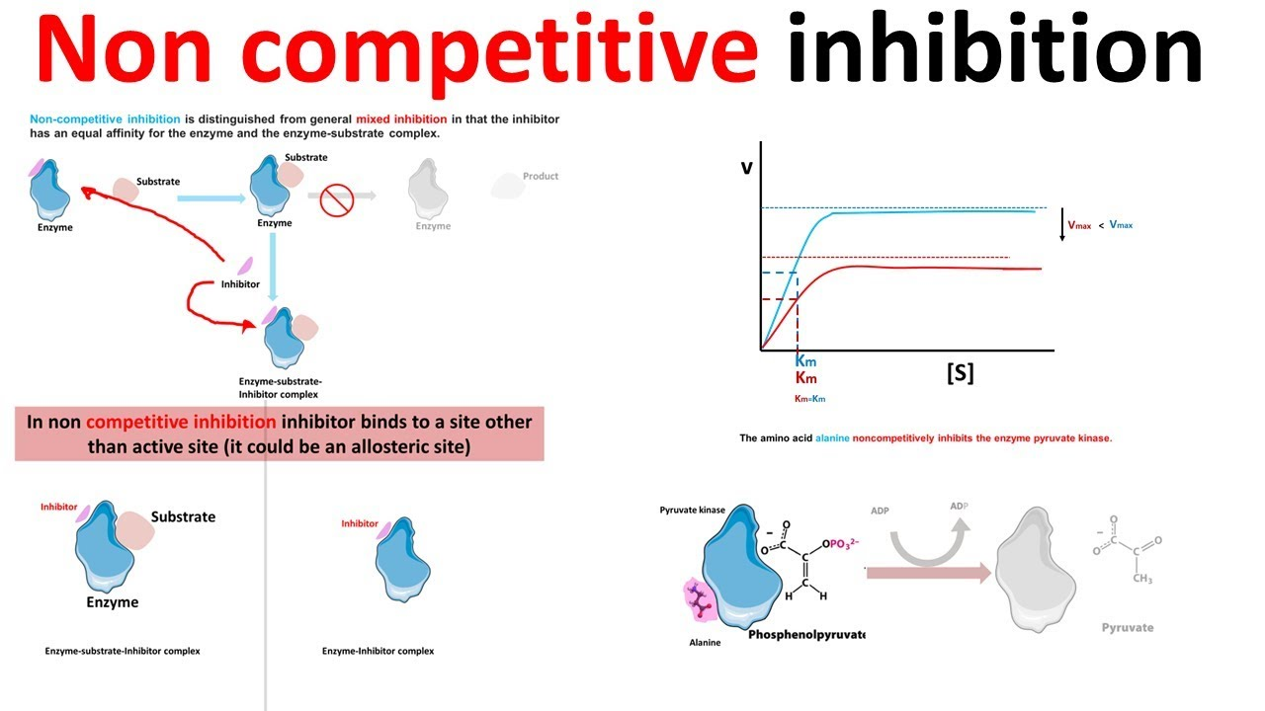
• Inhibitor binding site is distinct from substrate binding site. Can bind to free enzyme E and to ES • E + I = EI, ES + I = ESI or EI + S = ESI
• Both EI and ESI are enzymatically inactive
• The effective functional [E] (and [S]) is reduced
• Reaction of unaffected ES proceeds normally
• Inhibition cannot be reversed by increasing [S]
• KM is not changed, Vmax is decreased by (1 + I/Ki)
Uncompetitive Inhibitors
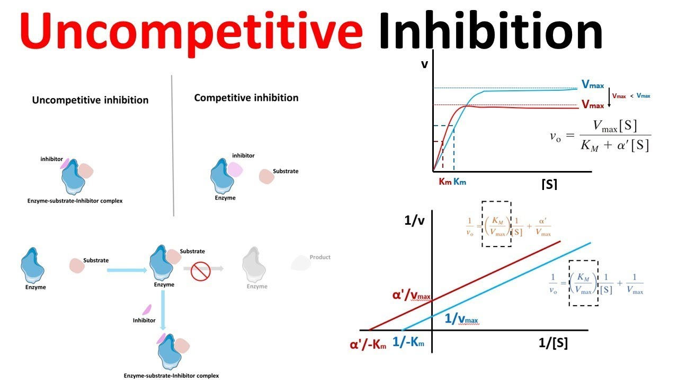
• The inhibitor cannot bind to the enzyme directly, but can only bind to the enzyme-substrate complex.
• ES + I = ESI.
• Both Vmax and KM are decreased by (1+I/Ki).

Irreversible Inhibitors
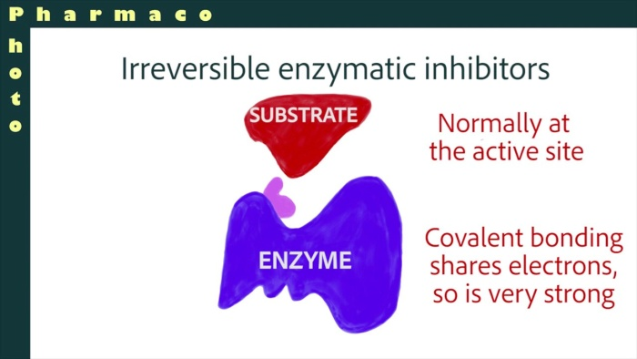
• Group-specific: covalently modify specific side chains of aa in active site of enzyme. Eg: DIPF reacts with serine, iodoacetamide modifies cys
• Some substrates transiently covalently modify the enzyme. Substrate analogs are structurally similar to such substrates. Since they are not actually substrates, the enzymatic reaction cannot proceed.
• Suicide inhibitors are modified substrates that trick the enzyme into initiating the reaction. Instead of product, reactive intermediates are released which react with the enzyme causing its inactivation
Transition State Analogs
• Enzyme action may involve conversion of substrate to a temporary transition state.
• The transition state of substrate has greater affinity for enzyme than native substrate stabilizing the ES complex and catalysis.
• Thus, analogs of substrate transition-state are potent and specific enzyme inhibitors
• Due to selective binding of enzyme to the substrate transition state, antibodies produced using transition state analogs as antigens have catalytic properties.
Vitamins and Coenzymes
• Most enzymes need cofactors for catalytic activity
• Coenzymes are enzyme cofactors derived from water-soluble B-complex vitamins.
• Vitamins are biomolecules required in minute amounts as dietary supplements.
• Fat-soluble vitamins are important for blood clotting (K), Ca and P metabolism (D), vision (A) and as an antioxidant (E)

UNIT-5 HYPERGLYCEMIA AND HYPOGLYCEMIA

Diabetes is a chronic disease that occurs when the pancreas is no longer able to make insulin, or when the body cannot make good use of the insulin it produces.
Insulin is a hormone made by the pancreas, that acts like a key to let glucose from the food we eat pass from the blood stream into the cells in the body to produce energy. All carbohydrate foods are broken down into glucose in the blood. Insulin helps glucose get into the cells.
Not being able to produce insulin or use it effectively leads to raised glucose levels in the blood (known as hyperglycaemia). Over the long-term high glucose levels are associated with damage to the body and failure of various organs and tissues.

Types of diabetes
There are three main types of diabetes – type 1, type 2 and gestational.
- Type 1 diabetes can develop at any age, but occurs most frequently in children and adolescents. When you have type 1 diabetes, your body produces very little or no insulin, which means that you need daily insulin injections to maintain blood glucose levels under control. Learn more.
- Type 2 diabetes is more common in adults and accounts for around 90% of all diabetes cases. When you have type 2 diabetes, your body does not make good use of the insulin that it produces. The cornerstone of type 2 diabetes treatment is healthy lifestyle, including increased physical activity and healthy diet. However, over time most people with type 2 diabetes will require oral drugs and/or insulin to keep their blood glucose levels under control. Learn more.
- Gestational diabetes (GDM) is a type of diabetes that consists of high blood glucose during pregnancy and is associated with complications to both mother and child. GDM usually disappears after pregnancy but women affected and their children are at increased risk of developing type 2 diabetes later in life.
Type 1 diabetes
Around 10% of all people with diabetes have type 1 diabetes.
Type 1 diabetes is caused by an autoimmune reaction where the body’s defence system attacks the cells that produce insulin. As a result, the body produces very little or no insulin. The exact causes of this are not yet known, but are linked to a combination of genetic and environmental conditions.
Type 1 diabetes can affect people at any age, but usually develops in children or young adults. People with type 1 diabetes need daily injections of insulin to control their blood glucose levels. If people with type 1 diabetes do not have access to insulin, they will die.
The risk factors for type 1 diabetes are still being researched. However, having a family member with type 1 diabetes slightly increases the risk of developing the disease. Environmental factors and exposure to some viral infections have also been linked to the risk of developing type 1 diabetes.

Symptoms of type 1 diabetes
The most common symptoms of type 1 diabetes include:
- Abnormal thirst and dry mouth
- Sudden weight loss
- Frequent urination
- Lack of energy, tiredness
- Constant hunger
- Blurred vision
- Bedwetting
Diagnosing type 1 diabetes can be difficult so additional tests may be required to confirm a diagnosis.

Management of type 1 diabetes
People with type 1 diabetes require daily insulin treatment, regular blood glucose monitoring and a healthy lifestyle to manage their condition effectively.

Insulin
All people with type 1 diabetes need to take insulin to control their blood glucose levels. There are different types of insulin depending on how quickly they work, when they peak, and how long they last. Insulin is commonly delivered with a syringe, insulin pen or insulin pump.
Types of insulin include:
- Rapid-acting: usually taken just before or with a meal. These insulins act very quickly to limit the rise in blood sugar, which follows eating. It is essential to avoid overdosage to minimize the risk of low blood sugar (hypoglycemia). Rapid-acting insulins include Asparat, Glulisine, Lispro.
- Short-acting: usually taken before meals. These insulins are also called regular or neutral insulins. They do not act as quickly as rapid-acting insulins and therefore may be more appropriate in certain people. Short-acting insulins include Actrapid, Humulin R, Insuman Rapid.
- Intermediate-acting: often taken together with a short-acting insulin. Intermediate-acting insulins start to act within the first hour of injecting, followed by a period of peak activity lasting up to 7 hours. Intermediate acting insulins include Humulin NPH, Protaphane, Insulatard.
- Long-acting: insulins that are steadily released and can last in the body for up to 24 hours. They are commonly taken in the morning or in the evening, before going to bed. Long-acting insulins include Detemir, Glargine.
Two common insulin treatment plans include:
- Twice-daily insulin: using both short-acting and intermediate-acting insulin.
- Basal bolus regimen: short-acting insulin taken with main meals (usually three times a day) and intermediate-acting insulin given once or twice daily (evening or morning and evening).

Self-monitoring
People with diabetes who require insulin need to check their blood glucose levels regularly to inform insulin dosage. Self-monitoring of blood glucose (SBMG) is the name given to the process of blood glucose testing by people with diabetes at home, school, work or elsewhere. SMBG helps people with diabetes and their healthcare providers understand how their blood glucose levels vary during the day so that their treatment can be adjusted accordingly.
People with type 1 diabetes are usually advised to measure their blood glucose level at least four times a day.

Healthy nutrition
Healthy nutrition — knowing what and when to eat — is an important part of diabetes management as different foods affect your blood glucose levels differently.
A healthy diet for all people with diabetes includes reducing the amount of calories if you are overweight, replacing saturated fats (eg. cream, cheese, butter) with unsaturated fats (eg. avocado, nuts, olive and vegetable oils), eating dietary fibre (eg. fruit, vegetables, whole grains), and avoiding tobacco use, excessive alcohol and added sugar.

Physical activity
Regular physical activity is essential to help keep blood glucose levels under control. It is most effective when it includes a combination of both aerobic (eg. jogging, swimming, cycling) exercise and resistance training, as well as reducing the amount of time spent being inactive.

Prevention of type 1 diabetes
No effective and safe intervention currently exists to prevent type 1 diabetes despite a large number of clinical trials aimed at halting the on-going autoimmune destruction of pancreatic beta cells. However, there is some evidence that overweight and a high growth rate in children are weak risk factors, indicating that a healthy lifestyle that avoids both over-eating and a sedentary lifestyle is recommended for high-risk groups such as the siblings of children with type 1 diabetes. However, this is just one of a number of factors that have also been implicated. These include not being breast-fed, being the first-born, being born by caesarean section and having an older or obese mother.
Although a ‘cure’ for type 1 diabetes is being actively sought, preventing or delaying it in those known to be at risk or, in those already diagnosed, slowing down the auto-immune destruction of beta cells and protecting those cells that are still active are likely to be more achievable goals in the foreseeable future. Neither has been convincingly achieved as yet. However, several studies are underway using interventions such as oral insulin in people known to have markers of islet autoimmunity, trialling drugs already used, for example in psoriasis, to prolong beta cell life and the use of peptide immunotherapies to ‘retrain’ killer T cells, the lymphocytes that are closely involved in the underlying mechanism of type 1 diabetes.
Type 2 diabetes
Type 2 diabetes is the most common type of diabetes, accounting for around 90% of all diabetes cases.
It is generally characterized by insulin resistance, where the body does not fully respond to insulin. Because insulin cannot work properly, blood glucose levels keep rising, releasing more insulin. For some people with type 2 diabetes this can eventually exhaust the pancreas, resulting in the body producing less and less insulin, causing even higher blood sugar levels (hyperglycaemia).
Type 2 diabetes is most commonly diagnosed in older adults, but is increasingly seen in children, adolescents and younger adults due to rising levels of obesity, physical inactivity and poor diet.
The cornerstone of type 2 diabetes management is a healthy diet, increased physical activity and maintaining a healthy body weight. Oral medication and insulin are also frequently prescribed to help control blood glucose levels.

Risk factors
Several risk factors have been associated with type 2 diabetes and include:
- Family history of diabetes
- Overweight
- Unhealthy diet
- Physical inactivity
- Increasing age
- High blood pressure
- Ethnicity
- Impaired glucose tolerance (IGT)*
- History of gestational diabetes
- Poor nutrition during pregnancy
* Impaired glucose tolerance (IGT) is a category of higher than normal blood glucose, but below the threshold for diagnosing diabetes.
Changes in diet and physical activity related to rapid development and urbanisation have led to sharp increases in the numbers of people living with type 2 diabetes.

Symptoms of type 2 diabetes
The symptoms of type 2 diabetes are similar to those of type 1 diabetes and include:
- Excessive thirst and dry mouth
- Frequent urination
- Lack of energy, tiredness
- Slow healing wounds
- Recurrent infections in the skin
- Blurred vision
- Tingling or numbness in hands and feet.
These symptoms can be mild or absent and so people with type 2 diabetes may live several years with the condition before being diagnosed.

Management of type 2 diabetes
The cornerstone of managing type 2 diabetes is a healthy lifestyle, which includes a healthy diet, regular physical activity, not smoking, and maintaining a healthy body weight.
Over time, a healthy lifestyle may not be enough to keep blood glucose levels under control and people with type 2 diabetes may need to take oral medication. If treatment with a single medication is not sufficient, combination therapy options may be prescribed.
When oral medication is not sufficient to control blood glucose levels, people with type 2 diabetes may require insulin injections.

Medications for type 2 diabetes
The most commonly used oral medications for type 2 diabetes include:
- Metformin: reduces insulin resistance and allows the body to use its own insulin more effectively. It is regarded as the first-line treatment for type 2 diabetes in most guidelines around the world.
- Sulfonylureas: stimulate the pancreas to increase insulin production. Sulfonylureas include gliclazide, glipizide, glimepiride, tolbutamide and glibenclamide.

Prevention of type 2 diabetes
There are a number of factors that influence the development of type 2 diabetes. The most influential are lifestyle behaviours commonly associated with urbanisation. Research indicates that a majority of cases of type 2 diabetes could be prevented through healthy diet and regular physical activity. A healthy diet includes reducing the amount of calories if you are overweight, replacing saturated fats (eg. cream, cheese, butter) with unsaturated fats (eg. avocado, nuts, olive and vegetable oils), eating dietary fibre (eg. fruit, vegetables, whole grains), and avoiding tobacco use, excessive alcohol and added sugar.
Regular physical activity is essential to help keep blood glucose levels under control. It is most effective when it includes a combination of both aerobic (eg. jogging, swimming, cycling) exercise and resistance training, as well as reducing the amount of time spent being inactive.
COMPLECATIONS OF DM-
People with diabetes have an increased risk of developing a number of serious health problems. Consistently high blood glucose levels can lead to serious diseases affecting the heart and blood vessels, eyes, kidneys, nerves and teeth. In addition, people with diabetes also have a higher risk of developing infections. In almost all high-income countries, diabetes is a leading cause of cardiovascular disease, blindness, kidney failure, and lower limb amputation.
Maintaining blood glucose levels, blood pressure, and cholesterol at or close to normal can help delay or prevent diabetes complications. Therefore people with diabetes need regular monitoring.
Cardiovascular disease: affects the heart and blood vessels and may cause fatal complications such as coronary artery disease (leading to heart attack) and stroke. Cardiovascular disease is the most common cause of death in people with diabetes. High blood pressure, high cholesterol, high blood glucose and other risk factors contribute to increasing the risk of cardiovascular complications.
Kidney disease (diabetic nephropathy): caused by damage to small blood vessels in the kidneys leading to the kidneys becoming less efficient or to fail altogether. Kidney disease is much more common in people with diabetes than in those without diabetes. Maintaining near normal levels of blood glucose and blood pressure can greatly reduce the risk of kidney disease.
Nerve disease (diabetic neuropathy): diabetes can cause damage to the nerves throughout the body when blood glucose and blood pressure are too high. This can lead to problems with digestion, erectile dysfunction, and many other functions. Among the most commonly affected areas are the extremities, in particular the feet. Nerve damage in these areas is called peripheral neuropathy, and can lead to pain, tingling, and loss of feeling. Loss of feeling is particularly important because it can allow injuries to go unnoticed, leading to serious infections and possible amputations. People with diabetes carry a risk of amputation that may be more than 25 times greater than that of people without diabetes. However, with comprehensive management, a large proportion of amputations related to diabetes can be prevented. Even when amputation takes place, the remaining leg and the person’s life can be saved by good follow-up care from a multidisciplinary foot team. People with diabetes should regularly examine their feet.
Eye disease (diabetic retinopathy): most people with diabetes will develop some form of eye disease (retinopathy) causing reduced vision or blindness. Consistently high levels of blood glucose, together with high blood pressure and high cholesterol, are the main causes of retinopathy. It can be managed through regular eye checks and keeping glucose and lipid levels at or close to normal. .
Pregnancy complications: Women with any type of diabetes during pregnancy risk a number of complications if they do not carefully monitor and manage their condition. To prevent possible organ damage to the fetus, women with type 1 diabetes or type 2 diabetes should achieve target glucose levels before conception. All women with diabetes during pregnancy, type 1, type 2 or gestational should strive for target blood glucose levels throughout to minimize complications. High blood glucose during pregnancy can lead to the foetus putting on excess weight. This can lead to problems in delivery, trauma to the child and mother, and a sudden drop in blood glucose for the child after birth. Children who are exposed for a long time to high blood glucose in the womb are at higher risk of developing diabetes in the future.
Oral complications: People with diabetes have an increased risk of inflammation of the gums (periodontitis) if blood glucose is not properly managed. Periodontitis is a major cause of tooth loss and is associated with an increased risk of cardiovascular disease (CVD). Regular oral check-ups should be established to ensure early diagnosis, particularly among people with previously undiagnosed diabetes and prompt management of any oral complications in people with diabetes. Annual visits are recommended for symptoms of gum disease such as bleeding when brushing teeth or swollen gums.
Gestational Diabetes Mellitus (GDM)
Introduction-
Gestational Diabetes Mellitus (GDM) is defined as Impaired Glucose Tolerance (IGT) with onset or first recognition during pregnancy. Worldwide, one in 10 pregnancies is associated with diabetes, 90% of which are GDM. Undiagnosed or inadequately treated GDM can lead to significant maternal & fetal complications.
Moreover, women with GDM and their offsprings are at increased risk of developing type 2 diabetes later in life. In India, one of the most populous country globally, rates of GDM are estimated to be 10-14.3% which is much higher than the west. As of 2010, there were an estimated 22 million women with diabetes between the ages of 20 and 39 & an additional 54 million women in this age group with impaired glucose tolerance (IGT) or pre-diabetes with the potential to develop GDM if they become pregnant.
Consequences of GDM Maternal risks of GDM include-
Polyhydramnios, pre-eclampsia, prolonged labour, obstructed labour, cesarean section, uterine atony, postpartum hemorrhage, infection and progression of retinopathy which are the leading global causes of maternal morbidity and mortality.
Fetal risks include
Spontaneous abortion, intra-uterine death, stillbirth, congenital malformation, shoulder dystocia, birth injuries, neonatal hypoglycemia and infant respiratory distress syndrome.
Protocol for investigation
- Testing for GDM is recommended twice during ANC.
- The first testing should be done during first antenatal contact as early as possible in pregnancy.
- The second testing should be done during 24-28 weeks of pregnancy if the first test is negative.
- It is important to ensure second test as many pregnant women develop blood sugar intolerance during this period (24-28 weeks).
- Moreover, only one third of GDM positive women are detected during first trimester. If it could not be done during this time, then it can be done any time after 24 weeks of pregnancy.
- There should be at least 4 weeks gap between the two tests. The test is to be conducted for all pregnant women even if she comes late in pregnancy for ANC at the time of first contact.
- If she presents beyond 28 weeks of pregnancy, only one test is to be done at the first point of contact.

Methodology:
- Test for diagnosis Single step testing using 75 gm oral glucose & measuring blood sugar 2 hours after ingestion.
- 75 gm glucose is to be given orally after dissolving in approximately 300 ml water whether the pregnant women comes in fasting or non-fasting state, irrespective of the last meal.
- The intake of the solution has to be completed within 5-10 minutes. A plasma standardized glucometer should be used to evaluate blood sugar 2 hours after the oral glucose load.
- If vomiting occurs within 30 minutes of oral glucose intake, the test has to be repeated the next day, or else refer to a facility.
- If vomiting occurs after 30 minutes, the test continues. The threshold blood sugar level of ≥140 mg/dL (more than or equal to 140) is taken as cut off for diagnosis of GDM.

Hypoglycemia
Hypoglycemia is a condition in which your blood sugar (glucose) level is lower than normal. Glucose is your body's main energy source.
Hypoglycemia is often related to diabetes treatment. But other drugs and a variety of conditions — many rare — can cause low blood sugar in people who don't have diabetes
Hypoglycemia needs immediate treatment when blood sugar levels are low. For many people, a fasting blood sugar of 70 milligrams per deciliter (mg/dL), or 3.9 millimoles per liter (mmol/L), or below should serve as an alert for hypoglycemia. But your numbers might be different. Ask your doctor.
Treatment involves quickly getting your blood sugar back to normal either with high-sugar foods or drinks or with medications. Long-term treatment requires identifying and treating the cause of hypoglycemia.

Symptoms
If blood sugar levels become too low, signs and symptoms can include:
- An irregular or fast heartbeat
- Fatigue
- Pale skin
- Shakiness
- Anxiety
- Sweating
- Hunger
- Irritability
- Tingling or numbness of the lips, tongue or cheek
As hypoglycemia worsens, signs and symptoms can include:
- Confusion, abnormal behavior or both, such as the inability to complete routine tasks
- Visual disturbances, such as blurred vision
- Seizures
- Loss of consciousness

When to see a doctor
Seek a doctor's help immediately if:
- You have what might be hypoglycemia symptoms and you don't have diabetes
- You have diabetes and hypoglycemia isn't responding to treatment, such as drinking juice or regular soft drinks, eating candy, or taking glucose tablets
Seek emergency help for someone with diabetes or a history of hypoglycemia who has symptoms of severe hypoglycemia or loses consciousness.

Causes
Hypoglycemia occurs when your blood sugar (glucose) level falls too low. There are several reasons why this can happen; the most common is a side effect of drugs used to treat diabetes.

Blood sugar regulation
When you eat, your body breaks down carbohydrates from foods — such as bread, rice, pasta, vegetables, fruit and milk products — into various sugar molecules, including glucose.
Glucose, the main energy source for your body, enters the cells of most of your tissues with the help of insulin — a hormone secreted by your pancreas. Insulin enables the glucose to enter the cells and provide the fuel your cells need. Extra glucose is stored in your liver and muscles in the form of glycogen.
If you haven't eaten for several hours and your blood sugar level drops, another hormone from your pancreas signals your liver to break down the stored glycogen and release glucose into your bloodstream. This keeps your blood sugar within a normal range until you eat again.
Your body also has the ability to make glucose. This process occurs mainly in your liver, but also in your kidneys.

Possible causes, with diabetes
If you have diabetes, you might not make enough insulin (type 1 diabetes) or you might be less responsive to it (type 2 diabetes). As a result, glucose tends to build up in the bloodstream and can reach dangerously high levels. To correct this problem, you might take insulin or other drugs to lower blood sugar levels.
But too much insulin or other diabetes medications may cause your blood sugar level to drop too low, causing hypoglycemia. Hypoglycemia can also occur if you eat less than usual after taking diabetes medication, or if you exercise more than you normally do.

Possible causes, without diabetes
Hypoglycemia in people without diabetes is much less common. Causes can include the following:
- Medications. Taking someone else's oral diabetes medication accidentally is a possible cause of hypoglycemia. Other medications can cause hypoglycemia, especially in children or in people with kidney failure. One example is quinine (Qualaquin), used to treat malaria.
- Excessive alcohol drinking. Drinking heavily without eating can block your liver from releasing stored glucose into your bloodstream, causing hypoglycemia.
- Some critical illnesses. Severe liver illnesses such as severe hepatitis or cirrhosis can cause hypoglycemia. Kidney disorders, which can keep your body from properly excreting medications, can affect glucose levels due to a buildup of those medications.
Long-term starvation, as can occur in the eating disorder anorexia nervosa, can result in too little of substances your body needs to create glucose.
- Insulin overproduction. A rare tumor of the pancreas (insulinoma) can cause you to produce too much insulin, resulting in hypoglycemia. Other tumors also can result in too much production of insulin-like substances. Enlargement of cells of the pancreas that produce insulin can result in excessive insulin release, causing hypoglycemia.
- Hormone deficiencies. Certain adrenal gland and pituitary tumor disorders can result in a deficiency of key hormones that regulate glucose production. Children can have hypoglycemia if they have too little growth hormone.

Hypoglycemia after meals
Hypoglycemia usually occurs when you haven't eaten, but not always. Sometimes hypoglycemia symptoms occur after certain meals high in sugar because your body produces more insulin than you need.
This type of hypoglycemia, called reactive hypoglycemia or postprandial hypoglycemia, can occur in people who have had stomach bypass surgery. It can also occur in people who haven't had this surgery.

Complications
Untreated hypoglycemia can lead to:
- Seizure
- Loss of consciousness
- Death
Hypoglycemia can also contribute to the following:
- Dizziness and weakness
- Falls
- Injuries
- Motor vehicle accidents
- Greater risk of dementia in older adults

Hypoglycemia unawareness
Over time, repeated episodes of hypoglycemia can lead to hypoglycemia unawareness. The body and brain no longer produce signs and symptoms that warn of a low blood sugar, such as shakiness or irregular heartbeats. When this happens, the risk of severe, life-threatening hypoglycemia increases.
If you have diabetes, recurring episodes of hypoglycemia and hypoglycemia unawareness, your doctor might modify your treatment, raise your blood sugar level goals and recommend blood glucose awareness training.

Undertreated diabetes
If you have diabetes, episodes of low blood sugar are uncomfortable and can be frightening. Fear of hypoglycemia can cause you to take less insulin to ensure that your blood sugar level doesn't go too low. This can lead to uncontrolled diabetes. Talk to your doctor about your fear, and don't change your diabetes medication dose without your doctor's okay.

Prevention

If you have diabetes
If you're taking new medications, changing your eating or medication schedules, or adding new exercise, talk to your doctor about how these changes might affect your diabetes management and your risk of low blood sugar.
A continuous glucose monitor (CGM) is an option for some people, particularly those with hypoglycemia unawareness. A CGM has a tiny wire that's inserted under the skin that can send blood glucose readings to a receiver.
If blood sugar levels are dropping too low, some models of CGM will alert you with an alarm. Some insulin pumps are now integrated with CGMs and can shut off insulin delivery when blood sugar levels are dropping too quickly to help prevent hypoglycemia.
Be sure to always have a fast-acting carbohydrate with you, such as juice or glucose tablets so that you can treat a falling blood sugar level before it dips dangerously low.

If you don't have diabetes
For recurring episodes of hypoglycemia, eating frequent small meals throughout the day is a stopgap measure to help prevent your blood sugar levels from getting too low. However, this approach isn't advised as a long-term strategy. Work with your doctor to identify and treat the cause of hypoglycemia.
Hyperglycemias
Hyperglycemia is a medical condition characterized by high blood glucose levels. The condition is primarily caused by significantly lower blood insulin levels or improper functioning of insulin.

What is hyperglycemia?
Hyperglycemia is characterized by fasting and 2-hour postprandial blood glucose levels of more than 125 mg/dl and 180 mg/dl, respectively. A patient with a fasting glucose level of 100 – 125 mg/dl is considered pre-diabetic; whereas, a patient with a fasting glucose level of more than 125 mg/dl is considered diabetic.
If left untreated, hyperglycemia can lead to serious complications, including damage to the eyes, kidneys, heart, blood vessels, and nervous system. In some extreme cases, it can lead to a diabetic coma.
Causes-
- Empaired glucose homeostasis is the main causative factor for hyperglycemia, which primarily occurs due to an imbalance between glucose production in the liver and its uptake and utilization in the peripheral cells.
- Insulin is a hormone responsible for cellular glucose uptake and maintenance of normal blood glucose levels. An abnormal increase in blood glucose level occurs when insulin is produced in lesser amount by the pancreatic cells (type 1 diabetes), or when the body becomes resistant to normal insulin effects (type 2 diabetes).
- There are several risk factors that can increase the chance of developing hyperglycemia.
- People with diabetes can be affected by hyperglycemia if they are not using the proper dose of diabetes medications. Eating a high quantity of carbohydrate-rich foods can also lead to a sudden increase in blood glucose levels.
Symptoms-
- For effective management of hyperglycemia, it is important to recognize its primary signs and symptoms. The condition is associated with high blood glucose levels as well as the presence of glucose in urine. The most common early symptoms include fatigue, headache, blurred vision, frequent urination, and increased thirst.
- If left untreated, chronic hyperglycemia can lead to abnormal accumulation of toxic acids called ketones in the blood and urine, which is medically termed as ketoacidosis.
- Due to the absence of insulin, the cells cannot use glucose as an energy source; instead, the cells breakdown fats to get energy and subsequently produce ketones as byproducts.
- The symptoms of ketoacidosis include nausea/vomiting, shortness of breath, fruity-smelling breath, abdominal pain, weakness, weight loss, dry mouth/skin, confusion, and coma.
- A long-term presence of hyperglycemia can also be associated with frequent infections and a slower rate of wound healing.
Preventions-
- The best way to prevent hyperglycemia-related complications is to monitor blood glucose levels daily using a glucose meter. For diabetic patients, it is vital to properly consume the prescribed medicines (insulin shots or glucose-controlling medicines) and follow the diet plan.
- Diabetic patients should also follow a strict physical activity regimen. However, if ketones are present in the blood or urine, exercise is not recommended as it can further increase the ketone level.
The recommended target blood glucose levels for diabetic patients include:
- Fasting blood glucose level: 80 – 130 mg/dl
- 2-hour postprandial blood glucose level: less than 180 mg/dl
- If blood glucose level goes above 240 mg/dl, doctors generally recommend urine tests to check the glucose level in the urine.
Also, doctors may ask for the HbA1C test, which is conducted to check glucose tolerance. This test measures the percentage of glucose attached to hemoglobin and gives an average blood glucose level for past 2 -3 months. An HbA1C value of 7% or lower indicates that the blood glucose level is relatively well controlled.
In case of severe hyperglycemia, emergency treatments may be required, including fluid replacement, electrolyte replacement, or insulin therapy. A fluid replacement treatment is necessary to rehydrate the body and dilute the glucose in the blood.
Electrolyte replacement is required as the absence of insulin can decrease the electrolyte level in the blood. Electrolytes are necessary for the proper functioning of the heart, muscles, and nerves.
An insulin therapy, which is performed by injecting insulin through veins, is required to immediately prevent the formation and accumulation of ketones in the blood.
GLUCOSE TOLERANCE TEST
The oral glucose tolerance test (OGTT) is used to define the status of glucose tolerance based on the plasma glucose level at 120 min. The glucose tolerance test (GTT) consists of drinking 100 grams of glucose solution and measuring the blood glucose values every hour to get a curve. The values obtained tell a lot about the body's sugar metabolism. The following tables of results are typical and are interpreted briefly. A 2 hour GTT is used to diagnose diabetes, but a 6 hour test might also diagnose diabetes plus hypoglycemia, because symptoms of hypoglycemia occur after the 5th hour. To diagnose a person as hypoglycemic, not only the blood glucose values are important but also the person must experience the symptoms of hypoglycemia in the course of the test.

RENAL THRESHOLD FOR GLUCOSE:
In normal persons, so long as the blood sugar is below 160 to 180 mg/dl, glucose in amounts which are detected by the routine tests used is not excreted by the kidneys. This level blood sugar has been termed the renal threshold for glucose.
The test is usually carried out in the morning after a night's fast, but, if necessary, it may be done some four to five hours after the last food was taken. Blood is taken for the determination of the fasting blood sugar and a specimen of urine is collected. All medication and nutritional supplements should be suspended a few days before the test, because they might influence blood glucose metabolism. No meals should be eaten after 8:00 PM on the day before the test. During the test, no eating or smoking is permitted. If diabetes is found, it might be wise to extend the test to 6 hours to see if hypoglycemia occurs after the 5th hour.

TYPICAL GLUCOSE TOLERANCE TEST CURVES
Fifty to 100 grams of glucose dissolved in water is taken at the beginning of the test. All of the following tests lasted 6 hours, with blood samples being taken at the beginning, 30 min., 60 min, 120 min, 180, 240, 300, and 360 minutes (0, .5, 1, 2, 3, 4, 5, 6 hrs.). Glucose in the urine might be an indication of diabetes. The curves shown are used to diagnose several blood sugar metabolism disorders. Actual curve may vary from person to person and in the same person from month to month. If the measured values lie within the ranges of the following 'normal curve,' and if no typical symptoms are present, then it is concluded that the person has "good enough glucose tolerance".
The following tables show only: Normal (Min / Max), Mild Diabetes, Severe Diabetes, and Diabetes with Hypoglycemia.
1- Normal Minimum curve
Time [hours] | 0 | 0.5 | 1 | 2 | 3 | 4 | 5 | 6
Glucose [mg/dl] | 80 | 90 | 105 | 90 | 80 | 80 | 80 | 80

A "Normal-Min" curve means your pancreas is still in very good shape. Insulin release is strong and sufficient to keep glucose from rising. Keep your pancreas healthy by not stimulating much release of insulin, ie, eat low carbohydrate meals.
2- Normal Maximum curve
Glocose Tolerance Curves
350
300
250
200
150
100
50
0
fasting
0.5 hour
1 hour
2 hour
3 hour
4 hour
5 hour
6 hour
Time (hours)
Normal-Min Normal-Max Mild-D Severe-D Diabetic-Hyp Flat

Time [hours] | 0 | 0.5 | 1 | 2 | 3 | 4 | 5 | 6
Glucose [mg/dl] | 120 | 135 | 160 | 130 | 110 | 100 | 110 | 105

The "Normal-Max" response means you are already well started on the road to diabetes. This is "normal" but it is not good. You are aging faster than the minimum possible. Your pancreas is still releasing enough insulin, but may be 10% to 30% of your beta cells are not functioning.
The stream of insulin is not as much as it was before which is the reason why glucose is rising. You should care for the remaining beta cells by not stimulating release of insulin. To prevent the advance to diabetes, pretend that you are already a diabetic, and start to take care of yourself as if you are a diabetic.... Eat like a diabetic.
3- Mild diabetes curve
Time [hours] | 0 | 0.5 | 1 | 2 | 3 | 4 | 5 | 6
Glucose [mg/dl] | 115 | 145 | 180 | 160 | 120 | 130 | 130 | 130

Your pancreas is already partly shut down... perhaps 40% to 60% of your beta cells are burned out, and the stream of insulin is not enough to lower glucose quickly. Your pancreas is working overtime to bring down glucose. For this reason you are burning beta cells at a faster rate than ever before. The low quality of the insulin is not as good as before.

4- Severe diabetes curve

Time [hours] | 0 | 0.5 | 1 | 2 | 3 | 4 | 5 | 6
Glucose [mg/dl] | 200 | 235 | 265 | 280 | 300 | 295 | 280 | 270

5-Diabetes and hypoglycemia curve

Time [hours] | 0 | 0.5 | 1 | 2 | 3 | 4 | 5 | 6
Glucose [mg/dl] | 100 | 160 | 220 | 160 | 85 | 60 | 50 | 85
This is a curve of a patient that is both diabetic and hypoglycemic.With such a curve severe symptoms can be expected.

6- Flat curve

Time [hours] | 0 | 0.5 | 1 | 2 | 3 | 4 | 5 | 6
Glucose [mg/dl] | 90 | 90 | 90 | 100 | 90 | 100 | 80 | 90

This is a flattened glucose tolerance curve. This curve may be characteristic for people who conduct a tedious, monotonous life. They complain about chronic fatigue, boredom, and disinterest.

