Microbiology

History and Scope of Microbiology
Medical microbiology is the study of causative agents of infectious disease of human beings and their reactions to such infections. In other words, it deals with etiology, pathogenesis, laboratory diagnosis, treatment, epidemiology and control of infection. Obviously, medical microbiology has close link with other disciplines, i.e. pathology, clinical medicine, surgery, pharmacology cum therapeutics and preventive medicine.
Historical Events Long before the discovery of microorganisms certain processes caused by their life activities, such as fermentation of wine juice, milk, yeast, etc. were known to mankind. In ancient times at the beginning of civilization, man by using these processes learned to prepare koumurs, sour milk and other products. In the works of Hippocrates (460-377 BC), Verona (2nd century BC), Lucretins (95-55 BC), Pliny (23-79 AD), Galen (131-211 AD) and other scientists of that time, the hypotheses of living nature (contagium vivum) of contagious diseases was described. Varo and Columella (first century BC) suggested that diseases were caused by invisible organisms (animalia minuta) inhaled or ingested. Fracastorius of Verona (1546) felt that contagium vivum may be the cause of infectious disease. Kircher (1659) could find minute worms in the blood of a plague patient. It is more likely that he observed perhaps only blood cells with the apparatus which he had at his disposal at that time. Antoni van Leeuwenhoek (1683) could give description of various types of bacteria. He also invented the simple microscope. As microbes are not visible to the unaided eye, the observation had to wait till microscopes were developed.
The credit for observation and description of bacteria is attached to Antony van Leeuwenhoek of Holland (1683). An amateur lens grinder and was first person to make glass lenses powerful enough for observation and description of bacteria. He suggested that population of increase of animalcules were progeny of few parenteral organisms and described many different living and parasitic protozoa, filamentous fungi and globular bodies (yeast cells) from human and animal stools. He introduced meat and vegetable infusions in culture medium and 250 single lensed microscopes. Robert Hook, a contemporary of Leeuwenhoek developed compound microscope in 1678 and confirmed Leeuwenhoek’s observation.
Von Plenciz (1762) proposed that each disease was caused by a separate agent.
Augustino Bassi (1835) proposed that muscardine disease of silk worm was caused by fungus.
Oliver Wendell Holmes (1843) and Ignaz Semmelweis in Vienna (1846) independently put forward the view that puerperal sepsis was transmitted by the contaminated hands of obstetricians and medical students. Washing of hands in antiseptic solution was suggested for its prevention.
Pasteur (1857) established that fermentation was the result of microbial activity. Different types of fermentation were associated with different kinds of microorganisms. He introduced techniques of sterilization and developed steam sterilizer, hot air oven and autoclave. He started his work on pebrine, anthrax, chicken-pox, cholera and hydrophobia. He attenuated culture of anthrax bacilli by incubation at high temperature (42o C to 43o C) and proved that inoculation of such culture in animal induced specific protection against anthrax. Pasteur’s development of vaccine for hydrophobia was the greatest breakthrough in medicine. He is remembered as a man who laid the foundation of microbiology. He is also known as father of microbiology.
Robert Koch (father of bacteriology) perfected bacteriological techniques during his studies on the culture of anthrax bacillus (1876). He introduced staining techniques and also methods of obtaining bacteria in pure culture using solid media. He discovered bacillus tuberculosis (1882), Vibrio cholera (1883) and also demonstrated Koch’s phenomena which is the expression of hypersensitivity phenomena of Mycobacterium tuberculosis. He also suggested criteria before blaming the organism responsible for disease.
It goes by the name of Koch’s postulate, according to which:
1. Organism should be present in the pathological lesion and its demonstration from this lesion.
2. We must be able to culture the organism from the lesion.
3. These cultured organisms must be able to produce same lesion when injected into animals.
4. Again these organisms should be cultured from animal lesion.
5. Antibodies against these organisms should be demonstrable (added subsequently).
Lord Lister (1854) used carbolic acid spray on wound during operation. He is also called father of antiseptic surgery.
Hansen (1874) described leprosy bacillus.
Neisser (1879) described gonococcus.
Ogston (1881) discovered staphylococcus.
Loeffler (1884) isolated diphtheria bacillus.
Nicolaier (1884) observed tetanus bacilli in soil.
The methods of many infectious diseases and vaccine production have been revolutionized, e.g. recombine DNA technology, PCR, nuclear anaprobes, radioimmunoassay, ELISA, etc.
One of the best ways of learning microbial nomenclature is to look up the characteristics of each genus and species of organism that is encountered in the classroom, in the laboratory, or in practice. With this practice, a lot of information will quickly become a part of working knowledge, on which one can build the sound practice of the profession. Branches of Microbiology
1. Medical microbiology
2. Industrial microbiology
3. Food microbiology
Here we are concerned with medical microbiology. It is studied under following-
a. Parasitology deals with the study of parasites causing diseases in human being.
b. Mycology deals with the study of fungi causing diseases in human beings.
c. Immunology is concerned with mechanism involved in the development of resistance by body to infectious diseases.
d. Bacteriology deals with the study of bacteria.
e. Virology is the study of viruses
Scope of Microbiology
1. Diagnostic, e.g. isolation and identification of causative organism from the pathological lesions. We can also diagnose typhoid fever by doing Widal’s test.
2. Prognosis of disease, e.g. in Widal’s test rising titer signifies active disease and ineffective treatment. Falling titer means effective treatment and curing of disease.
3. Guidance in treatment, e.g. by culturing the organism in pure form and then performing drug sensitivity test we can suggest the effective drug for the treatment of that particular infection.
4. Source of infection, e.g. in sudden outbreak of infectious disease we can find out the source of infection.
5. Detection of new pathogens and then development of vaccines.
Free Living Nature of Bacteria
1. Some bacteria improve the natural environment by giving away carbon, nitrogen, oxygen and other elements in the air produced during metabolism and thereby a favorable atmosphere for other forms of life is created.
2. Some bacteria are useful in souring milk and ripening cheese.
3. Many free living bacteria produce acetic acid, citric acid, butanol and antibiotics as end product of their metabolism. The metabolic property of bacteria is utilized in certain cases for manufacturing of these substances.
4. The resident flora of the body that are constantly present on the body surface are known as commensals. They play an important role in maintaining health and normal function of the body, e.g. Staphylococcus epidermidis of skin and Escherichia coli of intestinal tract.
5. Natural water organisms present in the air find their way into the natural water through rains. Soil organisms may also be found in natural water. In addition, water may be polluted by human and animal stools. The principal water organisms are coliform, Pseudomonas aeruginosa, Bacillus subtilis, clostrudia, actinomyces, micrococcus, chromobacter and achromobacter.

Molecular Epidemiology
Molecular epidemiology is defined as a science that focuses on the contribution of potential genetic and environmental risk factors, identified at molecular level, to the etiology, distribution and prevention of diseases within families, countries and continents. Genetic variability within and between infectious agents/disease pathogens forms the foundation of molecular microbiology.
Application of Molecular Epidemiology
• Tracing the source and origin of infection
• Tracking the routes of pathogen transmission
Identifying reservoirs sustaining transmission
• Identifying new, emerging and reemerging pathogens
• DNA finger printing in actual diagnosis of pathogens
• Characterizing drug resistant strains
• Monitoring the progress of disease and central activities
• Identifying links between cases and infections
• Linking pathogen variants to endemicity and epidemicity
• Monitoring impact of immunization program, e.g. polio eradication
Morphology of Bacteria
Bacteria are unicellular free living organisms without chlorophyll having both DNA and RNA. They are capable of performing all essential processes of life, e.g. growth, metabolism and reproduction. They have rigid cell wall containing muramic acid. They were originally classified under plant and animal kingdoms. This being unsatisfactory a third kingdom PROTISTA was proposed by Hackel in 1866 for them.
Protista is again divided into 2 groups:
(a) Prokaryotes, and (b) Eukaryotes.
Bacteria and green algae (photosynthetic and possess chlorophyll which can exhibit gliding movement like photosynthetic bacteria) are prokaryotes while fungi, algae, slime moulds and protozoa are eukaryotes. It is worth mentioning to enumerate the differences between prokaryotic and eukaryotic cells.
Size of bacteria:
Most of bacteria are so small that their size is measured in terms of micron.
1 micron (µ) or micrometre (µm) = One-thousandth of millimetre.
1 millimicron (mµ) or nanometre (nm) = One-thousandth of micron.
1 Angstrom units (Å) = One-tenth of nanometre.
Eg:- Generally cocci are about 1 µ in diameter and bacilli are 2 to 10 µ in length and 0.2 to 0.5 µ in width. The limit of resolution with unaided eye is about 200 µ. Obviously bacteria can be visualized only under magnification.
Shape of bacteria:
On the basis of shape, bacteria are classified as under:
(A) Cocci (from kakkos, meaning berry): They are spherical. On the basis of arrangement of individual organisms,
Staphylococci (clusters like bunches of grapes),
Streptococci (arranged in chains)
Diplococci (forming pairs),
Tetrads and sarcina are cocci arranged in groups of four and cubical packet of eight cell respectively.
B) The cylindrical or rod shaped organisms are called bacilli (from baculus, meaning rods).
1. In some of the organisms length may approximate the width of the organisms. These are called coccobacilli.
2. Chinese letter arrangement is seen in corynebacteria.
3. Vibrio: These are comma shaped, curved rods and derive the name from their characteristic vibratory motility.
4. Spirochaetes (from speria meaning coil, chaete meaning hair). They are relatively longer, thin, flexible organisms having several coils.
5. Actinomycetes (actis meaning ray, mykes, meaning fungus) are branching filamentous bacteria, so called because of resemblance to radiating sunrays.
6. Mycoplasma are organisms which lack cell wall and so do not possess a stable morphology. They are round or oval bodies with interlacing filaments.
Bacterial Anatomy
The outermost layer consists of two components—
(a) a rigid cell wall, and
(b) cytoplasmic membrane or plasma membrane. Inside this there is protoplasm comprising of the cytoplasm, cytoplasmic inclusions such as ribosomes, mesosomes, granules, vacuoles and nuclear body. The cell may be enclosed in a viscid layer which may be loose slime layer or organised as a capsule. Nowadays all substances containing polysaccharides lying external to cell wall (both slime layer and capsule) are called glycocalyx.
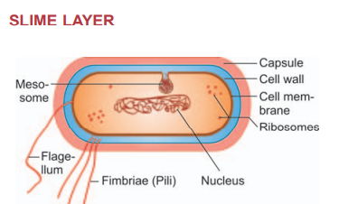
Apart from this some bacteria carry filamentous appendages protruding from cell surface; the flagella, organ of locomotion and the fimbriae which seem to be organ of adhesion. The important structural features of bacterial cell as found under electron microscope are described below

CAPSULE
It is the gelatinous secretion of bacteria which gets organized as a thick coat around cell wall and is known as capsule. Capsulated bacteria are usually nonmotile as flagella remains unfunctional in the presence of capsule. Development of capsule is dependent on the existence of favorable environmental conditions such as presence of high sugar concentration, blood serum or growth in a living host. The capsules which are thinner than true capsules are called microcapsule, e.g. Meningococci, Streptococcus pyogenes and Haemophilus influenzae. It may be composed of complex polysaccharide (pneumococci and klebsiella) or polypeptide (Bacillus anthracis) or hyaluronic acid (Streptococcus pyogenes). Capsules have no affinity for dyes and so they are not seen in stained preparations.
Functions
1. Protection against deleterious agents, e.g. lytic enzymes.
2. Contribute to the virulence of pathogenic bacteria by inhibiting phagocytosis.
CELL WALL
Cell wall is elastic and porous and is freely permeable to solute molecules of less than 10,000 molecular weight. The mucopeptide component of cell wall possesses target site for antibiotics lysozymes and bacteriophages. The cell wall is the outermost supporting layer which protects the internal structure. It is about 10 to 25 nm in thickness and shares 20 to 30 percent of dry weight of the cells.
Cell wall is composed of mucopeptide (muerin), scaffolding formed by N. acetyl glucosamine and acetyl muramic acid molecules alternating in chain cross-linked by peptide chain. Cell wall antigens of Gram negative organisms act as endotoxin.
A comparison of cell walls of Gram positive and Gram negative bacteria is-
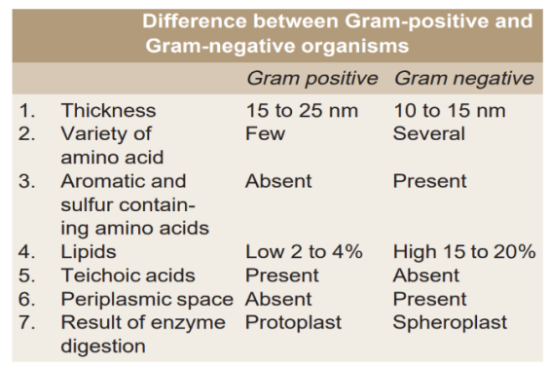
Gram-negative cell wall: It is a complex structure -
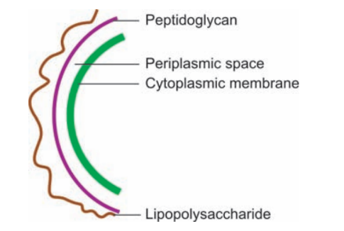
i. Lipoprotein layer which connects outer membrane to peptidoglycan. ii. Outer membrane is a phospholipid bilayer containing specific proteins. These specific proteins form porins and hydrophilic molecules are transported through these porins. Other proteins are target sites for phages, antibiotics and bacteriocins.
iii. Lipopolysaccharide consists of a complex lipid, called lipid A, to which is attached a polysaccharide. Lipopolysaccharide is the endotoxin of Gram negative bacteria—The toxicity is associated with lipid portion (lipid A) and the polysaccharide represents a major surface antigen, the O antigen. The polysaccharide consists of a core and a terminal series of repeat units. These terminal repeat units confer antigenic specificity to the bacterium.
iv. The periplasmic space is the space in between the inner and outer membranes and contain a number of important proteins (such as enzymes and binding proteins for specific substrates) and oligosaccharides (which play an important role in osmoregulation of the cells).
Gram-positive cell wall
- The peptidoglycan layer of Gram positive bacteria is much thicker (15 to 25 nm) than that in Gram negative (10 to 15 nm). The periplasmic space is absent and the peptidoglycan is closely associated with cytoplasmic membrane.
ii. Specific components of Gram positive cell wall include significant amount of teichoic and teichuronic acids which are soluble polymer containing ribotol or glycerol polymers and maintain a level of divalent cations outside cell membrane. The teichoic acids constitute major surface antigens of Gram positive bacteria.
iii. Other components of Gram positive cell wall contain antigens such as the polysaccharide and protein.
Functions
1. Protection of internal structure (supporting layer).
2. Gives shape to the cell.
3. Confers rigidity and ductility (mucopeptide).
4. Role in division of bacteria.
5. Offers resistance to harmful effect of environment.
6. Contains receptor sites for phages and colicin.
7. Provides attachment to complement.
CYTOPLASMIC MEMBRANE
It is thin semipermeable membrane which lies just beneath the cell wall. The whole bacterial cytoplasm is bound peripherally by a very thin, elastic and semipermeable cytoplasmic membrane also known as cell membrane. It is 5 to 10 nm in width. Electron microscope shows the presence of three layers constituting a unit membrane structure. Chemically the membrane consists of phospholipid with small amount of protein. Sterol is absent except in mycoplasma.
Functions
1. It controls inflow and outflow of metabolites to and from protoplast.
2. Presence in the membrane of specific enzyme. which plays important role in passage through membrane of selective nutrients.
3. The cytoplasmic membrane contains some other enzymes, e.g. respiratory enzymes and pigments.
4. It provides little mechanical strength to bacterial cell.
5. It helps DNA replication
CYTOPLASM
The bacterial cytoplasm is suspension of organic and inorganic solutes in viscous watery solution. It does not exhibit protoplasmic streaming (internal mobility) and it lacks endoplasmic reticulum or mitochondria. It contains ribosomes, mesosomes, inclusions and vacuoles.
Ribosomes: Ribosomes appear as small granules and pack the whole cytoplasm. These are strung together on strands of mRNA to form polymers. The code of mRNA is translated into peptide sequence at this place. The ribosomal particles become linked up and travel along the mRNA strand. It determines the sequence of amino acids brought to the site on tRNA molecule and build up the polypeptide. Ribonucleoprotein granules measure 10 to 20 nm units in diameter and their sedimentation coefficient is 70 svedberg units. The 70s ribosome is composed of two smaller units of 50s and 30s. Functions: They are the sites of protein synthesis.
Polysomes: They are groups of ribosomes linked together like beads of chain by messenger RNA.
Mesosomes: They are vesicular, convoluted or multilaminated structures formed as invaginations of plasma membrane in the cytoplasm. They are prominent in Gram positive bacteria.
Functions
1. They are the sites of respiratory enzymes in bacteria.
2. Coordinate nuclear and cytoplasmic division during binary fission.
3. Responsible for compartmenting DNA at sporulation.

NUCLEUS- It is a long filament of DNA tightly coiled inside the cytoplasm. The bacterial nucleus is not surrounded by nuclear membrane and is Feulgen positive. It is an ill-defined homogenous pale area of cytoplasm. The nuclear DNA does not appear to contain some basic protein. It does not have nucleolus. Nucleus cannot be demonstrated under direct light microscope. It appears as oval or elongated body, generally one per cell.
FLAGELLA- These are long, sinnous contractile filamentous appendages known as flagella. These are organs of locomotion, e.g. Escherichia coli, salmonella, vibrio, pseudomonas, etc. The number of flagella varies up to 10 to 20 per cells according to species of bacteria. Escherichia coli has a motility of about 30 µ and that of Vibrio cholerae about 60 µ per second. These are extremely thin 12 to 30 nm, helical shaped structure of uniform diameter throughout their length. These are 3 to 20 µ long. Each flagellum consists of hook and basal body. It originates in a spherical body (basal granule) located just inside cell wall. These are antigenic and are composed of protein called flagellin which has properties of fibrous protein, keratin and myosin. Around 40 gene products are involved in its assembly and function.
The number and arrangement of flagella are characteristic of each bacteria. Flagella may be arranged on bacterial body in following manner
Monotrichate: One flagellum at one end of the organism, e.g. vibrio, pseudomonas, spirillum, etc. Amphitrichate: One flagellum at both poles, e.g. Alcaligenes fecales.
Lophotrichate: A tuft of flagella at the end, e.g. pseudomonas.
Peritrichate: Several flagella present all over the surface of bacteria, e.g. Escherichia coli, salmonella.
Function: It is responsible for bacterial motility. Motility may be observed microscopically (hanging drop preparation) or by detecting the spreading growth in semi solid agar medium.
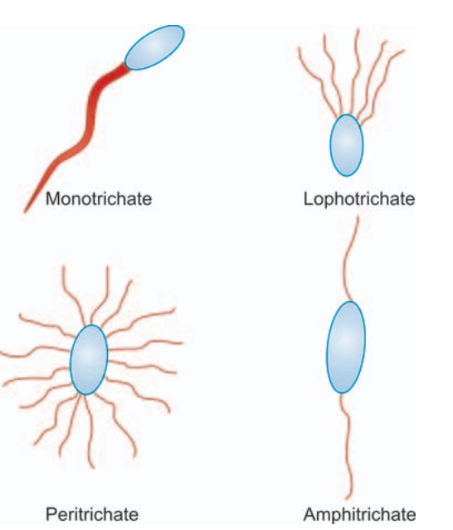
FIMBRIAE
Fimbriae (fringes) are filamentous, short, thin, straight, hair-like appendage 0.1 to 1.5 µ long and less than 4 to 8 nm thick. They are also called pili (hair). Fimbriae are seen only in some Gram negative bacteria. Each bacterium may have 100 to 500 fimbriae peritrichously all over the body of bacteria. They project from cell surface, as straight filaments. They are best developed in freshly isolated strains and in liquid culture. They tend to disappear following subcultures on solid media. Fimbriae are composed of protein known as pillin.
Functions
Organ of adhesion.
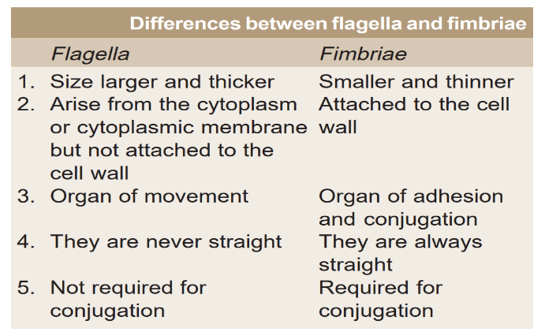
SPORES
They are highly resistant dormant state of bacteria found in certain genera, e.g. bacillus, clostridium, sporosarcina (Gram positive coccus) and Coxiella burnetii. They are not destroyed by ordinary methods of boiling for several hours. They are killed when autoclaved at 15 lb pressure per square inch at 121°C for 20 minutes. The spores are characterized by the presence of 5 to 20 percent dipicolinic acid which is not found in vegetative cell and by their high calcium content. The resistance to destruction by physical or chemical method is ascribed to factors like impermeability of spores, cortex and coat, low contents of water, low metabolic activity, low enzymatic activity and high contents of calcium and dipicolinic acid. Spores of different species of bacteria are antigenically distinguishable. Spores are highly refractile and require special staining for demonstration, e.g.
(1) Modified ZiehlNeelsen method,
(2) Gram stain,
Function: They make survival of certain organisms possible under unfavorable condition like dry state. Spores are resistant to heat, drying, freezing and toxic chemicals. Laboratory application: Can be used as sterilization control i. Bacillus stearothermophilus is killed at 121°C in 15 to 30 minutes. ii. Bacillus subtilus may be destroyed at 105°C in 5 minutes.

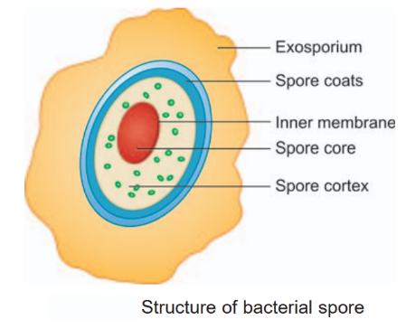
Formation of Spores
Exact stimulus for sporulation is not known. Perhaps it is related to depletions of exogenous nutrient. Sporulation involves the production of many new structures, enzymes and metabolites along with the disappearance of many vegetative cell components.
During the process of sporulation, some bacteria may release peptide antibiotics which may play a role in regulating sporogenesis.
Sporulation is initiated by appearance of clear area near one end of cell which gradually becomes more opaque to form forespore. The fully developed spore has its core nuclear body surrounded by spore wall, a delicate membrane (future cell wall). Outside this is spore cortex which in turn is enclosed by multilayered spore coat. Spore cortex contains an unusual type of peptidoglycon sensitive to lysozyme.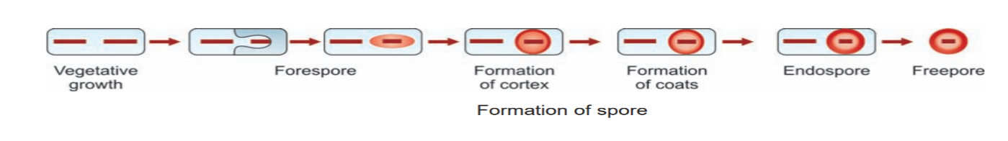
Spore forming bacteria:
Gram positive bacilli
1. Obligatory aerobic Bacillus anthracis Bacillus subtilis
2. Obligatory anaerobic Clostridium tetani Clostridium perfringens Clostridium botulinum
3. Other bacteria Gram positive coccus—Spore sarcina Gram negative bacillus—Coxiella burnetii
Study of Morphology of Bacteria
It is of considerable importance that identification of bacteria be made. For this purpose, following methods are employed:
Optical Methods
a. Light microscopy is useful for the motility, size, shape and arrangement of bacteria. Due to lack of contrast, details cannot be appreciated.
b. Phase contrast microscopy makes evident structure within cells that differs in thickness and refractive index. In the phase contrast microscope “phase” differences are converted into differences in intensity of light producing light and dark contrast in the image.
c. Dark ground microscopy in which reflected light is used instead of direct transmitted light used in ordinary microscope. With its help extremely thin slender organism like spirochaetes can clearly be seen.
d. Oil immersion microscopy in which magnification produced by oil immersion objective of light microscope makes visible majority of bacteria.
e. Fluorescence microscope in which bacteria are stained with auramine dye or rhodamine dye. Dye changes the wavelength of bacteria stained with above dye and become visible as shining objects against a dark background. Here ultraviolet light is used as a source of light
f. Electron microscope where beams of electron is used instead of beams of light used in optical microscope. The electron beam is focussed by circular electromagnets, analogous to the lenses in light microscope. The object which is kept on path of beam scatters the electrons and produces an image which is focussed on fluorescent viewing screen. Resolving power of electron microscope is 0.1 nm. Scanning electron microscope is a recent development and provides a 3 dimensional image of the surface of the object.
Other types of microscope available are scanning electron microscope, X-ray, dissecting microscope, laser microscope (vaporize minute part of tissue in vivo or in vitro or biopsy specimen which is then subjected to emission spectrography) and operation microscope for conducting delicate surgical operations.
STAINING OF BACTERIA
The bacterial nucleic acid contains negatively charged phosphate group which combines with positively charged basic dye. Acidic dye does not stain bacterial cells and are used to stain background material.
Most commonly used stains to study bacterial morphology are as under:
GRAM’S STAIN
First described by Gram in 1884. It is used to study morphologic appearance of bacteria. Gram’s stain differentiates all bacteria into two distinct groups: a. Gram positive organisms. b. Gram negative organisms.
Principle: Some organisms are not decolorized and retain color of basic stain, e.g. gentian violet (Gram positive organisms) while the others lose all gentian violet when treated with decolorizing agent and take up the counter stain, e.g. safranin (Gram negative organisms).
Procedure: Bacterial suspension is spread in the form of thin films on the surface of clean glass slide and allowed to dry in air. It is called smear. Smear is fixed by passing the slide over the flame two or three times. Now proceed as follows:
1. Cover the slide with gentian violet for 1 to 2 minutes.
2. Wash the smear with Gram’s iodine and keep Gram’s iodine on the slide for 1 to 2 minutes.
3. Decolorize the slide with acetone or alcohol carefully and immediately wash the smear with water.
4. Counter stain with 0.5 percent aqueous safranin for 1 to 2 minutes.
5. Finally wash the smear, allow it to dry in air and put a drop of oil and see under oil immersion lens.

ALBERT STAIN
Some bacteria may have metachromatic black granules, e.g. Corynebacterium diphtheriae which stain dark bluish or black with methylene blue or a mixture of taludine blue and malachite green.
Procedure: Heat fixed smear is covered with Albert stain I. After 5 to 7 minutes it is replaced by iodine solution (Albert stain II) and is kept there for 5 minutes. Smear is washed with water and studied under oil immersion lens. The body of bacilli look green while granules take bluish-black color.
ZIEHL-NEELSEN STAIN This is also called acid-fast stain. Principle: Some organisms retain carbol fuchsin even when decolorized with acid. Such organisms are called acid fast organism. However, mycolic acid is thought to be responsible for acid fastness.
Procedure: Take heat fixed smear and add concentrated carbol fuchsin. Now gently heat it till steam comes out. Do not allow the stain to boil or dry. Keep it up for 8 to 10 minutes. Now decolorize the smear with 3 percent solution of hydrochloric acid in 95 percent ethyl alcohol or 20 percent aqueous sulfuric acid. Now wash the slide with water and counter stain it with methylene blue or melachite green. Acid fast organisms take red stain.
Acid-fast organisms are: Mycobacteria (tubercle bacilli, leprabacilli).
OTHER STAINING
Spores are resistant to ordinary method of staining. In Gram stain spores appear as clear areas in deeply stained body of bacilli.
Methods of spore staining are:
Modified acid-fast stains:
Treat the heat fixed smear with steaming carbol fuchsin for 3 to 6 minutes. Decolorize with 0.5 percent sulfuric acid or 2 percent nitric acid in absolute alcohol. Wash and counter stain with 1 percent aq. methylene blue. Wash with water and study it under oil immersion lens. Spores are stained bright red and vegetative part of bacilli blue.
India ink method:
Emulsify small amount of culture in a loopful of India ink on a slide and cover it with coverslip. Capsule is seen as clear halo between refractile outline of cell wall and greyish background of India ink. It is the best and rapid method of capsule demonstration.
Bacterial Nutritional
Bacteria may require adequate nutrition, optimum pH, temperature and oxygen for multiplication and growth. Bacteria can be classified into following types on the basis of nutritional requirement:
I. On the basis of energy sources:
a. Phototrophics which get energy from photochemical reaction.
b. Chemotrophics which get energy from chemical reaction.
II. On the basis of their ability to synthesize essential metabolites.
a. Autotrophic: These are the organisms in which all essential metabolites are synthesized from inorganic sources. They use carbon dioxide as the main source of carbon and simple inorganic salts, e.g. nitrates, nitrites, ammonium sulfate, phosphates, etc. to form new protoplasm of the cell.
b. Heterotrophic: Here some of the essential metabolites are not synthesized. Organic compounds, e.g. protein, peptones, amino acids, vitamins and growth factors are supplied from outside. Most of the bacteria producing disease in man are heterotrophic.
GROWTH REQUIREMENTS
Nutritional Requirements
.1. Essential elements The essential elements required for synthesis of bacterial structural components (carbohydrate, lipid, protein nucleic acid) are hydrogen, carbon and nitrogen. Of course phosphorous and sulfur are also required for bacterial growth.
Hydrogen and oxygen are made available from water added to culture medium. Heterotrophic bacteria require organic carbon for growth in a suitable form and can be assimilated by the bacteria. Carbohydrate is principal source of carbon which is degraded by the bacteria either by oxidation or by fermentation. Thus providing energy in the form of adenosine triphosphate.
Nitrogen is a major component of protein and nucleic acids and its main source is ammonia usually in the form of ammonium salt. The ammonium salt is made available either from environment or it may be produced by deamination of amino acids by bacteria.
2. Mineral salts They are potassium, calcium, magnesium, iron, copper, manganese, molybdenum and zinc required in traces for enzyme function and can be provided in tap water or as contaminant of other medium ingredients.
3. Growth factor These may be essential for some who do not grow in their absence. Following a gene mutation of bacterium, there results in failure of one of the enzymes to synthesize amino acids or purines or pyrimidines from simpler compounds. In such case exogenous supply of relevant factor is required called accessory growth factors.
The other nutritional requirements are-
Gas Requirements
- Oxygen: The capacity of bacteria to grow in the presence of oxygen and to utilize it depends on possession of a cytochrome oxidase system.
Aerobes: The aerobe organisms grow only in the presence of oxygen, e.g. pseudomonadaceae, bacillus, nitrobacter, sarcina, etc. They require oxygen as hydrogen acceptor.
Facultative anaerobes: They are the organisms that can live with or without oxygen, e.g. vibrio, Escherichia coli, Salmonella, Shigella and Staphylococcus. The microaerophilic organisms grow well with relatively small quantities of oxygen, e.g. Hemophilus.
Obligate anaerobes: The strict anaerobes multiply only in the absence of oxygen, e.g. Bacteroides, Clostridium. They require a substance other than oxygen as hydrogen acceptor.
- Carbon dioxide: The metabolic activities of some organisms like Neisseria gonorrhoeae, Brucella abortus are greatly enhanced by the presence of extra-amount of carbon dioxide (capnophilic bacteria) in atmospheric air.
- Moisture Bacteria require water for their growth. Desiccation may kill most of bacteria.
Bacterial growth in vivo depends upon:
• Availability of nutrition with human body
• Generation time of bacteria
• Cellular and humoral defence of host, i.e. human body
• pH
GROWTH CURVE
When organisms are cultured in appropriate fluid media, there would be increase in the size of bacteria without any multiplication for some time (lag phase). This is followed by multiplication and increase in number of bacteria to the extent that media look turbid to the naked eye (log phase). After some time growth rate becomes stationary and later on declines. Counting of bacteria at different periods after inoculation and then events of sequences are represented on a graph which is called growth curve .

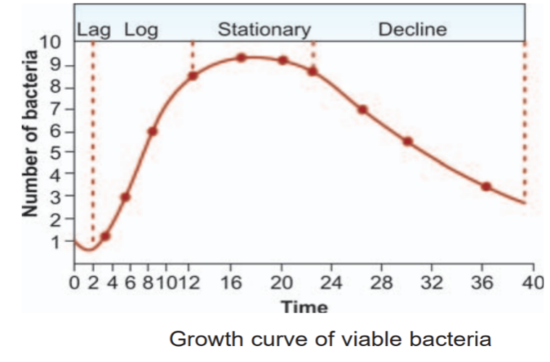
1. Lag Phase
It has short duration and during this phase there occurs:
1. Increase in size of cell.
2. Increase in metabolic rate.
3. Adaptation to new environment and necessary enzymes plus intermediate metabolites are built up for multiplication to proceed.
The length of lag phase depends upon:
a. Type of bacteria.
b. Better the medium, shorter the lag phase.
c. The phase of culture from which inoculation is taken.
d. Size of inoculum.
e. Environmental factors like temperature.
2. Log Phase
Following lag phase the cells start dividing and their number increase by geometric progression with time. Logarithms of viable count plotting time gives straight line.
During this period:
i. Bacteria have high rate of metabolism.
ii. Bacteria develop best morphologically with typical biochemical reactions.
iii. Bacteria are more sensitive to antibiotics. Control of log phase is brought about by:
a. Nature of bacteria.
b. Temperature.
c. Rate of penetration of the medium depends on the concentration of material in the medium.
3. Stationary Phase
After some time (few hours to few days) a stage comes when rate of multiplication and death becomes almost equal. It may be due to:
a. Depletion of nutrient.
b. Accumulation of toxic products. Sporulation may occur during this stage.
4. Decline Phase
During this phase (few hours to few days) population decreases due to death of cells.
Factors responsible for this phase are:
- Nutritional exhaustion.
- Toxic accumulation.
- Autolytic enzymes. Involution is common in phase of decline.
Survival Phase
When most organisms have died, a few survive for several months or years
Factors Influencing Growth
1. Temperature: The temperature range at which an organism grows best is called optimum temperature. In human parasitic organisms, optimum temperature ranges between 30° and 37°C. There are three groups of bacteria related to regards the temperature of growth.
a. Psychrophilic: These are the organisms growing between 0° and 25°C. They are mostly soil and water bacteria.
b. Mesophilic: They grow between 20° and 44°C. This group includes bacteria producing disease.
c. Thermophilic: Some organisms grow between 50° and 60°C, e.g. bacillus and algae. The upper range of temperature tolerated by them correlates well with the thermal stability of the species protein as measured in cell extract.
2. Hydrogen ion concentration: Most of pathogenic bacteria grow best at pH 7.2 to 7.6. However, Lactobacillus and Thiobacillus thiooxidans grow at acidic pH while Vibrio cholerae, Alcaligenes fecalis grow at alkaline pH.
3. Moisture: Water is quite essential for the growth of bacteria. Organism like Neisseria gonorrhoeae and Treponema pallidum die almost at once on drying. However, Mycobacterium tuberculosis and Staphylococcus aureus survive for quite a long time even on drying.
4. Osmotic pressure: Bacteria are usually resistant to changes of osmotic pressure. However, 0.5 percent sodium chloride is added to almost all culture media to make environment isotonic.
5. Light: Darkness is usually favorable for the growth and viability of all the organisms. Direct light exposure shortens the survival of bacteria. Photochromogenic mycobacteria form pigment on exposure to light. Organisms are sensitive to ultraviolet and other radiations.
BACTERIAL COUNT
1. Total bacterial count includes living as well as dead bacteria. It can be obtained by following methods:
a. Direct counting under microscope using counting chamber.
b. Counting may be in an electronic device called Coulter counter.
c. Direct counting using stained smears prepared by spreading known volume of culture over measured area of a slide.
2. The viable count measures number of living organism. It can be obtained in the manner described ahead.
Media for Bacterial Growth
Culture media gives artificial environment simulating natural conditions necessary for growth of bacteria. The basic requirement of culture media are:
1. Energy source.
2. Carbon source.
3. Nitrogen source.
4. Salts like sulphates, phosphates, chlorides and carbonates of sodium, potassium, magnesium, ferric, calcium and trace elements like copper, etc.
5. Satisfactory pH 7.2 to 7.6.
6. Adequate oxidation-reduction potential.
7. Growth factor like tryptophan for Salmonella typhi, glutathione for gonococci, X and V factors for hemophilus.
The characteristics of an ideal culture medium are:
1. Must give a satisfactory growth from single inoculum.
2. Should give rapid growth.
3. Should be easy to grow.
4. Should be reasonably cheap.
5. Should be easily reproducible.
6. Should enable to demonstrate all characteristics in which we are interested.
Types of Liquid Media Broth
It is a clear transparent straw colored fluid prepared from meat extract or peptone. Following types of broth are in common use:
a. Infusion broth: Fat free minced beef meat is added to water and kept in refrigerator overnight. Fluid obtained after removal of meat is boiled for 18 minutes. To it peptone and 0.5 percent sodium chloride is added.
b. Meat extract broth: This is commercially available as Lab Lemco.
Peptone
It is a protein partially digested with hydrolytic enzymes like pepsin, trypsin, papain, etc. Peptones supply nitrogenous material and also act as a buffer. Several bacteria can grow in 1 percent peptone water. Constituents of peptone are proteoses, polypeptides and amino acids.
Yeast extract:
It is prepared by extracting autolyzed yeast with water. It has high contents of vitamin B.
The other examples of liquid media are sugar media (1% sugar in peptone water), glucose broth (1% glucose in nutrient broth), bile broth (0.5% bile salts in nutrient broth), Hiss serum (1 part serum and 3 parts glucose broth), liquid MacConkey, glycerol saline and enrichment media (tetrathionate and selenite).
SOLID MEDIA
They are used to study colonies of individual bacteria. They are essential for isolation of organism in pure form.
a. Agar: It is important constituent of solid media. It is complex polysaccharide obtained from seaweeds (Algae geledium species). It melts at 80 to 100°C and solidifies at 35 to 42°C. It does not provide any nutrition to the bacteria. It acts only as solidifying agent. It is not metabolized by any pathogenic bacteria.
b. Gelatin: It is protein prepared by hydrolysis of collagen with boiling water. It is in liquid form at 37°C. It forms transparent gel below 25°C. The main use of gelatin is to test the ability of bacteria to liquefy it. This feature is important in the identification and classifications of bacteria. Blackening of media indicates hydrogen sulfide production.
Classification of Media
Media have been classified in many ways:
A. (i) Solid media
(ii) Liquid media
(iii) Semisolid media.
B. (i) Simple media
(ii) Synthetic media or defined media
(iii) Complex media
(iv) Semidefined media
(v) Special media.
Special medias are further divided as under:
(i) Enriched media
(ii) Enrichment media
(iii) Selective media
(iv) Indicator and differential media
(v) Sugar media
(vi) Transport media.
C. Aerobic media and anaerobic media.
1. Simple media: It is also called basal media. It consists of meat extract, peptone, sodium chloride and water.
a. Peptone water: - It is prepared by adding 1 gram peptone, 0.5 gram sodium chloride to 100 ml of distilled water.
b. Nutrient agar: - Addition of 2 percent agar in nutrient broth constitute nutrient agar.
2. Complex media: These are ingredients for special purposes or for bringing out certain characteristics or providing special nutrient required for the growth of certain organisms.
3. Synthetic or defined media: These media are prepared solely from pure chemical substances and the exact composition of medium is known. They are used for research purposes.
4. Special media
a. Enriched media: In these media substance like blood, serum or egg is added to basal medium, e.g. blood agar, chocolate agar, egg media and Loeffler serum slope.
b. Enrichment media: Some substances are added to liquid media with the result that wanted organism grow more in number than unwanted organism. Such media are called, enrichment media, e.g. selenite F broth, tetrathionate broth.
c. Selective media: This is like enrichment media with the difference that inhibiting substance is added to solid medium, e.g. deoxycholate citrate medium which contains nutrient agar, sodium deoxycholate, sodium citrates lactose and neutral red.
d. Indicator media: The media contain an indicator which changes color when bacterium grow in them, e.g. Salmonella typhi reduces sulphite to sulphide in Wilson and Blair medium (colonies of Salmonella typhi have black and metallic sheen).
e. Differential media: A medium which has substance enabling it to bring out differing characteristic of bacteria thus helping to distinguish between them, e.g. MacConkey’s medium (peptone, lactose, agar, neutral red and tauro-cholate). It shows lactose fermenter as red colonies while nonlactose fermenter as pale colonies.
Blood agar is an enriched medium but also differentiates between hemolytic organisms and non-hemolytic organisms. So it also acts as a differential medium.
f. Sugar media: The usual sugar media consist of 1 percent sugar concerned, in peptone water along with appropriate indicator. A small tube (Durham’s tube) is kept inverted in sugar tube to detect gas production.
g. Hiss’s serum (25% serum) is used for organisms which are exacting in their growth requirement, e.g. pneumococci.
h. Transport media: Delicate organisms like gonococci which may not survive the time taken for transporting the specimen to the laboratory or may be overgrown by nonpathogen (dysentery or cholera organism) special medium is required called transport medium, e.g. Stuart medium for gonococci and glycerol saline for stool.
Anaerobic media: These media are used to grow anaerobic organisms, e.g. Robertson’s cooked meat medium.
Anaerobic indicators used is reduced methylene blue and it contains NaOH, methylenes blue, glucose.
Culture Techniques
In clinical laboratory indications for culture are:
a. Isolation of bacteria in pure culture.
b. To demonstrate their properties.
c. To obtain sufficient pure growth for preparation of antigen and for other tests.
d. For typing of bacterial isolate by method like bacteriophage and bacteriocin susceptibility.
e. To determine sensitivity to antibiotics.
f. To estimate viable count.
g. To maintain stock culture

Methods of Culture
1. Streak culture (surface plating) is the method routinely employed for the isolation of bacteria in pure culture. A platinum loop with 2½” long wire and loop with diameter 2 mm is charged with specimen to be cultured and is placed on the surface of dried plate of solid media towards peripheral area. The inoculum is spreader thinly over the plate in series of parallel lines in different segment of the plate. On incubation we may find confluent growth at the site of primary inoculum. Well-separated colonies are obtained over the final series of streaks.
2. Stab culture: It is prepared by puncturing with charged long, straight wire (4" long). Stab culture are employed mainly for demonstration of gelatine liquefactions and for maintaining stock culture.
3. Liquid culture in a tube, bottle or flask may be inoculated by touching with a charged loop. Liquid cultures are preferred when large and quick yield is required. The major disadvantage of liquid culture is that it does not provide pure culture from mixed inoculation.
Sterilization and Disinfection
The process of sterilization finds application in microbiology for prevention of contamination by extraneous organisms, in surgery for maintenance of asepsis, in food and drug manufacture for ensuring safety from contaminating organism and many other situations. Sterilization: It is a process by which articles are freed of all microorganisms both in vegetative as well spore state. Disinfection: It is a process of destruction of pathogenic organisms capable of giving rise to infection.
APPLICATION OF DISINFECTANTS
In Bacteriology
• For disposal of culture (3% Lysol)
• For preservation of sera, agar or phenol agar, vaccine, etc. In Surgical Procedures
• Washing the hand
• To prepare and clean the area of operation
• To collect the blood under aseptic precautions
• For safe disposable of excreta and surgical dressing
• Cleaning of infected wounds
• For disinfection of used instrument. In Hospitals
• To disinfect the operation theaters
• To disinfect costly equipments like endoscopes and cystoscopes etc.
• To control the spread of cross infection
• To disinfect linen and surgical dressing.
In Public Health Services
• For providing safe drinking water (e.g. chlorinated water)
• For disinfection of sewage before its disposal into the fields.
Antiseptic: It means prevention of infection by inhibiting growth of bacteria.
Bacteriocidal agents: These are those which are able to kill bacteria.
Bacteriostatic agents: Only prevent multiplication of bacteria and they may remain alive.
Mainly there are two methods of sterilization.
Physical-
1. Sunlight
2. Drying
3. Dry heat
4. Moist heat
5. Filtration
6. Radiation
7. Ultrasonic vibrations.
Chemicals –
1. Acids
2. Alkalies
3. Salts
4. Halogens
5. Oxidizing agents
6. Reducing agents
7. Formaldehyde
8. Phenol
9. Soap
10. Dyes
11. Aerosol, etc.
Physical Methods
1. Sunlight: It possesses appreciable bacteriocidal activity. The action is due to ultraviolet rays. This is one of the natural methods of sterilization in case of water in tanks, river and lakes.
2. Drying: Drying in air has deleterious effect on many bacteria. Spores are unaffected by drying. Hence it is a very unreliable method.
3. Heat: The factors influencing sterilization by heat are:
i. Nature of heat (a) dry (b) moist
ii. Temperature and time.
iii. Number of organisms present.
iv. Whether organism has sporing capacity.
v. Type of material from which organism is to be eradicated.
Dry Heat Killing by dry heat is due to:
1. Protein denaturation.
2. Oxidative damage.
3. Toxic effect of elevated levels of electrolytes.
(a) Red heat: It is used to sterilize metallic objects by holding them in flame till they are red hot, e.g. inoculating wires, needles, forceps, etc.
(b) Flaming: The article is passed over flame without allowing it to become red hot, e.g. mouth of culture tubes, cottonwool plugs and glass slides.
(c) Incineration: This is an excellent method for rapidly destroying material, e.g. soiled dressing, animals carcasses, bedding and pathological material, etc. On the negative side incinerators send toxic material like dioxin and mercurial products into the environment and cause pollution. Dioxin is released from half burnt chlorin based plastics, e.g. PVC. The source of mercury and its products may be broken thermometers, blood pressure apparatus and other diagnostic products. Mercury is known to cause irreversible poisoning. Dioxinmay cause cancer and hormone mimicking, i.e. it replaces the natural hormones and can cause serious disturbances in reproductive process.
(d) Hot air oven Sterilization by hot air oven requires temperature of 160°C for one hour. We can sterilize all glass syringes, petridishes, test tubes, flask, pipettes, cotton swabs, scalpel, scissors, liquid paraffin, dusting powder, etc.
Precautions in Use of Hot Air Oven-
1. It must be fitted with fans to ensure distribution of hot air.
2. It should not be overloaded.
3. Oven must be allowed to cool for about 2 hours before opening the doors otherwise glasswares are likely to get cracked. Sterilization Control of Hot Air Oven 1. The spores of non-toxigenous strain of Clostridium tetani are used to test dry heat efficiency. 2. Browne’s tube (green spot) is available for sterilization by dry heat. A green color is produced after 60 minutes at 160°C. 3. Thermocouples may be used.
Moist Heat
The lethal effect of moist heat is by denaturation and coagulation of protein.
Temperature below 100°C
- Pasteurization of milk: Temperature employed is either 63°C for 30 minutes (holder method) or 72°C for 15 to 20 seconds (flash method). Heating is always followed by sudden and instant cooling of milk. Organisms like mycobacterium, salmonellae and brucellae are killed. Coxiella burnetii is relatively heat resistant and hence, may survive the holder method.
- Vaccine bath : It is used for killing non-sporing bacteria which may be present in vaccine. In vaccine bath the vaccine is treated with moist heat for one hour at 60°C.
- Inspissation: The slow solidification of serum or egg is carried out at 80°C in an inspissator, e.g. serum slopes, Lowenstein-Jensen’s medium, etc.
Temperature at 100°C
- Tyndallisation: This is the process by which medium is placed at 100°C in flowing steam for 30 minutes each on 3 successive days. The mechanism underlying this method is that vegetative cells get destroyed at 100°C and remaining spore which germinate during storage interval are killed on subsequent heating. This method may be used for sterilization of egg or serum containing media.
- Boiling: Most of vegetative form of bacteria, fungi and viruses are killed at 50 to 70°C in short time. For needles and instruments boiling in water for 10 to 30 minutes is sufficient to sterilize them. Addition of little acid, alkali, or washing soda, markedly increases the sterilizing power of boiling water. Spores and hepatitis viruses are not readily destroyed by such procedure.
- Steam at atmospheric pressure (100° C): Here free steam is used to sterilize culture media which may decompose if subjected to higher temperature. A Koch or Arnold steamer is used. This is a cheap method of sterilization.
Temperature above 100°C
Steam under pressure: For bacteriological and surgical work boiling is not sufficient because spores survive boiling. Hence high pressure sterilizer or autoclave is used.
AUTOCLAVE
In this apparatus, material for sterilization is exposed to 121°C for 15 to 20 minutes at 15 lb pressure per square inch. Saturated steam heats the article to be sterilized rapidly by release of latent heat. The condensed water ensures moist conditions for killing bacteria.
Air is poor conductor of heat and must be removed from chamber. The contents must be so packed that free circulation of steam occurs. Autoclave is used for culture media, rubber goods, syringes, gowns and dressing, etc.
Types of Autoclave
1. Simple iron jacketed.
2. Low pressure/low temperature.
3. High pressure high vacuum type having facility to expel 98 percent of air rapidly by an electric pump and hence sterilization is done quickly.
Sterilization by Filtration
This is a method of sterilization useful for antibiotic solutions, sera, carbohydrate solution, etc. We may also get bacteria free filtrates of toxin and bacteriophages. It is also useful when we want to separate microorganisms which are scanty in fluid.
Other Uses of Filter
• Separation of soluble products of bacterial growth, e.g. toxins.
• Sterilization of hydatid fluid
• Sterilization of serum
• Sterilization of antibiotic solution
• Sterilization of blood products
• Purification of water.
Membrane filter: They may be comprised of cellulose esters. They can be used as under:
1. Water analysis
2. Sterility testing of solution
3. Preparation of parenteral solution.
Nitrocellulose membrane filter is commonly used. It is also called multipore. Membrane filters are available in pore sizes of 0.015 um, 0.12 um and 0.22 um. Drawback of filtration: Viruses and mycoplasma may pass through filter. Hence in filtered serum is not safe for clinical use as it may be containing viruses or mycoplasma.
Various types of filters are:
i. Earthen-ware candles, e.g. Berkefeld, Chamberland.
ii. Asbestos disk filter, e.g. Seitz.
iii. Sintered glass filters.
iv. Collodion or membranous filter.
Radiations
Ultraviolet radiations: It is chief bacteriocidal factor present in sunlight. Commonly used UV lamp is of low pressure mercury vapor type whose length is 253.7 mm.
It causes following changes in cell:
1. Denaturation of protein.
2. Damage to DNA.
3. Inhibition of DNA replication.
4. Formation of H2 O2 and organic peroxide in culture media.
5. Induction of colicin production in colicinogenic bacteria by destruction of cytoplasmic repressor.
Gram-positive bacteria show a little more resistance than Gram-negative bacteria to ultraviolet radiations. Spores are highly resistant to UV radiations.
X-rays and other ionizing radiations: Ionizing radiations have greater capacity to induce lethal changes in DNA of cell. They are useful for the sterilization of disposable material like catgut, disposable syringes, adhesive dressing, etc.
Gamma radiations X-ray are utilized using two types of mechanics. (i) Linear accelerator for X-ray (ii) Cobalt-60 for gamma rays. They are used to sterilize rubber or plastic syringes, surgical catgut, bone tissue graft, adhesive dressings, etc.
Ultrasonic and Sonic Vibrations They are bacteriocidal causing mechanical agitation and rupture of bacteria.
Chemical Methods
The chemical substances act as bacteriocidal agent as under:
a. Coagulation of bacterial protoplasm, e.g. heavy metals.
b. Disruption of cell membrane by chemical substances. They may alter physical and chemical property of cell membrane thus results in killing or inhibiting the bacterial cell growth.
c. Oxidation or burning out the bacterial protoplasm, e.g. halogens.
d. By affecting bacterial enzymes or coenzyme system thus causing interference of bacterial metabolism.
Following chemicals are of common use:
1. Acids and alkalies: They are inhibitory to the growth of bacteria. Mycobacteria are more resistant to acid than alkalies. Boric acid is weak antiseptic.
2. Distilled water: It causes loss of viability. This action may be due to traces of metal in distilled water.
3. Metallic ions: HgCl2 and AgNO3 prevent the growth of many bacteria in concentration less than 1 part per million. This action is due to affinity of certain protein for metallic ions.
4. Inorganic anion: They are much less toxic to bacteria. Potassium tellurite is inhibitory to gram-negative bacteria. Fluoride inhibits many enzymes of bacteria.
5. Halogens: Halogen derive their name from Greek word “halos” meaning salt. Hence, halogen means salt former. Three of the halogens, i.e. chlorine, iodine and bromine are among the best bacteriocidal agents. They act mainly by forming protein halogen (salt like) compounds in living cells and they get killed quickly. Because of both toxicity and high cost bromine is not used. Halogens kill vegetative bacteria, fungi, viruses but not tubercle bacillus or bacterial spores. Iodine is used chiefly for skin. Chlorine combines with water to form hydrochloric acid which is bacteriocidal.
6. Oxidizing agents: They are weak antiseptic, e.g. H2 O2 , potassium permanganate.
7. Formaldehyde: It is useful in sterilizing bacterial vaccine and in inactivating bacterial toxin without affecting their antigenicity. 5 to 10 percent solution in water kills many bacteria. It is bacteriocidal, sporicidal and lethal to viruses also.
Uses:
1. Disinfection of woolen blankets, wool hides to destroy bacterial spores.
2. Footwear of person with fungal infection (atheletic foot).
3. Wards and operation theater.
Fumigation: For sterilization of 100 cubic feet of air space in a room, 50 ml of 40 percent formalin is required. This gives vapor of 2 mg gas per liter of air. Formalin with sufficient water is heated in the room with its windows and doors closed and sealed. Articles and rooms are exposed to fumes for 4 hours. Alternatively, diluted formalin (50%) can be sprayed which also liberates formaldehyde gas. Ideally, humidity of air of room should be attained upto 60 percent to increase the sterilization power.
8. Phenol: It is used for sterilizing surgical instruments, and for killing culture accidentally split over in the laboratory. It is generally used in 3 percent solution.
9. Soap and detergents: They are bacteriocidal and bacteriostatic for gram-positive and some acid fast organisms. Detergent acts by concentrating at cell membrane and thus disrupting its normal function or it may denaturate protein and enzyme.
10. Alcohol: Ethyl alcohol is most effective in 70 percent solution than 100 percent alcohol. It is so because 70 percent alcohol has better penetration power than 100 percent alcohol. It does not kill spores.
11. Dyes: Gentian violet and malachite green, etc. are active against Gram-positive bacteria. They have poor penetration and hence action is bacteriostatic. Acriflavin is bacteriostatic for staphylococcus in 1:3000,000 concentration.
12. Aerosols and gaseous disinfectant: SO2, chlorine and formalin vapors have been used as gaseous disinfectant. Propylene glycol is powerful disinfectant.
13. Vapor phase disinfectants: Examples of vapor phase disinfectant are ethylene oxide and formaldehyde. Ethylene oxide can kill all kinds of microbes (Spores and tubercle bacilli). It is useful to sterilize material likely to be damaged by heat, e.g. plastics and rubber items, drugs powder, heart lung machine, etc.
Hydrogen peroxide vapors: These vapors are oxidizing by nature and so they are effective sterilants. They may be used to sterilize instruments. Hydrogen peroxide is vaporized producing reactive free radicals either with microwave frequency or radiofrequency energy. There are many variations of hydrogen peroxide vapor or gas sterilization available, e.g. plasma gas sterilization, 100s sterilizer, etc. It is felt that in near future ethylene oxide may be replaced by above mentioned methods. Other sterilant gases are chlorine dioxide, paracetic acid, glutaraldehyde, etc.
Uses of Disinfectant
In practice disinfectant is useful and necessary for:
1. Contaminated disposable material before incineration
2. Surfaces like table and trolley top.
3. Cleaning material when contaminated material has been split.
4. Disinfection of instruments, not amenable to heat.
5. Disinfection of skin
Biomedical Waste Management
Hospital and laboratory waste includes all waste biological as well as non biological which is discarded and unlikely to reuse it in the hospital in future. Mainly hospital waste is of two following types:
Infectious waste: This type of waste of the hospital is harmful and may cause infectious diseases. In fact this type of waste may be microbiological waste, blood, body fluids, contaminated laboratory waste, sharps, pathological waste, soiled dressing, cotton plasters contaminated with blood or body fluids, cotton plugs, etc. Infectious waste is about 10 to 15% of total hospital waste.
Non-infectious waste: It is the waste of the hospital that is non infectious. It comprises of 80 to 85% of total hospital waste. This category of hospital waste does not cause any harm. Since we are facing diseases like AIDS, Hepatitis B, etc.
It is necessary to follow universal precautions which are as under:
1. Consider all patients and clinical specimens potentially infectious especially for AIDS, Hepatitis B, etc.
2. All specimens especially blood must be dispensed in leak proof impervious bags for transportation.
3. Use of gloves, face mask with glasses while handling blood or fluid specimens.
4. Wear proper laboratory coats while working in the laboratory.
5. Pipetting by mouth must not be done.
6. Decontaminate the laboratory working surface with decontaminant after completion of laboratory procedures.
7. In case of spillage of blood or other specimen treat the surface with appropriate disinfectant.
8. Biological safety hood must be used for laboratory procedures.
9. All potentially contaminated material should be decontaminated before disposal or reuse.
10. Remove all protective wearing/clothing before leaving the laboratory or attending the patients in operation theatre or OPD.
INFECTIOUS WASTE OF HOSPITAL AND LABORATORY
1. Microbiology waste
2. Blood and body fluids
3. Used sharps
4. Pathological waste, i.e. samples and tissues
5. Bandages and cotton swabs
6. Animal carcasses
7. Beddings.
INFECTIOUS MICROORGANISMS ASSOCIATED WITH HOSPITAL OR LABORATORY
1. HIV
2. Hepatitis B
3. Brucella
4. Mycobacterium tuberculosis
5 Bacillus anthracis
6. Francisella tularensis
7. Shigella
8. Salmonella
9. Coccidiodes immitis
SEGREGATION OF HOSPITAL WASTE
Hospital waste is segregated and disposed of as under:
1. Yellow plastic bags and containers with human anatomical and pathological waste are directly dispatched for deep burial or incineration.
2. Red plastic bags and containers having infectious waste material are quickly sent for sterilization by autoclavation. Thereafter they are disposed of by land filling.
3. Blue plastic bags and containers with plastic and rubber disposable material are first of all cut into small pieces to prevent reuse followed by treatment with sodium hypochlorite solution. Now they are autoclaved and disposed of by land filling or burial. If feasible treated material as mentioned above may be transported to reputed plastic industry for further reuse. By no means should it be allowed to incinerate or burn as they contain halogenated polyvinyl chloride. It emits dioxin gas into the air which is highly carcinogenic.
4. Blue or white transparent puncture proof containers need a little different treatment before disposal. Sharps must be destroyed, disinfected with 1% sodium hypochlorite solution and then finally disposed of in sharp pit that is covered and protected and not accessed to rag pieces for reutilization. However, non-infectious waste can be collected in any appropriate container and dispatched to municipal garbage bins.
TECHNIQUES FOR WASTE TREATMENT
Chemical Method to Dispose of Hospital Waste Formaldehyde 6 to 8%, glutaraldehyde, hydrogen peroxide 6 to 30% or sodium hypochlorite 0.1% are in common use.
Incinerator
Advantages
• Ensures complete and safe disposal of waste.
• Volume of waste is reduced considerably.
Disadvantages
1. Sharps cannot be disposed of.
2. Not suitable at all for PVC plastic material because of possible emission of harmful gases.
3. It is quite expensive to operate and maintain.
Autoclave
Uses
1. Microbiological and pathological waste
2. Blood and its products
3. Sharps
4. Plastic waste
5. Body fluids.
Advantages
1. Quite economical
2. Easy to operate
3. Waste is transformed into non-infectious form
4. Waste is disinfected without hazardous emission.
Disadvantage In fact there is no reduction of volume of waste at all.
Microwaving
Uses
1. In real sense it involves the use of radiations produced by microwave to break down molecular chemical bonds and as a result disinfect waste.
2. This process may require preceding the waste and injecting it with steam treatment chamber. Thus, they evenly heat it for 25 minutes at 97°C to 100°C under series of microwave units (radiation spectrum between frequencies of 300 to 300,000 MHz).
Advantage It disinfects waste without any harmful emission.
Disadvantages As it requires pre-treatment of shredding of the waste, it is full of risks for infectious waste. Further, it cannot be used for cytotoxic hazardous and radioactive waste.
Hydroclaving
Advantages
1. It is used to dispose of microbiological and pathological waste, sharps, etc.
2. No pre-treatment is needed.
3. Perfect fragmentation and dehydration is done.
4. It is ideal for infectious waste.
5. Volume as well as weight reduction makes its transportation and land filling easy and less expensive.
6. There is no emission of toxic gases etc. It is quite simple, cheap to operate and maintain. There is hardly any disadvantage of hydroclaving.
Plasma Technology
It allows a complete and satisfactory destruction of waste.
Advantages
1. It does transformation of all hydro carbonated products into combustible gases without leaving behind any solid remnant.
2. Here there is no need of segregation of waste.
DISPOSAL OF HOSPITAL AND LABORATORY WASTE
1. Land filling
2. Burial
3. Sewage draining
Infectious hospital and laboratory material after treatment may be disposed of by land filling or deep burial. Waste in fluid form can be discarded in sewage drains. Apart of this treatment incineration is also a vital method of disposal.

Fundamental Principle of Clinical Specimen

Collection

Introduction of Clinical Specimen Collection
- The laboratory can make accurate and useful determinations only if a specimen has been collected properly.
- The specimens to be analyzed are likely to contain living organisms; the goal of the specimen collector must be to maintain the viability of these organisms with minimal contamination.

Specimen Collection
The following basic principles of specimen collection are fundamental to ensuring appropriate specimen management:
- If possible, collect the specimen in the acute phase of the infection and before antibiotics are administered.
- Select the correct anatomic site for collection of the specimen.
- Collect the specimen using the proper technique and supplies with minimal contamination from normal biota (normal flora).
- Collect the appropriate quantity of specimen.
- Package the specimen in a container or transport medium designed to maintain the viability of the organisms and avoid hazards that result from leakage.
- Label the specimen accurately with the specific anatomic site and the patient information patient’s name and a unique identification number.
- Transport the specimen to the laboratory promptly or make provisions to store the specimen in an environment that will not degrade the suspected organism(s).
- Notify the laboratory in advance if unusual pathogens or agents of bioterrorism are suspected.

Collection of Clinical Specimen Procedures
- Specimens for microbiology cultures should be collected in sterile containers except for stool specimens, which can be collected in clean, leak proof containers.
- Generally, swabs are not recommended for collection because they do not provide sufficient quantity, are easily contaminated, and can become dried out leading to a loss of organisms.
- Swabs are appropriate for specimens from the upper respiratory tract, external ear, eye, and genital tract.
- The tips of swabs may contain cotton, Dacron, or calcium alginate. Cotton-tipped swabs tend to have excessive fatty acids, which may be toxic to certain bacteria.
- Dacron or polyester swabs have a wide range of uses.
- Swab collection systems are available that provide transport media and protect the specimen from drying.
- Lesions, wounds, and abscesses present many problems to the microbiology laboratory.
- The term wound is not an appropriate specimen label, and the exact anatomic site must be provided.
- The specimen is collected from the advancing margin of the lesion and should be collected by needle aspiration rather than by swab.
- Before the specimen is collected, the area should be cleansed to eliminate as much of the commensal flora as possible.
- Aspirated material should be placed into a sterile tube or transport vial and not “squirted” onto a swab.

Patient-Collected Specimens
- In certain situations, patients are asked to collect the specimen themselves.
- Medical personnel should provide patients with thorough instructions on how to collect the sample.
- It should not be assumed that the patient knows how to collect a particular type of specimen.
- Attaching printed instructions in multiple languages to a collection device does not ensure that patients will read them or understand them.
- The most effective method is to provide verbal and written instructions.
- It may be necessary to read the instructions to the patient.
- The instructions should be written using simple language and pictures to help the patient understand the procedure as it is verbally explained.

The specimens commonly obtained by the patient are urine, sputum, and stool:

Urine collection
- Instructions for urine collection must include an explanation of the clean-catch midstream urine specimen.
- A first morning specimen is preferred because it provides a more concentrated sample.
- The patient collects this specimen following cleansing of the external genitalia to reduce the presence of indigenous flora.
- Patients are asked to void without collecting the first portion of the urine flow and instead to collect the middle portion.
- The first portion of the urine flow washes contaminants from the urethra, and the midstream portion is more representative of the urine in the bladder.
- Personnel who collect catheterized specimens should also use this technique to eliminate organisms carried up the urethra during catheterization.

Sputum collection
- Sputum specimens are often collected for the diagnosis of bacterial pneumonia.
- Lower respiratory tract specimens are among the most difficult specimens to collect adequately because they are contaminated with oropharyngeal flora.
- For this reason, they are one of the least clinically relevant specimens received for culture.
- Other specimens, such as blood or a Broncho alveolar lavage (BAL), may be more accurate in detecting the etiologic agent (i.e., the microorganism causing the disease).
- Collection of a quality sputum sample requires thorough patient education and medical personnel oversight of the process.
- The first early morning specimen is preferred.
- The patient needs to understand the difference between sputum, saliva, and nasal secretions.
- The patient should rinse the mouth with water and expectorate with the aid of a deep cough directly into a sterile container (expectorated sputum).
- Patients with dentures should remove the dentures first.
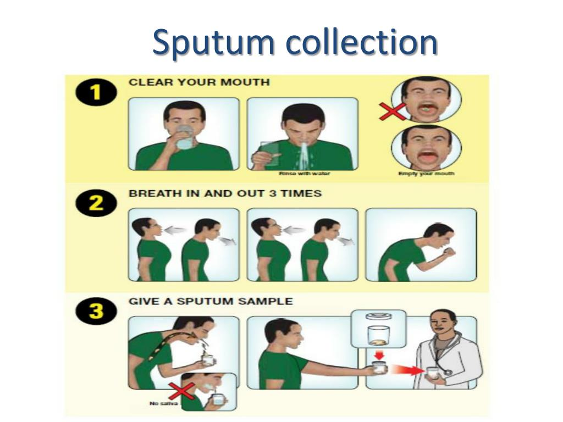
- A single specimen should be adequate for detection of bacterial lower respiratory tract infection.
- If fungal or mycobacterial infections are suspected, three separate early morning specimens are appropriate.
- Respiratory therapy technicians may assist patients who are unable to expectorate a respiratory specimen.
- These specimens may be collected through aerosol induction, in which the patient breathes aerosolized droplets of a solution that stimulates cough reflex (induced sputum).
- When sputum specimens are submitted to microbiology, the laboratory should be informed of whether the specimen is expectorated or induced.

Stool collection
- The specimen of choice for the detection of gastrointestinal pathogens is stool.
- A rectal swab can be submitted for bacterial culture as long as fecal material is visible on the swab.
- A single specimen that has yielded a negative result is not usually sufficient to exclude bacteria or parasites.
- If a bacterial infection is suspected, three specimens should be collected—one a day for 3 days.
- If parasites are suspected, three specimens collected within 10 days should be sufficient for microscopic detection of ova and parasites.
- Some laboratories offer an initial parasite screening for Giardia lamblia and Cryptosporidium spp.
- Newer methods detect parasite antigens, and one sample is usually sufficient.
- If the screen is negative, the physician can decide whether to perform complete parasite studies.
- Patients should be instructed to excrete directly into the collection device.
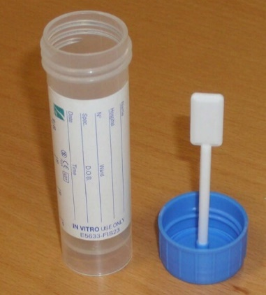
- Specimens should never be taken from the toilet and should not be contaminated with urine.
- Commercial systems are available with preservatives for bacteria and parasites.
- The appropriate ratio of stool to preservative is 1 : 3, and the patient must understand that if this ratio is not met, the test will be invalid.
- In addition, the patient needs to be told that the specimen must be thoroughly mixed with the preservative.
- Specimens for parasite microscopic studies should be collected before any barium studies are done; if this is not feasible, the patient must delay specimen collection until the barium is cleared (4 to 5 days).
- Barium appears as a white chalky substance in the specimen and masks the appearance of parasites under the microscope.

Labelling and Requisitions of clinical sample
- It is important that correct patient identification to be put on the specimen and the requisition.
- The specimen label must contain sufficient information for the specimen and requisition to be matched up when received in the laboratory.
- The laboratory loses valuable time when specimens are unlabeled or mislabelled.
Proper identification of each specimen includes a label attached to the container with the following information:
  - Name
  - Identification number
  - Room number
  - Physician
  - Culture site
  - Date of collection
  - Time of collection
- To perform quality laboratory analysis, the laboratory needs specific information regarding the patient and the specimen.
- All that the laboratory knows about the patient is learned from the requisition form. The less information that is provided, the more difficult it is for the laboratory to provide good patient care.
- Incomplete information on the requisition is often a weak link in the specimen management process.
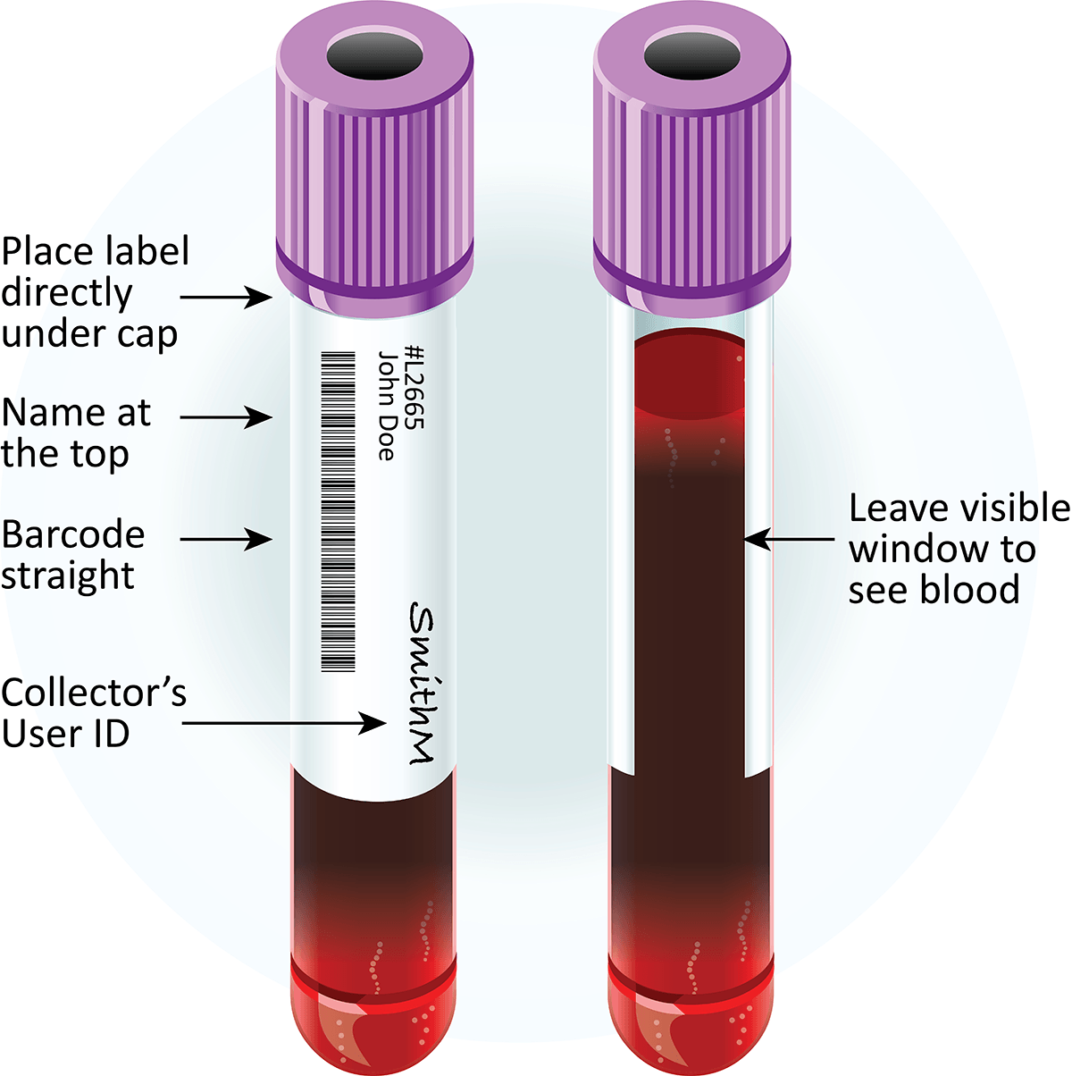
The requisition form should provide the following information:
  - Patient’s name
  - Patient’s age (or date of birth) and gender
  - Patient’s room number or location
  - Physician’s name and address
  - Specific anatomic site
  - Date and time of specimen collection
  - Clinical diagnosis or relevant patient history
  - Antimicrobial agents (if the patient is receiving)
  - Name of individual transcribing orders
- Complete and thorough requisitions can often lead the microbiology technologist to suspect certain pathogens based on the diagnosis or patient history.
- This knowledge can allow use of specific media or making certain adjustments to the incubation to maximize recovery of the pathogen.
- Computer-based ordering is performed at many institutions. Ideally, the microbiology technologist should design the test ordering process; this will enable the laboratory to elicit the necessary information.
- These systems should be designed to provide key fields that must be completed to submit the request transaction.
- The microbiologist should recognize that the individual ordering the test does not have a complete knowledge of what are and are not appropriate tests for each specimen.
- If the test requested is not recommended, it is the responsibility of the laboratory to communicate with the physician to determine exactly what needs to be done.

Safety during clinical specimen collection
- It is imperative that specimens collected for microbiology not pose a safety hazard to the individuals who handle them.
- Leaking containers and specimens with needles attached present the greatest hazards.
- All specimens must be transported in leak proof secondary containers.
- Because the specimen should be kept separate from any paperwork, plastic bags with permanent seals and separate pouches on the outside for requisitions are recommended.
- Transporting personnel should refuse to transport specimens without the protection of a secondary container. Refusing to accept syringes with needles attached is also appropriate.
- A needle must be replaced with a tight-fitting rubber stopper or a stopcock to put resistance on the plunger.
- The aspirated material could also be transferred to another sterile container with a tight lid or to an anaerobic transport system.
- Laboratory personnel must also adhere to strict safety guidelines as they begin to work with the patient’s specimen.
- All individuals handling patient specimens must wear protective clothing, and specimens should be opened only in a biological safety cabinet.

The following points must be kept in mind while collection of samples from a patient suspected to have anaerobic infection:

1. Avoid contamination with normal flora.

2. Avoid contact with oxygen.

3. Do not refrigerate the samples.

4. Process immediately after collection.

5. Transport media should be used only when delay in culturing specimen is inevitable.

Specimen Containers and their Transport

A sterile container should be used and specimen be plated as soon as possible. Apart from usual containers the most useful piece of collecting equipment is cotton, calcium alginate or polyester tipped applicator stick. Collection of material from throat, nose, eye, ear, wound at operative site, urogenital orifices and rectum is done in a Pyrex test tube (20 × 150 mm) which is cotton plugged having applicator stick and small test tube containing thioglycollate broth. The swab inoculated with material from the patient is placed in inner broth tube to prevent drying out and promptly sent to the laboratory.

In case significant delay is unavoidable between collection of specimen and culturing, transport media are required. Transport media prolong the survival of microorganisms, e.g. Stuart medium maintains a favourable pH and prevents both dehydration of secretions during transport as well as oxidation and enzymatic self destruction of pathogen present in the specimen. Cary and Blair transport medium is used for fecal culture to isolate Salmonellae, Shigellae, Vibrio, etc. For anaerobic culture double stoppered collection tube gassed out with oxygen-free carbon dioxide or nitrogen are recommended for collection of specimen and transporting it to laboratory.

Some bacteria such as meningococcal in cerebrospinal fluid are quite sensitive to low temperature and require immediate culturing. On the contrary clinical material likely to contain abundant microbial flora may be held at 4°C in a refrigerator for several hours before culturing if it cannot be processed immediately, e.g. urine, feces, etc. Refrigeration will preserve the viability of most pathogens and also prevent the overgrowth of commensals.

If specimen is to be delivered by post it must be sealed in such a way as to prevent the leakage of material and outer envelope must be marked “Microbial Specimen and Fragile— Handle with Care”
Handling of Specimen in the Laboratory
It is not always practical for many specimens to be inoculated as soon as they arrive in the laboratory. Refrigeration at 4°C to 6°C offers a safe and reliable method of storing many clinical samples until they can be conveniently handled. However, some may require immediate plating.
Urine specimens for culture may be refrigerated for 24 to 48 hours without affecting the bacterial flora. Swabs from wound, urogenital tract, throat, rectum and samples of feces and sputum may be refrigerated for 24 to 48 hours without appreciable loss of pathogens. Gastric washings and resected lung tissue for the culture of Mycobacterium tuberculosis should be processed immediately after delivery as tubercle bacilli may die rapidly in these specimens.
Sputum, bronchial secretions, bone marrow and purulent material from patients suspected of having systemic fungal infection should be inoculated as soon as possible, particularly when diagnosis of histoplasmosis is considered. However, pieces of hair or scraping from skin and nail submitted for fungal culture may be kept at room temperature for several days before inoculation. Specimen submitted for isolation of virus should be frozen immediately. Specimen of clotted blood for virus serology may be refrigerated but never frozen.
Selection of Laboratory Investigations
Diagnostic tests in infectious diseases fall into following 4 groups:
1. The demonstration of an infectious agent (bacterial, viral, protozoal, helminthic or mycotic) in specimens obtained from the patient.
2. The demonstration of a meaningful antibody response in the patient. It requires two serum specimens usually obtained at an interval of 10 to 20 days or longer.
3. The demonstration of meaningful, cell mediated responses or skin tests to antigens associated with a particular infectious disease.
4. The demonstration of deviation in a variety of clinical laboratory determinations that non-specifically suggest or support a suspicion of infectious diseases
Handling Laboratory Animals
These guidelines have been developed to introduce investigative staff to procedures recommended for handling and restraint of small laboratory animals. Techniques for performing parenteral injections and blood collection are addressed by separate Animal Care Services (ACS) guidelines. This document is intended to supplement hands-on instruction by an experienced member of your laboratory There are a variety of other techniques in addition to those described in this document that are suitable alternatives.
Handling
Although there are significant species differences when handling and restraining a laboratory animal, there are several important concepts that apply equally to all species. These include:
1. Handle animals gently but firmly.
2. Approach an animal slowly but purposefully.
3. Wear disposable gloves.
4. Always wash your hands prior to and after handling animals, as odors of other species or blood is frequently distressing. Additionally, your hands can act as a means of spreading infectious agents from one group of animals to another.
5. Wear a clean laboratory coat or disposable gown.
6. Use an appropriate method. Animals used in experimental protocols that involve extensive manipulation should be handled frequently before the onset of the study to allow the animal to acclimate to your scent and the procedure(s). Frequent handling makes them more docile while restrained. Within specie, particular stocks or strains of animals may have distinctive behavioural responses.
General considerations
Approach
Animals should be approached in a calm and confident manner, avoiding exaggerated or sudden movements, such as waving of the hands and arms. Using soft tones and a quiet voice when talking to animals may help alert them to a non-threatening approach and reinforce a caring attitude in the handler.
Handling method
Choice of an appropriate method to pick up, carry and/or restrain an animal is perhaps the most crucial aspect of handling. The method needs to be suited to the particular species (see specific recommendations below); any strain or individual differences also need to be taken into account. More anxious strains/individuals may be much slower to habituate to some methods, requiring further training and/or adjustment of handling techniques, until they are calm and have learned that handling is not a threat.
Restraint
Correct positioning of both the handler and animal is necessary to achieve quick and secure restraint. Animals need to feel secure and to be completely immobile to avoid struggling, which would promote anxiety and could result in injury to the animal or handler. During restraint, the animal should be gripped with just sufficient force to hold it firmly and securely, but not so tightly that it causes discomfort, compromises the animal’s breathing or causes bruising.
Observing the animal's response
It is important to observe the animal’s behaviour during handling as this allows immediate adjustment to keep the animal secure and safe. However, observing the animal’s response on approach and after the animal has been released back into its home environment also provides invaluable information. Anxious animals will often flee from the handler on release and try to evade recapture or, less obviously, they may attempt to hide quietly to avoid attention. By contrast, animals with a positive response to handling are generally curious and will voluntarily approach the handler to investigate and interact. To check the effectiveness of your own handling procedures, try standing motionless for a short period after handling to assess whether animals approach and seek contact.
Training and experience: handlers and animals
Acquiring good handling skills needs training in appropriate methods (see below) and much practice to be able to handle quickly and effectively regardless of the specific presentation of the animal, its behaviour and context. Skill should be sufficient to capture animals quickly, confidently and securely on first approach without any chasing. Failed attempts to catch an animal can increase its anxiety and lead to further evasive response, resulting in frustration and sometimes impatience in the handler. Non-aversive handling from a young age during routine husbandry is a fast and effective way to tame animals. The use of non-aversive methods promotes rapid habituation, which is particularly relevant when time is constrained.
Continuous Culture
Continuous culture is a continuous process where nutrients are continually added to the bioreactor and the culture broth (containing cells and metabolites) is removed at the same time. The volume of the culture broth is constant due to a constant feed-in and feed-out rate (i.e consumed nutrients are replaced and toxic metabolites are removed from the culture).
Some advantages of continuous culture are:

- In continuous culture, keeping the working volume constant simplifies culture scale-up based on a constant- power-to-volume strategy.
- It is possible to set up the optimum conditions for maximum and long-term product synthesis.
- Ability to obtain stable product quality (the steady-state consists of homogeneous cell culture with a constant biomass and metabolite concentration).
- It also results in higher productivity per unit volume, as time-consuming tasks, such as cleaning and sterilization are unnecessary.
- Cultures in a steady-state can last for days, weeks, or even months, thus greatly reducing the downtime and making the process more economically competitive.


Principle of continuous culture
- A continuous flow system consists of a reactor into which reactants are pumped at a steady rate and from which products are emitted.
- The factors governing their operation are:
  - how material passes through the reactor (which depends upon its design);
  - the kinetics of the reaction taking place.
- In continuous culture, growth-limiting nutrients can be maintained at steady-state concentrations, which permits microorganisms to grow at submaximal rates.
- In a steady-state, the cellular growth rate and environmental conditions, like the concentrations of metabolites, stay constant
- Moreover, in continuous culture, parameters such as pH, oxygen tension, the concentration of excretion products, and population densities can easily be monitored and controlled.
Process of Continuous Culture
- In continuous culture, an open system is set up in which one or more feed streams containing the necessary nutrients are fed continuously, while the effluent stream containing the cells, products, and residuals is continuously removed.
- A steady-state is established by maintaining an equal volumetric flow rate for the feed and effluent streams.
- The culture volume is kept constant, and all nutrient concentrations remain at constant steady-state values.
- During this process, the exponential growth phase is prolonged and the formation of by-products is avoided.
Batch Culture Definition
- In batch fermentation, all the medium components are placed in the reactor at the start of cultivation except for atmospheric gases, acid or base for pH control, and antifoaming agents.
- There is a continuous change in the nutrient concentrations over time, and the system remains unsteady.
- The microbial metabolites may be produced at a primary or secondary stage of the microbial cultivation period.
- Fermentation is terminated when either all the nutrient is exhausted or the desired concentration of product is achieved.
Batch culture has the following mention advantages:
- Reduced risk of contamination or cell mutation as the growth period is short.
- Lower capital investment when compared to continuous processes for the same bioreactor volume.
- More flexibility with varying product/biological systems.
- Higher raw material conversion levels, resulting from a controlled growth period.
Batch Culture Principle
- A batch fermentation system is a closed system.
- At time t=0, the sterilized nutrient solution in the fermenter is inoculated with microorganisms, and incubation is allowed to proceed at a suitable temperature and gaseous environment for a suitable period.
- In the course of the entire fermentation, nothing is added, except oxygen (in the case of aerobic microorganisms), an antifoam agent, acid, or base to control pH.
- The composition of the medium, the biomass concentration, and the metabolite concentration generally change constantly as a result of the metabolism of the cells.
After the inoculation of a sterile nutrient solution with microorganisms and cultivation under physiological conditions, four typical phases of growth are observed.
- Lag phase
- Log phase
- Stationary phase
- Death phase
Batch Culture Process
- A batch culture begins with sterilization, and the sterile culture is then inoculated with microbes (about 2-5 % of the total volume).
- The percentages of nutrients, vitamins, and microbial cells in the reaction mixture and the temperature difference during the reaction cycle.
- The proper mixing keeps them at acceptable concentrations and temperatures.
- The process is carried out in anaerobic conditions by bubbled oxygen in or out, while acidic or alkaline solutions are added to control the pH.
- Antifoaming agents are added when indicated by a foam sensor.
- The microorganism growth is allowed to take place for days, weeks, or months.
- In the lag phase, little or no growth is observed at the beginning of fermentation, depending on a physiochemical equilibrium between the microorganism and the environment.
- Once the cells have adapted to the new conditions of growth, they enter the exponential phase.
- Primary metabolites are produced during the log or exponential phase with their formation decreasing when growth ceases. For example, Saccharomyces cerevisiae produces ethanol as a primary metabolite.
- When the cells enter the stationary phase, secondary metabolites are produced. Most antibiotics are metabolized as secondary metabolites. For example, Penicillium chrysogenum produces Penicillin as a secondary metabolite.
- The fermentation is terminated when one or more of the following has been reached:
  - The microbial growth has stopped due to the depletion of the nutrients or the build of toxic compounds;
  - After a fixed predetermined period;
  - The concentration of desired product has been achieved.
Batch Culture Applications
- It is beneficial for the construction of biomass (Baker’s yeasts) and primary metabolites (lactic acid, citric acid, acetic acid, or ethanol production).
- In food industries, organic acids are used as preservatives or acidifiers (lactic acids, citric acids, and acetic acids), alcoholic beverages (wine, beer, and distilled spirits i.e. brandy, whisky, and rum), and sweeteners (e.g., aspartate) or amino acids used as flavouring agents (e.g., monosodium glutamate) are the various product manufactured by batch cultivation.

